Chapter 1

Introduction to Report

1.1 BACKGROUND of Study
Institute of Management Studies requires its student to undergo an eight-week internship program. Selection of organization depends upon the interest of the student +as well as the field of specialization. This document known as “Internship Report” is based on theoretical and practical learning of the internee. This report is about Bank Alfalah Limited (BAL) Haripur Branch. This Alfalah bank has given new dimension to banking in Pakistan. It provides new and improved customer service, facilities and also mobilizes the foreign investment. BAL has 189 branches in Pakistan, which are working in all big cities of the country.
1.2 PURPOSE OF STUDY
The purpose of this study is to review and analyze the functions being performed by the BAL Haripur branch and to translate attained knowledge into practice and preparing an analytical review with findings of the research and specific recommendations regarding the organization. This study will help the reader to know about the insight story and operational efficiency of the organization.

1.3 Scope of Study
BAL has only one branch in Haripur and this study is limited to the functions performed by the organization. However, the financial analysis and HRM functions are related to the whole bank because data is gathered from annual reports and the personnel of the bank.

1.4 Methodology of Research
The method for data collection is central theme of the study. No study is completed without using the scientific and systematic ways to get latest knowledge about the study. So the methodology for data collection is based on the traditional categories i.e;
i. Primary Data ii. Secondary Data
Primary data is collected based on my
- Personal observation.
- Briefing and discussion with officers of different departments.
- Unstructured interviews.
Besides secondary data is collected from:
- Working manual issued by Head office to branches.
- Annual reports from 2005 to 2006
- Brochures for information to customers
- Pamphlets
- Inter-bank office memo
- Newspapers and magazines

1.4 Scheme of Report
This internship report is broadly divided in four sections with number of chapters required in each section. The brief of each chapter is as follows:
- “INTRODUCTION OF REPORT” is divided into different topics which includes, the background of Study, Purpose of Study, Scope of Work, and Methodology of Research used during the internship.
- “INTRODUCTION TO BANK ALFALAH LTD” is about the brief history of banking sector in Pakistan and then specifically in NWFP. Then, background history of BAL, Bank’s Mission, Vision and Corporate Goals and Strategic Objectives are discussed under the shelter of this chapter.
- “ORGANIZATIONAL STRUCTURE” discusses the organizational setup in BAF and brief about Branch Network of bank.
- “BAL HARIPUR BRANCH” highlights the departmentalization in Haripur branch and then each department is discussed in detail about its functioning and working which include: Deposit department, Account department, Remittances department, Credit department and Trade Finance department etc.
- “BANK ALFALAH PRODUCT MIX” is about the product line and mix offered to their valued customers. It includes car financing, home financing, debit cards, credit cards and traveler cheques etc.
- HUMAN RESOURCE MANAGEMENT” is about the functions of HRM department at head office and branches and related issues to employees of the branch e.g. Procurement, Development, Promotion of Personnel and so on.
- FINANCIAL ANALYSIS” In this part, an analysis of financial data has been made which include computation of various critical ratios and its interpretation.
- “ORGANIZATIONAL ANALYSIS” highlights the various critical aspects of the branch, which include: Administrative, Personnel and Functional Analysis of the bank.
- “RECOMMENDATION AND ACTION PLAN” is about to suggestions and action plan for further improvement of the bank performance, which are both in qualitative and quantitative terms.

Section – II

Introduction to bank alfalah

2.1 Brief History of Banking
Banking in primitive societies also existed in some form. The greatest invention of all times is considered to be the invention of wheel which made transportation easy and transportation opened a gateway to business and exchange of goods flourished. The initial business was done on “barter” which meant an exchange of “commodity for commodity”. There is a myth also about the invention of money, which tells that king Midas of Libya invented money in 800 B.C. Another statement states that the king of Babylonian empire named as King Hummurabi in 1700 B.C. made all the rules and regulations of lending and borrowing and interest etc. He got his code inscribed on blocks of diorite about 8 feet tall, containing about 150 paragraphs which deal with nearly all aspect of loans, interest, pledges, guarantees, natural accidents, loss , thefts etc. It is not certain as to who invented money; but history records that Gyges (Croesus), King of Lydia, casted electrum(a natural alloy of gold and silver) of identical shapes and of uniform weights with a triple emblem engraved on it as an official guarantee of value in 687 B.C.
The first bank was established in Barcelona in Spain. Another statement tells that “Venice” and “Genoa” was the hub of financial transactions and the first bank was founded there in 14th century. The first public bank in Germany was formed comprising the operations of discounting, deposit and transferring of money. In the 16th century, some more public banks were formed in Hamburg, Nuremburg and Milan.
In 15th Century a number of conferences were held in Nuremburg for organize the banking techniques with facilities of growth and transfer. In 1587 the bank of Genoa was formed. In 1609 the Bank of Amsterdam was also formed. This bank rendered valuable services to the Netherlands traders up to the year 1795. Bank of Hamburg came into existence in Hamburg with the business of accepting deposits of fine silver or foreign currency. The bank rendered great service to the merchants as well as the countries. It dealt with them until 1873, when it was merged with the Reich bank.¹

2.2 Brief History of Banking in pakistan
Before the partition of India and Pakistan in 1947, branches of British banks dominated banking in Pakistan. The first domestic banking institutions emerged in the 1940s, immediately after Pakistan’s independence. These institutions include the Australasia Bank (today, Allied Bank Limited) or Habib Bank Limited, Muslim Commercial Bank, and the National Bank of Pakistan. The NBP was wholly government owned but prominent merchant families established the other three. In 1948, the State Bank of Pakistan (SBP) was formed. It assumed that the supervisory and monetary policy powers of the State Bank of India. From 1960 to 1970, a number of specialized Development financial institutions (DFIs) such as Industrial Development Bank of Pakistan and the Agricultural Bank emerged. These DFIs were either controlled directly by the state or through the SBP, and were intended to concentrate on lending to long-term projects in specific priority sectors.
In 1974 Government of Pakistan nationalized all the private sector banks. In addition to managing the monetary policy, SBP also oversees the entire financial system and has institutionalized the procedure for appointment of chief executive officer (CEO) and Board of the Nationalized Commercialized Banks and DFI’s.
Banking and Financial services sector in Pakistan comprises the commercial banks and the non-banking financial institutions, including the development finance institutions (DFIs), leasing companies, modarabas (Islamic Mutual Funds) and investment banks. These are controlled and regulated by the SBP. Pakistan is in the process of adopting an Islamic (Shariah) financial system, under which interest-based banking is not allowed. Since 1990 the Government of Pakistan has introduced various reforms in the financial services sector enhancing the level of autonomy enjoyed by the SBP.
Privatization program that began in Pakistan in 1991, two of five NCB’s and DFI’s were privatized and 11 new private banks were setup. The number of banks operating in Pakistan has increased, which in turn has resulted in increased competition. During previous five years, the combined total assets of domestic banks, showed an average annual increase of 22 percent, while combined deposits have recorded an increase of 27 percent per annum. A total of forty-six commercial banks, including twenty-one foreign banks, are operating in Pakistan. Additionally, sixteen Investment Banks, twenty-nine Leasing Companies and fifty-three Modaraba Companies provide a mix of financial services.
Opportunities for new foreign banks exist in consumer banking, corporate bonds, investment banking, leasing and housing finance sectors. Good reputation enjoyed by the existing foreign banks will be helpful for new entrants. Some challenges, however, do exist in the form of weak economic conditions in Pakistan and the turnaround possibilities in NCB’s through privatization.

2.3 History of Bank Alfalah Limited
Bank Alfalah Limited was incorporated on June 21, 1997 as a public limited company under the Companies Ordinance 1984. Its banking operations commenced from November 1st, 1997. Bank Alfalah Limited started its life as “Pakistan Operation” of BCCI. A multi-national conglomerate based in Luxembourg and Grand Cayman. BCCI was the 7th largest bank in the world. The estimated assets of BCCI were 20 billion dollars. The operations of the Bank were in 70 different countries. In July 1991, the Bank of England and International Liquidators accused BCCI of being involved in money laundering to the tune of 1.54 billion dollars.
Upon closing down of BCCI in 1992 the operations of BCCI in Pakistan were acquired by HBL, and were run as a wholly owned subsidiary by the name of Habib Credit & Exchange Bank (HCEB). HCEB was later acquired by the Abu Dhabi Group through privatization under the leadership of Sheikh Nahayan Mubarak Al-Nahayan, in 1997 and its 70% ownership was transferred to Abu Dhabi Group. The agreement was signed on July 7, 1997.

2.4 Bank Alfalah Today
The strength and stand of Abu Dhabi Group, principal owners of BAL, have helped Bank Alfalah Limited launch high quality consumer and corporate banking operations in Pakistan. BAL have embarked upon a rapid expansion program to make sure that the services reach more and more people, BAL is headed towards an optimum sized network reaching major urban centers in Pakistan. The Bank is well positioned and geographically poised, to cater for increased business demands, from its existing and potential clients.
There are 189 Branches of Bank Alfalah Limited in 74 different cities of Pakistan, with the registered office at B.A.Building, I.I.Chundrigar, Karachi. Islamic Banking Division is a recent initiative which operates as a separate branch. It offers shariah complaint products through a network of 50 branches.
With the implementation of the office automation and communication system BAL will be poised to compete with the best in quality and speed of customer services. Recently WARID telecom private limited signed strategic alliance agreement with Ericsson. Earlier, a latter of intent was signed in this regard on 5th September, 2004. The chairman of Abu Dhabi consortium, and of Warid telecom, his Highness Sheikh Nahayan Mubarak Al-Nahayan was the chief guest of the ceremony. Under this Strategic alliance agreement, Ericsson will provide Warid telecom a complete turnkey state of the art network GSM online.

2.5 Vision
“To be the premier organizations operating locally & internationally that provides the complete range of financial services to all segments under one roof.”
Bank Alfalah is one of the leading financial institutes and Bank alfalah day by day increasing its products for all the segments in Pakistan i.e for Businessmen, Industrialists, Agriculturists and for the Government bodies in the country. Bank Afalah is trying to reach each segment in Pakistan, and trying to provide its products at lowest charges and with easiest way, under one roof.

2.6 Mission Statement
“To develop & deliver the most innovative products, manage customer experience, deliver quality service that contributes the brand strength, establishes a competitive advantage and enhances profitability, thus providing value to the stakeholders of the bank.” In the above Mission the Management of Bank Alfalah emphasis on the following areas:
- To provide the new and more innovative products than the other banks.
- To take and manage the ideas of the valuable customer for the Bank
- To deliver high quality and quick services to the customers, who are keep great value for Bank Alfalah.
- Bank Alfalah tries to promote those activities which give the fruitful result to the customers and the stakeholder of the bank.

2.7 CORPORATE VALUES OF BANK ALFALAH LIMITED
The corporate values of the bank are excellent customer service, creativity, integrity, respect, teamwork and professionalism, which play an integral role in the fulfillment of the bank’s mission. Clearly these values are not new to the bank and have been high priorities since the bank was established. B continuously recognizing the importance of corporate values, the individual contributions from all employees has made the bank what it is today. In addition to the corporate values, bank urges to provide all those having interest in the bank with a number of criteria by which they can access the bank.

2.8 OBJECTIVES OF BANK ALFALAH LIMITED
- To create maximum economic value for shareholders through constant relationships focus on financial services.
- To promote industrial agricultural and socio-economic processes through active participation of private and public sector in the country,
- Create diversified and sound portfolio for utilization of idle funds and their investing in the existing and new venture especially in the pioneering of high tech agro based, export oriented and engineering projects to ensure maximum return

2.9 Bank Alfalah Credit Rating
Pakistan Credit Rating Agency – the leading credit agency in the country – has rated Bank Alfalah very favorably. The Bank has been awarded an AA- (double A minus) and an A1+ (A one plus) in the long and short term respectively. These ratings denote very high credit quality and very low expectation of credit risk.

2.10 Branch Network of BAL
Since the privatization in 1997, Bank Alfalah Limited has remained consistent in its mission to excel in providing innovative products and services to its customers. As a result of that, the yare 2007 has been most favorable for bank inspite of varying market conditions. The Bank recorded significant increase in its business volumes coupled with the broadening of network and clientele base.
The Bank is fully aware that the branch network has direct implications on the service that it provides to its customers. In the year 2007, commercial banking branches have reached to 166 and Islamic branches to 23. So in 2007, Alfalah network extend the coverage to 189 branches covering 74 cities nationwide and bank has also six international branches in four countries. Bank Alfalah is confident that a well-integrated branch network offers greater potential for serving a larger client base through high value products.
Range | South |  |  | North |  |  |  |  |  |  | Branches
 | I | II | III | I | II | III | IV | V | VI | VII
Commercial | 8 | 7 | 7 | 5 | 6 | 4 | 8 | 7 | 5 | 6 | 63
Islamic | 1 | - | - | - | 3 | 1 | - | 1 | 1 | - | 7
Total |  |  |  |  |  |  |  |  |  |  | 70
Source: BAL Manual, December (2007)

Organizational Structure of BAL
Organizing is a function of management. It is a process of breaking down the overall tasks of an enterprise into individual assignments and then getting them put together in units along with delegation of authority to a manager of a department.
Bank Alfalah is a highly developed organization, disciplined along clear lines. This principle of clarity of authority, responsibility, and job description is evident from their organizational hierarchy. At the top of the structure is the Board of Directors, which is in Abu Dhabi. The Chairman of the Board of Director is His Highness Sheikh Nahayan Mubarak AI-Nahayan. Then there are six directors. The CEO is Pakistani and holds his office at Head Office Karachi. The CEO is reported by five executive in charges looking after personnel training, credits, IT, operations, strategic planning and finance.
The whole country is divided into two zones (areas) Northern and Southern, headed by two Area Managers. All Branch Managers reports to Area Managers. The organizational structure of Bank Alfalah is pyramid like, though culturally the pyramid works upside down. The different zones are encouraged to setup their own targets, subject to approval from top authority. In the same way, the different departments after choosing their realistic targets allow these goals to cascade down to employee level.
A general view of the structure of BAL is shown in the following organizational chart.
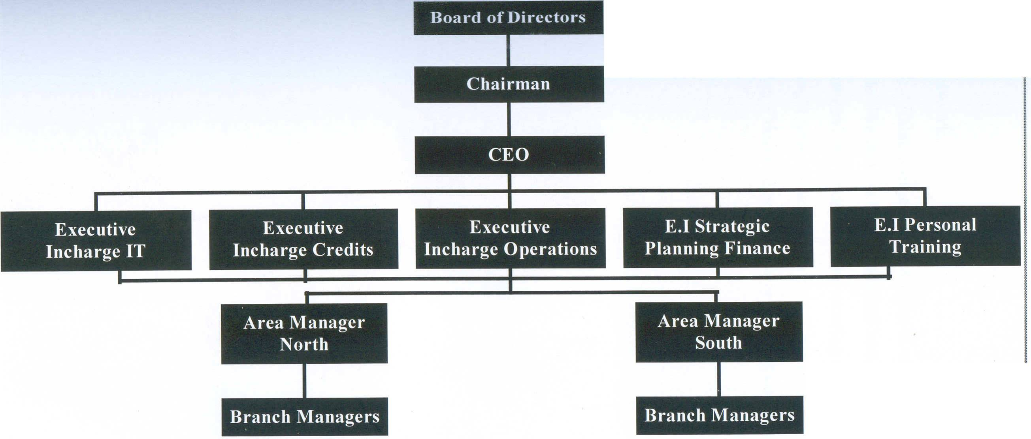

2.12 Management of Bal
BAL is managed by a 6-member Board of Directors headed by a Chairman. There is an Executive officer, who runs the Executive Committee. In Executive Committee there are 12 members.
The names of members of the Chairman, Board of Directors and Executive Committee along with their designations are given below:

2.13 Board of DIRECTORS & Management

Chairman
H.E. Sheikh Hamdan Bin Mubarak Al Nahayan

Board of Directors
H.E. Sheikh Hamdan Bin Mubarak Al Nahayan
Mr. Abdulla Khalil Al-Mutawa
Mr. Abdulla Nasser Hawaileel Al-Mansoori
Mr. Khalid Mana Saeed Al Otaiba
Mr. Ikram Ul-Majeed Sehgal
Mr. Nadeem Iqbal Sheikh

Chief Executive Officer
Mr. Mohammad Saleem Akhtar

Executive Committee
Mr. Mohammad Saleem Akhtar
Mr. Parvez A. Shahid
Mr. Mohammad Yousuf
Mr. Sirajuddin Aziz
Mr. Shakil Sadiq
Mr. Shahid M Murtaza
Mr. Nadeemul Haq
Mr. Bakhtiar Khawaja
Mr. Adil Rashid
Mr. Ijaz Farooq
Mr. Arfa Waheed Malik
Mr. Adnan Anwar Khan

Section – III

Departmentation
Bank Alfalah is a financial institution showing strong growth and development over the last five to six years. The Haripur Branch started its operation in December, 2006. It performs all the functions of a commercial bank from deposits to advances and from remittances to save custody services.
The branch will ensure that all its activities are properly recorded in accordance with direction and procedures of the bank, there by showing compliance with reporting requirements to be prompt and full.
It seems quite apparent that if the stated goals and objectives of an organization are to be attained, certain activities have to be performed and it would also seem that the organizing function of a manager would involve grouping the functions and activities necessary to attain the goals of an enterprise. The term for that process is “Departmentalization” or Division of Organization.
In Bank Alfalah Haripur Branch, departments are made on the basis of functions performed by the bank. The major divisions in the bank are:
- General Banking Division
- Credits Division
- Trade-Finance Division
In each division there are certain departments, which are as follows:

3.1 General Banking Division
The general banking division includes:
- Deposits Department
- Accounts Department
- Cash Department
- Remittances Department
- Clearing Department
The major activities and operations performed under this department are;

Deposit Department
In line with the “Client First” philosophy, Bank Alfalah offers a wide range of deposits to cater to the specific needs of various business segments classified as follows:
- Current Account
- Saving Account
- Term Deposits
- Call Deposits

Current Account
Current accounts are the running and active accounts, which may be operated upon by the customers for any number of time during a day I-e the depositor can deposit money. Cheques, warrants, dividends and other instruments and can demand payment for a part or the entire credit balance at any time during business hours without any restriction as to number of withdrawals. It can be further classified as Individual Account and Joint Account.
Individual Current Account:- Individual Account is opened by a single customer, only he can operate the Account, but he can give the Authority to the other person to operate the Account.
Joint Current Account:- If there are two or more customers who want to open Current Joint Account, so they will open a Joint Account. This Account may be operated;
- Jointly by all partners
- Either or savoir
- Any one of the partners

Saving Account
Saving account gives higher return with the added benefit of flexibility of drawing money at any time within business hours than the Current Account. Different types of Saving Accounts are:
- Individual Saving Account
- Joint or Partnership Saving Account
- Minor Saving Account

Features of Saving Account
Main features of Saving Accounts are as follows
- Currency Option PKR, US$, GBP, J¥
- Minimum Balance Requirement Rs. 5000 or US $ 500
- Checking Facility Unlimited
- Tax Application With holding Tax on Profit &
- Zakat on total amount
- A/C Statement Monthly
- Cheque Book 25, 50 leave @ Rs.2/leaf

Call Deposit
It is an interest bearing deposit account with a mandatory 7 or 30 days notice period preceding the release of funds. This account can be maintained in PKR. The interest depends upon the tenor of the deposits and is payable on maturity.
The tax withheld on the profit and Zakat is applicable to principle amount only.
- Currency Option PKR
- Minimum Balance Required None
- Tenor 7 to 30
- Profit On Maturity
- Checking Facility Nil
- Tax Application With holding tax on profit &
- Zakat on Total amount
- A/C Statement Nil

Term Deposit
It is one of the popular account types. The amount is deposited in this account for fixed i.e., from one month to five years. The interest varies with the variation of time limitation. The rate of profit increases as per increase in time period. The customer does not withdraw money before maturity of his/her account. The profit is paid after the maturity but in certain cases money can be withdrawn with the adjustment of rate of profit according to the time limitation.
Different Schemes Of Bank Alfalah
To boost up its deposits and to provide more facilities to its clients, Bank Alfalah has launched different peculiar schemes i.e.
- Royal Profit
- Royal Patriot
- Royal Custodial Services
- Royal Group
- The detail of the above stated schemes is as follows:

Royal Profit
It is highly flexible interest bearing account which calculates return on daily product basis.
Features of Royal Profit
- Currency option PKR, US $
- Checking Facility Unlimited
- Cheque Book 25 leave free of Cost
- Account Statement On Request
- Tax Application Zakat

Royal Patriot
This is a rupee term deposit which is designed to give your money at a much higher growth rate than a foreign currency account.

Features of Royal Patriot
- Choice of Term 1,3,6,9,12,24 months
- Profit Rate improves with tenure and amount
- No penalty in case of premature encashment
- No prior notice required before withdrawal
- Low minimum balance requires Rs. 25,000/-

Royal Custodial Service
Dollar Bond Custodial and Return Management Services are:
- Absolutely safe
- No need to maintain account to benefit from service
- Automatic opening of account both in PKR and US $
- Opens a door to an array of our top quality
- The service is available for bearer and registered bonds

Royal Group
This is a joint investment plan which allows the investors to make a group of people and open an account.

Features of Royal Group
- Profit will be calculated on daily product basis
- Profits will be disbursed on monthly basis
- Option of salary disbursement (for employees)
- Arrangement of secured collection of cash/cheque from work place
- High rate of return for even small depositors group
- Required number of people is two or more
Deposit Portfolio Highlight
Nature of Deposits | Percent Per Annum
Saving Account | 9%
Notice Deposits
7-29 Days | 6.10%
30 Days & Above | 7.50%
Term Deposits
1 Month | 8.00%
3 Month | 10.00%
6 Month | 10.50%
1Year | 11.00%
3 Years | 12.00%
5 Years | 13.00%
Royal Profit
From 50,000 to 999,999 |  |  | 9%
From 1,000,000 to 9,999,999 |  |  | 9.5%
From 10,000,000 & above |  |  | 10.5%
Royal Patriot
Duration Amount |  | 1 month |  |  | 3 months | 6 months | 12 months | 2 years
25,000 to 999,999 |  | 8.00% |  | 10.00% |  | 10.50% | 11.00% | 11.00%
1,000,000 to 4,999,999 |  | 8.10% |  | 10.10% |  | 10.60% | 11.10% | 11.25%
5,000,000 & above |  | 8.20% |  | 10.25% |  | 10.70% | 11.20% | 11.50%
Royal Group
100,000 to 999,999 |  | 9.50%
1,000,000 to 9,999,999 |  | 9.70%
10,000,000 & above |  | 10.50%
Accounts Department
This department coordinates all the banking activities there by keeping track of each activity in a sequential manner and provides up-to-date data. The accounts department is also responsible for proper accounting of assets and liabilities of the branch. This department is the backbone of the entire banking system. All the banking activities are placed through this channel. The main functions of this department are:
- Maintenance of books of accounts
- Preparation and disbursement of salaries of bank’s staff
- Maintenance of superannuating funds and investment of the staff
- Dealing with the disposal of commercial and external audit reports
- Preparation of budget and other financial statements

Cash Department
Unlike other departments in the bank, Cash Department also categorizes itself as one of the important department of the bank. Its significance being obvious by the fact that banking started because of transactions relating to cash — its safe keeping, trading etc. One drafts all the cash transactions with the clients by the cash department, specifically by the tellers. The amount of cash available at teller’s area is enough to meet daily requirements and is insured. After closing of the business hours, the teller verifies the amount of cash, physically, which is cross verified by the manager operations and tailed with the general ledger account. All the activities of the cash department are divided into two i.e. Cash Collection and Cash Payment.

Cash Collection
Cash collection is accompanied by cash deposit slip. The slip contains the account number; title of account and denomination of cash deposited both in words and in figures followed by the signature of the depositor. The cash received is counted and is verified with the deposit slip. Entries for cash deposits are recorded before handling over receipts to the customer. Customer’s copy of the deposit slip is handed over to the depositor. Before cash deposit slip is released, it is matched and validated with the entries in the register for cash collection.

Cash Payment
Amount of payment of cash in a single transaction is fixed. Payments beyond a certain limits are supported to be approved by an appropriate authority. Before payment, the cheque must be checked for staling, post dated, payee’s name, crossing, amount both in words and in figures and authentication of alterations. Tellers verify signatures on cheque before payment. In case of illiterate account holder the customer is identified through the photograph available in the bank’s record and thumb impression attested under the full signature of the teller who is authorized to approve the transaction.

Remittances Department
One of the most frequently used banking services is the transfer of funds through the banking channels, being local or outstation. Transfer of funds entails high level of efficiency and security on part of the bank. It creates a legal obligation for the bank of debtor/creditors in case of DD and principle agent in case of TT.
The remittances are of two types i.e.
- Local Remittances
- Foreign Remittances
BAL offers following modes for Local Remittances:
- Pay Order
- Demand Draft
- Tele-Phonic / Tele-Graphic Transfer
- Mail Transfer
- Travellers Cheques
The detail of each is as under:

Pay Order
Payment Order is a negotiable instrument to transfer money to other banks within the station and is payable on demand. It is non-transferable instrument valid for three months, making it an order by one party to make payment in favour of another party. It is also known as Banker’s Cheque.
The customer fills an application form for Pay Order in favour of a party and submits the amount in the cash department. It is competitively less risky. In case of cheques, the bearer might not get the desired amount for non-having sufficient funds available to him.

Demand Draft
Demand Draft is basically a bill of exchange, which orders to pay money on demand to a certain person specified on the instrument, or to the order, drawn by one bank to the branch of the same bank outside the station or on its corresponding banks. Legally, the instrument is governed by the Negotiable Instrument Act. The following parties are involved:
- Purchaser: The customer, one who’s request the DD is issued
- Drawing / Applicant Bank: The bank, which issues the DD
- Drawer Bank: The bank on which the issued DD is drawn
- Payee: The person entitled to receive the payment

Tele-Phonic / Tele-Graphic Transfer
It is an encoded message between the bank of the beneficiary and the remitter. It is one of the quickest mode of transfer of money where by the funds are transferred through telex or cable from remitter / customer at one bank / branch to a payee in another city / country through an intermediary bank / branch. It is neither transferable nor negotiable. In this case the customer is responsible for the instructions, being given, and the bank carries everything out. The payment instruments in a TT should be clearly specified and must contain the following information:
- Payment of specified amount
- Currency in which the payment is to be made
- The bank / branch where the payee’s account is being held, including the payee’s name and account number
- Value date for effecting the payment
The message is reproduced and signed by two officers. It is sent for test where coding and decoding figures related to day, month, amount, currency and city takes place.

Mail Transfer
When money is not required immediately, the remittances can also be made by MT. Here the sending office of the bank sends instructions in writing by mail to the payee bank for the payment of specified amount of money.
Schedule of Charges for Domestic Remittances
Services | Charges
1.a) Pay Order | Rs. 500 (flat)
1.b) Pay Order (Against Cash) | Rs. 100 (flat)
1.c) Cancellation of Pay Order | Rs. 200 (flat)
1.d) Issuance of Duplicate Pay Order | Rs. 200 (flat)
1.e) Issuance of Drafts, MTs & TTs.
(i) Up to Rs.10,000 | 0.25% or Minimum Rs. 50
(ii) From Rs.10,001 to Rs.100,000 | 0.20% or Minimum Rs. 100
(iii) From Rs. 100,001 to Rs. 1,000,000 | 0.10% or Minimum Rs. 200
(iv) From Rs. 1,000,001 to Rs, 2,000,000 | 0.075% or Minimum Rs. 1000
(v) Over Rs. 2,000,000 | 0.060% or Minimum Rs. 2000
1.f) Cancellation of DDs /TTs | Rs. 200 (flat) per cancellation
1.g) Issuance of Duplicate DD | Rs. 200 (flat) per item
Federal Exise Duty (FED) | 5% of the amount of commission

Travellers Cheques (TCs)
With the Rupee Travellers Cheques market growing rapidly, BAL is the latest entrant into the market. The bank was first to introduce TC’s in 2 Lac and 5 Lac denominations, the highest ever face value for any Travellers Cheques available in the Pakistani market. In fact the TC’s come in eight denominations, which according to the bank will help clients conduct transaction at all levels and with complete security. These cheques have added security features, including the fact that they are printed on scan proof paper and carry the bank’s watermark and security thread with a 24/7 security and Tele-verification line. Bank also launched a reward program aimed at buyers of the TCs and will not be charging any commission on the purchase or encashment of the Cheques.

Features of TCs
- Highest Denomination Available of Rs. 5, 2 and 1Lac along with 50, 20, 10, 5 and 1 thousands
- Receive commission if in cash TC’s in any of BAF branches
- Unlimited validity
- Maximum-security features
- Fully refundable
- Transferable and endorsable
- No account needed
- Round the clock customer services

Foreign Remittances
Foreign remittances include remittances (incoming and outgoing) outside Pakistan. There are two types of remittances i.e. Inward Remittances & Outward Remittances.

Inward Remittances
The term “Inward Remittances” means purchase of foreign currencies in whatever form and includes not only remittances by MT, TT, Draft etc. but also purchase of TC’s, Drafts under Traveller Letters of Credit, Bills of Exchange and Currency Notes etc.

Outward Remittances
The term “Outward Remittances” means sale of foreign exchange in any form and include not only remittances by MT, TT, Draft etc. but also sale of Travellers Cheques, Travelers Letters of Credit, Foreign Currency Notes etc.
Since Bank Alfalah does not have branches in all countries, it has correspondence with the following banks for remittances:
US Dollar ($) Citi Bank, American Express, ABN Amro,
Bankers Trust and Habib Bank New York
Pound Sterling (GBP) Habib Bank London
Deutch Mark (DEM) National Bank of Pakistan Frankfurt
Euro (€) Commerce Bank Frankfurt

Types of Outward Remittances
The foreign outward remittances can be of following types:
- Foreign Tele-Graphic Transfer (FTT)
- Foreign Demand Draft (FDD)
- Foreign Outward Bill for Collection (FOBC)
The details are as follows:

Foreign Tele-Graphic Transfer
The transfer procedure is same as for local TT. The customer either pays cash or gets his account debit. Since all arrangements are through main office, Bank Alfalah sends credit advice to Head Office, which gives credit to the correspondent bank of Bank Alfalah in that particular country, ultimately giving credit to required / designated bank and account. For ITT, Head Office account is debited and credit is given to the beneficiary account. If beneficiary does not have account with BAF, then M-form is required to fill in stating purpose of remittances.

Foreign Demand Draft
FDD is also an instrument to transfer fund from one country to another. The customer can make payments in three modes:
- Debit to Foreign Currency Account
- Foreign Currency (Cash)
- PKR (M-form is to be filled in)
When the customer fills in the M-form, he/she has to state the purpose of remittance. These can be on account of:
- Membership Fee of Institutions
- Examination Fee
- Membership Fee of Social Clubs
- Subscriptions to newspaper/magazine/purchase of books
Once the customer fulfills all the requisites of the prescribed, BAF issues FDD and deducts bank charges, excise duty and withholding tax. Customer being NTN cardholder is exempted to pay tax in this case. FDD is then allotted a number for reference purpose and finally FDD is issued (always typed written). Credit advice to Head Office along with a Telex message to foreign correspondent bank is sent.

Foreign Outward Bills for Collection
When customer deposits a foreign cheque / travelers cheques to Bank Alfalah, it becomes the bank’s liability to collect it. It is then sent to the bank of expected country and payment is made after confirmation. The foreign bill is sent for correction first and then payment to beneficiary is made. It is commonly presented through clearing.
Schedule of Charges for Foreign Remittances
Services | Charges
Outward TT through debit of account.  Against surrender of foreign currency notes | US $ 15 or equivalent PKR.  US $ 15 plus 0.50% minimum $5 or equivalent PKR.
Demand Draft through debit of account  Against surrender of foreign currency notes | US $ 5 or equivalent PKR.  US $ 5 plus 0.50% minimum $5 or equivalent PKR.
Issuance of duplicate FDD  Cancellation of FDD/FTT/FMT | Rs. 200 plus actual fax, telex and postal charges.  Rs. 200 plus actual telex/postal Charges
Inward:  If proceeds a credit to an account maintained with us.  Others. | Nil.  US $5 or equivalent.
Received from abroad or local bank branches and where payment is demanded in FCY. | Minimum US $3, Maximum US $6 plus actual postage/telex charges are recoverable from collecting bank.
Home Remittances | Nil, if proceeds are credit to an account with us.
Others | Rs. 10 plus Money Order/telegram charges.

Clearing Department
Clearing system is a device that enables bankers to settle cheques and other instruments, drawn on each other. System is of immense value in saving a lot of labor, time and expenditure there by increasing the efficiency of the banking system. SBP has its branches in all big cities nationwide and clearing in these cities is supervised by SBP. In cities with no SBP coverage, the clearing is supervised by NBP.

Brief Working of Clearing Department
The Cheques received by a bank drawn on other banks are sorted bank wise. A schedule is prepared for cheque drawn on each bank. The cheques along with the schedule are presented in the clearinghouse where they are delivered to the representative of the various banks. Thus each bank receives from other banks cheques drawn upon it and delivers to other bank cheques drawn upon them. The first one is the inward clearing and the other is the outward clearing. The net difference is settled by Dr, Cr. to their account with the supervising bank.

3.2 Credit Division
The Credit Division at Bank Alfalah is categorized into three sub- departments according to the functions:
- Advances Department
- Car Finance Department
- Structure Finance Department

ADVANCES DEPARTMENT
Bank is a profit seeking institution which attracts surplus balances from the customers at low rate of interest and makes advances at a higher rate of interest to the individuals and business firms. Advances made by commercial banks are of three types, namely:
- Over Drafts
- Cash Credit
- Loan against movable/immovable property and documents of title to goods

Over Draft
Over draft is the right given by a commercial bank to his customers to draw in excess of his current account up to a fixed limit.
The bank scrutinizes the application for over draft, examine the credit worthiness of each borrower and then approve the upper limit to overdraw the current account with or without security.
The bank often requires that the advances be secured, to reduce the risk of the bank. The principal type of securities assigned to the advances is:
- Government Securities
- Shares and bonds of listed companies
- Saving certificates
- Fixed deposit receipts

Cash Credit
Cash credit is the advancement of funds against the security of movable goods. Bank takes the physical possession of the goods.Cash credit is a short term, self-liquidating commercial loan. The bank allows the business firms to borrow up to a certain limit either in lump sum or installments.

Loans
A loan is an advance made by BAL to the borrower in lump sum for a period exceeding one year from the date and extended is to meet the long-term capital requirements of the borrower.
Bank loans are classified into:
- By Security
- By Maturity
- By Purpose

Loans by Security
Secured loans are backed by collateral. The main type of securities pledged with the bank for obtaining loans is:
- Stocks & Bonds
- Real Estate
- Live Stock
- Ware House Receipt
- Equipment

Loans by Maturity
Loans classified according to the maturity of the loans are:
- Short term loans — payable to the lender upon demand or a short notice.
- Intermediate loan — run from 1-5 years and repaid on installments.
- Long term loans — having longer maturity date and may be repaid before maturity.

By Purpose
Bank Alfalah advances loans to its customers for a variety of purposes.
- Commercial and Industrial loans
- Personal loans

Documentation Requirement for Loan Advancement
The bank while advancing loans needs written proof of the dealings between the party and the bank.
Documents required for applying for a loan are:
- Credit sanction advice
- Credit report
- Permanent information memo

1. Credit Sanction Advice
It is document for a loan, which is filled by a customer. It includes a margin and security section, which is filled by the banker.

2. Credit report
Credit Information Bureau (CIB) is a department of the State Bank of Pakistan, which has information about all the account holders of every bank. The credit request by customer is sent to CIB to check the client’s credit worthiness and send a CIB report of the client, containing complete information about the clients other accounts at other banks.
Other documents are:
- Balance sheet of the company
- Information and detailed address of stockholders
- Proposed letter from the company for the required facility
- Articles/memorandum of association.

CAR FINANCE DEPARTMENT

Alfalah Car Financing is specially designed for you with easy affordable and flexible installment plan

Benefits and Features
- Quickest processing
- No hidden charges
- Minimum down payment
- Complete repayment at any point of time
- Balance transfer facility {BTF} for existing as well as new clients from other Banks
- Tenor period ranging from 1 to 5 years.
- Financing of all brand new locally assembled vehicles.
- Financing limit ranging b/w Rs. 200,000/- to Rs. 2000,000/-

Corporate & Individual Car Leasing
BAL Haripur branch has recently introduced car leasing facility for individuals and corporate sector has set new dimensions for the product. Now you are provided with the option of either to get the vehicle leased or financed.
Insurance
Renowned and reliable Insurance companies are offering the competitive rates of Insurance. Pay year insurance premium in advance {at the time of down payment}and remaining in the subsequent equal monthly installment.

How Much Extra Money Being Paid? {Mark-up}
Offering lowest rate of markup of 9.5%, {per annum}, BAL has captivated a major market share and so is the plan for future.
Repayment
Easily affordable installments on monthly basis in the form of postdated cheques will set you free of depositing your rental cheques every month.
Security
Hypothecation of vehicle in the name of the Bank Alfalah Limited.

Documents Required
The following documents are required to be submitted by an applicant with the completed application.
- Two-passport size photographs.
- Copy of National ID card.
- Bank statement for the last six months.
- Salary certificate in case of salaried individual}.
- Business proof for self employed and business people}.
- Current Utility Bill.
- Co borrower’s NIC copy {if it is a co borrower case}.
Eligibility
Yes you get a car loan form bank Alfalah to purchase a brand new car if you are
- Pakistani National Identity Card holder.
- Over 20 years of age (Maximum 60 years in case of salaried and 62 in case of a business person at the time of maturity of the loan).
- Salaried, Businessman or self employed.

STRUCTURED FINANCE UNIT

Innovative solutions tailored to your needs
To provide innovative Investments banking Services, Bank Alfalah, have established Structured Finance Unit (SFU) for the benefit of the valued clients.
SFU has the capability to assist public and private sector entitles, major financial institution, multinational corporations, and domestic and international institution investors in innovative financing, including underwriting, private placement and securitization. SFU scope of activities also includes advisory assignments such as privatization, M & A’s domestic listings, IPO’s and restructuring.

For Capital Raising
- Loan syndication
- Public flotation of TFC’s and equity
- Private placement of TFCs and equity
- Underwriting
- Guarantee syndicate
- Term finance certificate

For Corporate Advisory
- Financial restructuring
- Mergers and acquisitions
- Fostering joint ventures
- Privatization sale side and buyers side advisory
- Structuring new financial instruments

3.3 Trade Finance Department
Opportunities for companies to buy and sell goods and services on a global basis will continue to increase. A new country, a new customer and a new source of needed materials; all these opportunities demand an experienced and innovative trade service bank as a partner.
Foreign Banks in Pakistan have traditionally been engaged in the financing of foreign trade. Likewise, BAL has been playing an important part in financing the international trade. For this purpose, BAL offers services for facilitating imports and exports of the country. The Import department of BAL Haripur Branch makes arrangement for settlement and financing of imports whereas Export facilities are not yet provided in the branch due to small no of industries in the Haripur region.

Import Department
The function of the import department is:
- Settlement of Imports
- Short-term Financing
The detail is as follows:

Settlement of Imports
The major function is to deal with the documentary credit (i.e. the letter of credit), which is the most convenient method for the settlement of international trade. Documentary credit is used as a method of payment by importers. The import facilitation offered by Bank Alfalah consists of the following i.e.
- Letters of Credit
- Payment against Documents
The details are as follows:

Letter Of Credit (L/C)
Letter of credit is a non-funded facility provided by the Bank to its clients on the basis of credibility of each individual party.
A letter of credit is an open letter of request whereby the importer’s bank request the exporter’s bank to advance money, or to give credit to the exporter for a certain amount and promises that he will repay the same to the exporter’s bank to accept bills drawn upon himself for the amount.
The Bank’s obligation to pay should arise only upon the presentation of a draft or other document specified in the letter of credit, and the bank must not be called upon to determine questions of fact or law at issue between the account party and the beneficiary.

Types of Letter of Credit
The following types of documentary credit facilities can be availed by the clients from the bank according to the rules of SBP.
- Revocable Credit
- Irrevocable Credit
- Confirmed & Unconfirmed Credits
- Sight Credit
- Acceptance Credit
- Negotiation Credits

Parties to Letter of Credit
Following parties are involved in the documentary credit
Issuing Bank: The bank that opens a letter of credit on the request of the customer is the issuing bank.
Beneficiary: Seller of goods or exporter to whom payment is to be made is known as beneficiary.
Advising Bank: When the opening bank is in a location different from that of the beneficiary of L/C, the L/C will be usually sent to a bank in the beneficiary’s location with a request that the beneficiary of L/C be advised the advising bank gives the L/C to the beneficiary with no responsibility on its part.
Confirming Bank: The opening ban sends the L/C to a bank in the seller’s location requesting the bank to confirm the L/C to seller. The confirming bank adds it confirmation (for a fee), thereby guaranteeing that it will pay if the terms of L/C are met irrespective of the opening banks’ ability to pay. The charges of confirmation are paid to the confirming bank and are recovered by importer or exporter depending upon the agreement.
Reimbursing Bank: It is the correspondent bank of the issuing bank for reimbursing funds to the negotiating bank. It only provides its services for the funds transfer and bears no liability of L/C.

Requirement for Opening L/C;
A customer requesting the Bank to open L/C must fulfill following requirements:
i) Registration with EPB and CCI & E
ii) Request Form
iii) I- form (Import form)
iv) Performance Invoice
v) Insurance Policy
The details of these requirements are as under:

Registration with EPB and CCI & E
One of the basic requirements for importer who wants to avail the facility of credit is to get him or his firm registered with Chief Controller of Imports and Exports (CCI & E). “No importer or exporter who has not been granted registration by the chief controller shall indent, import or export any good into or out of Pakistan”. Importers are required to submit prescribed documents with Treasury Challan for import registration through the Bank. The Bank attaches its covering schedule to the documents and sends to CCI & E, who in turn sends a category pass (CP) book for bank record and an import certificate for the importer. Import items have been classified into two categories.

Free List
These include items, which can be imported against cash, or under loan, credits barters from world sources.

Tied List
These items are importable exclusively from specified countries against Import License. Imports are prohibited from Israel and India. CCI & E have allotted ITC (Import Tariff Code) to importable items. The Bank officer checks if the ITC number of goods to be imported is correct or not. Under the new import policy, the importer will be registered by Export Promotion Bureau (EPB)
The Bank checks the Import License for the following items
- Value of import License
- Endorsement of Import License
- Date of issue and expiry
- SBP registration number
- Description of goods (allowed to be imported)

Request Form
After registration the customer makes request on the prescribed form to BAL to open a letter of credit in favour of seller. This form provides all the details regarding the sale contract and agreement between buyer and the seller needed by the Bank.

Performa Invoice
Performa invoice is issued by the beneficiary and it must have signature of both the parties i.e. buyer (importer) and seller (exporter). This is also known as sale contract and its copy must be submitted to the Bank for opening L/C. This copy is known as Indent Form if it is to be submitted by the agent of exporter. Performa invoice is rejected if its date exceeds six months. It gives details about terms and conditions of the transaction.

Insurance Policy
According to the ICC (International Chambers of Commerce), an insurance policy of goods, amounting to value plus 10% should be obtained. This policy can be of two types
a) Cover Note i.e., Policy covers only L/C amount
b) Open policy i.e., Amount greater than L/C amount is covered. Same policy would be used till the exhaustion of its limit
Usually, insurance policy is for full CIF (Cost, Insurance Freight) invoice value and is endorsed to the order of issuing bank (BAF in this case). When an importer brings the insurance policy, the import officer checks the following points:
a) Authorized signatures of officer of Insurance Company
b) Registration of Insurance Company with SBP
c) Description of goods insured
d) Place of dispatch and destination
e) Expiry date of Insurance
f) Last date of shipment valid

Terms and Conditions of letter of credit
Following terms and conditions are needed for opening L/C

Membership Certificate
The customer of BAL applying for L/C must be the resident of Pakistan and has the membership certificate of the concerned Chambers of Commerce and Industry or any of the concerned Trade Association.

Forward Booking
Forward booking is restored to guard against the risks involved in exchange fluctuation i.e., fluctuation in the rate of conversion of a local currency in terms of foreign currency. Such transaction is booked on the day of agreement/contract; but actual delivery of the exchange is mutually agreed to be effected at a later date. Thus, importer enters into a contract with the bank for the future purchase of the foreign currency i.e., contracting with the bank to supply him foreign exchange at a rate agreed now after a certain period.

Amendments
For any amendments, customer submits an application duly signed giving details of the amendments to a L/C issued with the Bank. On the receipt of documents the bank secure the application that it should be serially numbered and must be accepted by the parties.

Procedure for Opening Letter of Credit
On receipt of request, which is made on prescribed L/C application form addressed to the Bank it is checked, whether the item to be imported is licensable or non-licensable from import policy issued by CCI & E.
The terms of repayment relating to foreign exchange are also agreed, whether client wants to book a rate or will pay at the rate prevailing at the date of retirement.
The Bank recovers import fee, commission and other charges. A special adhesive stamp of Rs. 10/= should be affixed on application form and appendix B should be accordingly filled as required by Ministry of Commerce.
The L/C is then sent to the foreign correspondent (negotiating bank) to advise the beneficiary message attached to L/C indicates the required documents and conditions of L/C. A copy of this message is sent to advising bank and another to reimbursing bank. Copies are also sent to the applicant and beneficiary. Two copies are kept by issuing bank. Any conditions pertaining to part/transshipment and dates of shipment and negotiation are clearly specified in this message. Charges by negotiating and reimbursing banks are paid by opener / beneficiary as agreed upon by parties.

Handling of Documents
When the exporter receives a letter of credit after shipping the goods, the exporter sends the documents evidencing the shipments of goods to the opening bank through advising bank. These documents in confirmation with terms and conditions of L/C are known as Import Bills.

Receipt of Documents
Generally, following documents are received by the Import Department.
1) Covering Schedule
- Date of covering schedule must not be later than date of negotiation as
Provided in L/C Otherwise negotiating bank should a certificate that documents were received within a validity period of L/C.
- The amount of Bill of Exchange should not exceed the value of L/C
- Negotiating charges or Foreign Correspondent charges should not exceed the prescribed limit, otherwise SBP’s approval is required
- L/C date and number must be the same
- Tenure of draft or B/E must tally with the terms of L/C
- Number and details of documents supplied against L/C should be same as specified
2) Draft or Bill of exchange
In case of usance L/C, a draft is received by the importer’s bank
- Amount of draft is checked to see whether partial shipment has been effected or not
- Name of the importer and account number
- Tenure of L/C
- Date of draft not later than validity date of L/C and date of negotiation
- Draft should be signed by the beneficiary and drawn on opener
- The period between date of draft and date of shipment on B/L should not exceed 21 days
3. Commercial Invoice
This document needed in quintuplicate indicates:
- Name and address of Applicant and Beneficiary
- L/C number and date
- Unit price, total price of imported goods
- Origin of goods
- Import numbers, ITC number, import license number, SBP registration number, shipping mark
4) Packing List explaining description, weights etc of goods
5) Bill of lading / Airway bill depending upon the shipment is by sea or air.
- Any other document needed under L/C

Checking of Documents
After receiving, documents are checked against letter of credit, Generally following information is checked:
* Applicant’s full name
* Full or partial name
* Tenure
* Ready rates or forward booking rate
* Free list
* Shipping date
* Time limit for documents for presentation
* Date and place of expiry

Discrepancies in Documents
After checking whether documents are according to term and conditions of L/C or not, discrepancies (if any) are intimated to Importer.
If the importer accepts the documents with discrepancies e.g. excess amount, quantity differences or any other documents from L/C or contract terms or conditions, then before making payment to negotiating bank, the issuing bank is bound to seek permission from SBP.
If the importer rejects the documents then the documents are sent back to negotiating banks for removal of discrepancies.

Forms of Settlement
Settlement of L/C can take the following forms

By Payments
In case of sight L/C goods imported are part of securities because title documents to goods imported are released against payment i.e., reversing L/C opening entries and creating PAD (Payment against documents). In other words, on the receipt of set of documents the issuing bank is obliged to make payments immediately, therefore, the payment is made to the debit of PAD.

By Acceptance
Usance L/C requires some collateral securities because title documents are released against acceptance (a commitment to pay subsequently). The exporter draws a bill of exchange for required amount on importer. When the importer accepts the Bill of Exchange, the documents are released against acceptance. The L/C opening entries are reversed and entries for acceptance are made.

Forms of Bank’s Import Income
In the procedure of settlement of imports, Bank earns income from two sources

Mark-up
In case of sight L/C, mark up is recovered right from the date of negotiation until the payment from importer is received at prescribed rate. The period for which mark-up is recovered is classified as following Pre-lodgment Period: Period from date of negotiation to date of lodgment. Post-lodgment Period: Period from date of lodgment to the date when PAD is retired.
Mark up for pre-lodgment period is charged on total L/C amount, where for post lodgment period on the total L/C amount less margin, already held by the branch (if any)
In case of Acceptance, monthly commission is charged and on transfer to PAD, no mark up is charged for pre-lodgment period; only post-lodgment mark-up is recovered form client.

Commission and Charges
The second form of income is the Bank commission and courier charges.

Payment against Documents (PAD)
Payment against Document (PAD) is created at retirement of L/C or acceptance. It is a temporary loan to the computer and is adjusted as soon as the payment is received and documents are delivered to importer. At the lodgment date the L/C amount is converted at prevailing or booked rate.

Short-term Financing
BAL provides short term financing to the importer if he is short of working capital. In this case, there is an arrangement with the customer to allow him the facility of Finance against Imported Merchandise or finance against trust receipt.
Short-term financing facilities for imports include:
- Finance against Imported Merchandise
- Finance against Trust Receipt

Finance against Imported Merchandise
If the customer has not enough working capital to adjust PAD or to release the imported goods, and he has a limit to enjoy the facility of FIM, he requests the bank to transfer his obligation from PAD to FIM partly or in full amount. The set of documents is given to Mukadam (clearing agent) who release the imported goods from customer, which then are pledged in the name of bank for the agreed period and kept in a bounded warehouse. The terms of repayment are agreed between the bank and the customer. On the receipt of the part or full payment from the importer, the goods are released for the equivalent amount or as agreed upon. The pledged goods are insured on the customer’s expense and held under lock and a responsible bank official authorized and delivery from bounded warehouse whose specimen signatures are provided to Mukadam.

Finance under Trust Receipt
If the customer wants to release his goods immediately in absence of working capital and has a limit to enjoy FTR, he applies for the said facility. Application is received by import officer who checks the request with the sanction limit of the party against particular facility.
If found appropriate goods are delivered to importer under trust and the importer is supposed to pay back after the sale of goods or availability of working capital or at expiry of specified period which ever is earlier. Normally the repayments are made after the period agreed i.e., 30 days, 60 days etc.
A duly signed “Letter of Trust” is obtained from the client usually known as IB-27. FTR is secured by collector securities for example mortgage of property, pledge of deposits etc.

Schedule of Charges on Import Facilities by Bank
Services | Charges
Letter of Credit Commission:
Cash L/C where total volume of import business of a customer during the period of limit or calendar year is: | First Quarter (or part thereof) | Each sub-sequent quarter (or part thereof) | Minimum
L/C’s up to Rs. 20M | 0.40% | 0.20% | Rs. 1000
L/C volume from Rs. 20M to 100M | 0.35% | 0.15% | Rs. 1000
L/C volume from Rs. 100M to 300M | 0.25% | 0.10% | Rs. 1000
L/C volume from Rs. 300M and above | 0.15% | 0.05% | Rs. 1000
L/C under “Supplier Credit”, pays as you-earn scheme and Deferred payment L/C for period over one year. | Commission at the time of opening of L/C at the rate of 0.40% per quarter or part thereof up to final payment. Commission to be charged on full amount of L/C, that is, liability plus interest payable thereon for the period form date of opening of L/C till its expiry, thereafter, commission will be recovered on quarterly basis on outstanding/reduced liability as per revised Schedule of Charges applicable as on date.
Revalidation Commission. | On expiry of L/C when the same is validation revalidation commission will be recovered as is applicable for opening fresh L/C as above.
Transfer of L/C to new beneficiary. | When L/C is transferred to new beneficiary, Transfer commission will be charged as applicable in case of opening fresh L/C as above.
L/C Confirmation. | At actual as claimed by the confirming bank plus 0.25% per quarter or part thereof till final settlement.
Letter of credit cancellation | Rs 250 plus swift charges
Non-reimbursable L/C under Barter/Aid/Loans.
1st quarter. | 1% per quarter/part thereof. Min. Rs.1000
Subsequent quarter. | 0.30% for each subsequent quarter or part thereof. Minimum Rs. 500
If bills are to be drawn at Usance under above L/Cs. | Rs 500 per bill (flat) to be charged at the time of retirement of bills.  In addition, commission at the rate of 0.125% per month or part thereof to be charged from the date of expiry of the L/C until the date of payment. Min. 400
Amendments. | Rs. 600 per amendment (flat)
Amendment involving increases in amount and on extension in period of shipment/negotiation. | Rs. 600 per transaction plus commission as per item above.
Other Charges:
Postage | Rs. 150 or Actual. Whichever is higher
Courier Service. | Upto Rs 1250 per application
Telex Messages.
Full telex of L/C. | Rs. 1500 or Actual. Whichever is higher.
Brief Telex of L/C. | Rs. 500 or Actual. Whichever is higher.
Brief Telex/Fax amendment of L/Cs. | — do —
Obtaining credit reports on supplier. | Rs. 500 per report.
Correspondence Charges, if any will be recovered. | Actual.
Service charges against import transactions i.e., Import bill (PAD), Usance bills under L/C, collection and consignment basis. | 0.10% (flat). Minimum Rs. 300
Handling of discrepant documents presented under L/C. | US $ 25 (to be recovered from presenting bank).

Section – IV

BAL- PRODUCT MIX

4.1 CONSUMER DURABLE


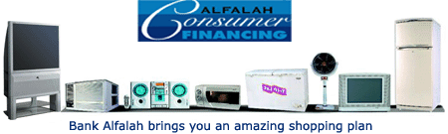
- 0% Down Payment
- Lowest Mark-up
- No Processing Charges
- No Early Payment Charges
- 12,18,24 & 36 Month Tenure
- Financing from Rs. 10,000 to Rs. 500,000
- Free Doorstep Delivery
- Free Credit Life Insurance Coverage
- Actual Stamp Duty and legal charges will be applicable.

Eligibility Criteria
- Total gross salary / income of Rs. 15,000/- or more per month.xi
- Aged between 25 to 60 years (60 years at maturity of facility).
- Should be Pakistani National.

Documents Required
For Salaried Persons
- One copy of N.I.C.
- Employment Certificate with date of joining, current designation emolument.
- Most recent Salary Slip.
- Copy of last utility bill (Residence).
- Income & Wealth Tax Returns (for the last three years) [if required].

For Self Employed
- One copy of N.I.C.
- Bank Statement for the last six months.
- Copy of last utility bill (residence).
- Proprietorship Certificate / Partnership Deed (where applicable).
- Income & Wealth Tax Returns (for the last three years) [if required].


4.2



Convenient denominations
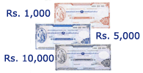
Bank Alfalah presents Rs.1,000, 5,000 and 10,000 denominations of traveller’s cheques, making it very convenient to carry money while travelling or keeping your emergency cash safe.

Your great companion while traveling

Bank Alfalah travellers’ cheques are your best travel companion as they provide the most benefits that no other traveller’s cheques offer. Alfalah TCs have unmatched security features Plus, you don’t have to be an account holder to avail these benefits! Free from the risk and hassle of carrying cash during travel, Bank Alfalah TCs ensure safe and smooth travel.

The maximum security features

Lithographic security features, invisible UV printing, high definition micro-lines, anti-scanner effect, mould based paper, Alfalah watermark and printing in the UK, are just some of the security features of our TCs which prevent counterfeiting. Just in case you are still not convinced, we refund your money in case of loss or theft of your TCs.

Fully Refundable
You can refund your TCs without any penalty or loss

Transferable and endurable
You can transfer and endorse your TCs over to anyone

Unlimited validity
Bank Alfalah TCs will always remain encashable

No account needed
You don’t have to be an account holder to get our TCs benefits

Network of Branches
Bank Alfalah branches all across Pakistan.

4.3 CREDIT CARDS
This Card is for you, if you are Graduate.

have just started your Career...
not qualified for any other credit card’s income criteria.
As a Classic Blue Cardholder you have a privilege of having access to all features of Alfalah VISA Credit Cards including one free supplementary card.

A Card Exclusively for Women..
Now for the first time in Pakistan, Bank Alfalah has introduced a credit card exclusively for women.This card has its unique features which have been tailor-made for the women in Pakistan.
Liability
The liability of this card depends on what basis this card has been applied for:
- If female is applying on her own income basis, she herself will be liable to pay for the amount spent through the cards
- If female is a house wife and does not have any direct income source, she can apply for the card through the person responsible for the household (husband, parent, bother or sister) who will sign an undertaking to be responsible for the amount spent through the card(s) issued under this scheme.

Supplementary Cards
All BAL Basic Card members can apply for supplementary cards in separate categories including Son’s Card, Daughter’s card (children above 13 years of age) and House Staff’s card. This feature has been introduced for the first time in Pakistan, yet another beginning made by Bank Alfalah Credit Cards. In addition, supplementary cards can be issued to anyone you like thus giving you complete freedom of choice.

Separate Card Design for Each Category
Each supplementary card category contains its own specific design of card. These card designs which have been specifically designed keeping in view the trends and tastes of the modern day young generation who has the desire to look exclusive in itself. You can get supplementary cards in unique designs for your son, daughter and House staff.


Separate Spending Limit for Each Category
Basic Cardmember can also assign a separate percentage or amount of the total credit limit of the credit card account to each of the supplementary cards. So, whether it is your son who needs his monthly pocket money, or your daughter needs to make school fees payments, or your chef, chauffeur or maid is usually the one who buys all the groceries it is you who will decide how much each of them gets for it.


Control Over Household Expenses
Alfalah VISA credit card helps in controlling your household expenses, that is why it is the best suited card available in the market. By using this card, you can:
- Control your son and/or daughter’s spending habits.
- Control your household expenses by giving a supplementary card to your House Staff responsible for day to day shopping.
- Forget about the need to keep a record all the time of each expense made from your household budget, your Monthly statement will show the detail of each transaction card-wise.
- Give cards to children with fixed spending limit and feel free of the tension of giving them allowances and monitoring them.

Monitoring
Now you don’t have to maintain that little diary recording your day to day expenses. With the Women’s Exclusive Card, your statement will contain all the detail that you need to know….who spent what, where and how much!


Credit Cover -Protection when you need it
Alfalah VISA offers its card members a new and powerful protection against the uncertainties of life. In the unfortunate event of prolonged illness, disability or death, it’s reassuring to know that with Alfalah Credit Cover you have no cause to worry about your monthly credit card repayments. Alfalah Credit Cover has a range of features designed to protect you and your family from the setbacks of life, at rates that are affordable. Low Rates – High Protections As an Alfalah VISA card member (Basic Card member up to the age of 60 yrs), you can protect yourself with Alfalah Credit Cover that offers you and your family an unbelievable low rate of 36 paisa for every Rs. 100 to insure your credit balance. You and your family can enjoy one of the lowest rates in the market with peace of mind.
Protection against Uncertainties In the unfortunate event of terminal illness, permanent disability or death, your entire outstanding balance amount on your VISA account will be waived without causing any inconvenience to your dear ones. No Worries – Just Peace of Mind

While You Recover – We Will Cover
In the unfortunate event of temporary disablement due to an injury or illness for a period exceeding 45 days, we will pay the minimum outstanding on your Alfalah VISA. It’s just our way of ensuring that you enjoy complete peace of mind with flexibility.

Convenient and Hassle Free
As an Alfalah VISA card member, you are automatically enrolled to the benefits of Credit Cover, no forms to fill or applications to submit. It is completely hassle free. If you feel that you do not need Alfalah Credit Cover, simply call our 24-Hour Phone Banking Service on 111-225-111. (Reversal/Cancellation of Credit Cover charges is not applicable in case of Classic Blue Cards.)

All on the Statement
All transactions will appear under a separate heading stated as “Credit Cover Premium”. You will be charged 36 paisa per Rs. 100 of your statement balance each month.

Legalities
The rights and obligations of any card member subscribing to Alfalah Credit Cover will be governed by the definitions, terms and conditions defined by Bank Alfalah. By virtue of Credit Cover, Bank Alfalah aims to offer through an insurance company of its choice, certain protection to those card members who are subscribing to Credit Cover in the event of death, prolonged illness, permanent, temporary or total disability.

Usage & Protection of your Card
Report the Loss, Theft or Damage of your Card immediately to Bank Alfalah Credit Card Center on the following contacts so that your card can be blocked. If you are traveling abroad, report the loss, theft or damage on these Toll Free Numbers.
Telephone Number: 111-225-111
Fax Number: 0092-42-5888610
0092-42-5888626
Location of Card Center: 8 Ali Block, New Garden Town,
Lahore, Pakistan.

4.7 ATM


Bank Alfalah through its commitment to provide superior and improved services to its valued customers, has unveiled a nationwide network of ATMs. For your convenience, you now have access to instantaneous cash availability, 24 hours a day, 7 days a week. Our ATM network is geared up to exploit the latest technology, and is equipped to meet the highest standards of security and efficiency. With your new ATM card you can now:
- Withdraw Cash
- Use our convenient, user-friendly fastcash option
- Make a Balance Inquiry.
- Get an instant printout of your account balances
- Get a printout of your last transactions (Mini-statement) on the spot.
- Change your PIN (Personal Identification Number).
Bank Alfalah is pleased to introduce 27 state of the art ATMs, deployed at the most convenient and accessible locations. Bank Alfalah is a founder member of the 1-Link Switch, thus making a countrywide network of ATMs available. Please contact your nearest Bank Alfalah branch for further details and for acquiring your ATM card.

4.8 Hilal debit card

Features of Hilal Card
- Foreign Transactions
- No Minimum Income Requirement
- Simplicity
- Flexibility
- Promptness

Controlled Spending
- Overview of Expenses
- Immediate Payment

Purchase Limit
- Purchase limit is the Account Balance.
- If A Customer has multiple accounts with Bank Alfalah Limited: Default Account Used

Daily Cash Withdrawal Limit
Rs. 50,000/-

No limit on number of transactions
Daily overall limit
Rs. 100,000/-
Insurance Power

Lost or Stolen Cards
Customer will immediately report the loss by calling Bank Alfalah Call Centre at 111-225-111 Bank only responsible after receiving the call at Call Centre.

Schedule of Charges

Description Charges Entry
Joining Fee N/A N/A
Annual Fee N/A N/A
Late Fee N/A N/A
Card Replacement Fee Rs. 200/- Manual
ROC Retrieval Fee Rs. 250/- for local ROC Manual& Rs. 800/- for Int’l ROC
ATMs –Off us (Other Banks) Rs. 300/- or 3% System
(other than our switch member) of cash withdrawal amount
(whichever is higher)
ATM-Off us (our switch member) Rs. 15/- per transaction System
Other than Bank Alfalah ATMs
ATM -On us N/A N/A
Bank Alfalah ATMs
Cash Wihdrawal – Other banks Rs. 300/- or 3% of cash System
Over the cash counters withdrawal amount
(whichever is higher)
Cash Wihdrawal -On us N/A N/A
Bank Alfalah Cash Counters
Balance Inquiry – Other Banks Rs. 25/- per inquiry System
(other than our switch member)

Application Process
- Applications available at all branches in Pakistan.
- Cards Division to send directly received applications to the respective branch.
- Branch to verify following details on the application:
- Application’s decision for approving or declining: Branch Responsibility
- To be forwarded after decision to the Card Center, Lahore (for processing and archiving).
- Customer savings/current account number
- Customer signature
- Customer Address

Requirements
- Saving / Current Account with Bank Alfalah
- Application Form duly filled by customer.
- Latest photograph of customer.
- Signatures of the customer.
- Branch will verify the signatures

In case, customer fails to provide a latest photograph:
- Photos to be taken through the Digital Camera
- To be sent to the Card Centre on Email: jamshedy@bankalfalah.com
- HilalCard applications received and completed during the day to be sent to:
Manager New Accounts (NAS) Credit Card Center, Bank Alfalah Limited 8 Ali Block, New Garden Town, Lahore, Phone: 5888630

FUNCTIONS OF hrm DEPARTMENT IN BAL
Human Resource Management (HRM) is a general term used to describe a Varity of functions aimed at effectively managing and organizations employees or “Human Resources”. HRM professionals oversee the people side of an organization including benefits, career development, training, hiring and many other functions. Bank Alfalah is governed by a unified HRM policy, to optimally utilize their human resources, automated systems and research and product development experts. Bank Alfalah attest to the fact that the pooling of the best minds, ideas and systems creates significant synergies to position the group in a most favorable competitive position in today’s dynamic market.
Functions of Personnel and Administration Department

Procurement of Personnel
Bank Alfalah is a place for innovation and ideas, for people who enjoy the buzz of working in a dynamic environment of constant change. The procedure of procurement entails advertisement in newspapers for the job, which follows an aptitude test, an interview; the successful candidates are later interviewed by the area manager along with selection committee. The system for procurement of staff designed and maintained by the human resource department at head office and practiced by the branches.

4.11 BASIC WORK PLACE RULES
General norms of office behavior that all employees of Bank Alfalah need to abide by are briefly described below.

Dress Code
Dress code for all employees of the bank is suit and tie. Those working in support offices (Head Office and Area Offices), may choose to wear national or informal (not casual) attire on Fridays and informal (not casual) dress on Saturday, while maintaining the decorum and dignity of the office.

Courtesy and Manners
Employees of Bank Alfalah will maintain utmost courtesy and exemplary manners when interacting with clients or with each other. Any violations of this code should be brought to the attention of supervising officials as well as the HRD for their information, record and remedial or disciplinary action.

Office decorum
All staff members working in any Unit/Branch will:
Speak in low volume and pitch. The test is that colleague sitting at the next table should not be disturbed by your speech
Not talk to departmental staff or colleagues across desks and will use intercom facility instead.

Attendance and punctuality
Punctuality is one of the basic rules of office discipline, which needs to be meticulously observed by all employees of the Bank. Office timings of the Bank are as follows. These timings may be changed by the Bank’s management to comply with governmental regulation or to suit business exigencies.
Monday to Thursday: 9:00 a.m. to 5:00 p.m. (with one hour lunch/prayer break)
Friday: 9:00 a.m. to 5:00 p.m. (with two hours’ lunch/prayer break)
Saturday: 9:00 a.m. to 1:30 p.m. (without break)
(Timings in some areas may vary to comply with local laws)

4.12 DEVELOPMENT OF PERSONNEL
Bank Alfalah expects a lot from its staff. They seek people of higher caliber and in return set out to provide very best in training, development opportunities, working conditions and rewards. BAL provides for success an;
- Environment.
- Equipment.
- Training.
- Appraisal.
- Compensation.

Environment
The employees are provided a friendly though highly competitive and creative environment. No matter what the job or level of responsibility is, every member is treated an individual with fairness, dignity and respect.

Equipment
Bank Alfalah has latest technology available at all of its branches. Peshawar branch has also queering system of the province. The proper state of the art equipment is necessary to insure employees’ confidence in their dealing swiftly with bank procedures.

Training
Recognizing the need to cater to changing competencies, skill sets and succession needs, Bank Alfalah continues to invest in and focus on employees’ development and training.
- Pre-service training.
All newly recruited personnel are provided with training facilities, during which an employee is rotated through different operations of the branch. So that he may learn through practical experience
- In-service training.
The in-service training program can be arranged any time when the need for the training is arises. These courses arrange at the home station or any other station.

Appraisal Methods
Recent studies regarding motivational patterns in their influence and employee efficiency have shown a light degree of positive correlation. Low efficiency coupled with high frustration among bank employees reflects inadequacy of motivational force and paucity of financial incentives and reward system for high performance as a result their attitude towards work and behavior with colleagues has a negative effect in job performance and service standard.
The management of BAL uses deficient measures for the motivational and evaluation of the performance of their workers. The performance methods are:
- Performance report.
This is one of the best ways for the management record about the performance of the individual. In BAL different aspects are counted to make the performance report. For example, language, dress, attendance, behaviour with customers, behaviour with colleagues, behaviour among boss and sub-ordinates, attainment of targets of deposits etc.This performance report is made monthly.
- Inspection.
Inspection teams are often sent to the branches. These inspections come from other branches as well as from head office. The members of these teams are often contacting the customers of the bank to know about the inconvenience by bank personnel and their services.
- Audit report.
This report is prepared by auditors, who are sent from head office for auditing. This audit emphasize on business transaction, managerial functions and operative functions. This audit report indicate and point out the mistakes made by workers in routine work. All the work done by workers is signed by the worker and his officer, incharge; therefore it is easy to catch that person who makes the mistake.

Compensation
The compensation to the bank employees’ is given in different ways, which are described as follows:
- Salary and Wage Policy.
All organizations, small or large, are running under proper procedures and systems. The BAL has also a sound system of wage and salary.
- Bonus.
It is determined on the basis of profit earned by the bank every year and dispersed in the manner are approved by the board.
- House Rent Allowance.
70 percent of basic pay at all categories of the staff.
- Conveyance Allowance.
Motor cycle/scooter maintenance allowance is Rs. 300 per month for those who have these vehicles and motorcar maintenance allowance is Rs. 600 Per month.
- Medical Allowance.
For officers and executives, one and a half month’s pay for cost of medicines to be paid in twelve equal installments. Subject to provide of actual bill on reimbursement cases. For staff two month’s basic pay for cost of medicine in a calendar year to be paid in twelve-month equal installments.
- Utility Allowance.
10 percent of the basic pay for officers. For executive director Rs. 1500 local call charges, for senior directors Rs. 500 local call charges per month and Rs. 400 local call charges for managers below the status of joint directors.

Fringe Benefit
Management is concerned with attracting and keeping employees whose performance nets at least minimum levels of acceptability and absenteeism and tumover at tolerable level. The purpose of such benefits and services is to retain in the organization and not to stimulate them to greater effort and higher performance.

Group Insurance
Arranged with State Life Insurance Corporation between Rs. 50,000 to Rs. 180,000 for various categories of employees at premium rate of 4.85% per thousand. The premium is born by the employees contributed provident fund. The employee contributing 10% of the basic pay and the bank also give a matching contribution towards the fund.

Leaves
The employees of the bank are given the following options for leaves.
- Provisional Leaves.
Thirty days per calendar year. Provisional leaves will not be granted for a period in excess of no of days to the credit of an employee. Provisional leave may not be taken more after than three times in year and may not be granted less than six days at a time.
- Casual Leaves.
Maximum 24 in per calendar year and may not be granted more than three days at a time and may be granted with combination in other leaves.
- Sick Leaves.
Up to 10 sick leaves per calendar year with full pay. The bank may grant additional on half pay up to one month in the same year.

Promotion
Bank Alfalah has clear policies and procedure for the promotion of its employees. The promotions are based on appraisal and outstanding services to the organization.

Transfer Policy
Transfers are rarely made and generally at the managerial level according to the requirement of the position. Bank Alfalah usually does not encourage inter bank transfers.
4.13 PERSONNEL POLICY
Resignation
A confirmed employee may resign from the Bank’s service upon giving one month’s prior written notice to the Bank, failing which he will be liable to pay
One month’s basic salary in lieu of notice period.
During the probationary period, an employee may resign at any time after giving seven days’ notice and he/she shall be entitled only to remuneration at the agreed rate of salary for the time that he/she has actually been employed.

Suspension from Service
The Bank, if it thinks fit, may put an employee under suspension pending finalization of the case of his dismissal.

During suspension
The employee shall be entitled to one half of his pay which he may be in receipt of prior to suspension as subsistence grant.
He shall attend office as usual and not leave office without prior permission of the competent authority.

Termination
Services of a confirmed employee may be terminated by the Bank without assigning any reason whatsoever, at any time, as elaborated below:
The services of a confirmed employee can be terminated by the Bank on one month’s notice in writing or on payment of one month’s basic salary in lieu of notice period.
The Bank’s management may allow, at its discretion, any of the benefits admissible on retirement from the service, to an employee whose services have been terminated except when the terminated employee is involved in fraud, misconduct or gross negligence.
The services of an employee under probation may be terminated on seven days’ written notice or on payment of 7 days’ basic salary in lieu of notice period.
When an employee remains absent from his duty without proper authorization, or fails to return for duty within specified period mentioned in the written notice issued to him, he/she will be liable for disciplinary action which may include termination of service.
Bank Alfalah Ltd. reserves the right to dispense with the services of an employee who is declared unfit for service by a Medical Board.

RETIREMENT

Conditions for Retirement
An employee may exercise an option to retire after completing 25 years of continuous service with Bank Alfalah Ltd.
All employees of Bank Alfalah Ltd. are liable to retire from the Bank’s services on attaining the age of 60 years.
The Bank’s management may, at its discretion, re-employ an employee due for retirement on contractual basis for a defined period, on salary and allowances not less favorable than those admissible to him at the time of his retirement. Such re-employment may include part time engagement, in which case, the remuneration package will be worked out according to the number of hours agreed on a pro-rata basis.
The services of a person, who is thus employed, may be terminated by serving one month’s prior notice in writing or one month’s gross salary in lieu thereof.

Section - V

SWOT ANALYSIS OF BAL

5.1 INTRODUCTION
“A scan of the internal and external environment is an important part of the strategic planning process. Environmental factors internal to the firm usually can be classified as strengths (S) or weaknesses (W), and those external to the firm can be classified as opportunities (0) or threats (T). Such an analysis of the strategic environment is referred to as a SWOT analysis.
The SWOT analysis provides information that is helpful in matching the firm’s resources and capabilities to the competitive environment in which it operates.

5.2 STRENgTHS
A firm’s strengths are its resources and capabilities that can be used as a basis for developing a competitive advantage. Examples of such strengths include:
- Patents
- Strong brand names
- good reputation among customers
- cost advantages from proprietary know-how
- exclusive access to high grade natural resources
- Favorable access to distribution networks”.

Strengths of BAL

1. Reputation
BAL has a very good reputation for its auto finance, home finance and agriculture finance. They have been the pioneers of auto finance and have carved a name for them selves in this field.

2. Market Leader
BAL has been the market leader in auto finance since its early days. Auto finance was offered by other banks as well but BAL was far ahead of other banks because of better service and low mark up rate.

3. Deal with Auto Dealers
BAL has signed a contract with Suzuki motors and for six months only BAL can provide any Suzuki vehicle which the other banks can’t so in this way BAL has got the product to be delivered.

4. Better service
BAL’s management pays a lot of attention to customer service. They make sure that the customer are treated in a nice way and their complaints and suggestions are always welcomed.

5. Better Environment
BAL has got a very friendly environment and the surroundings are also very pleasant. The clients are treated as guests and are given proper place to sit and discuss different issues.

6. Quick processing
BAL sanctions the auto loan for your car much faster than any other bank.

7. Credit Rating
BAL has been rated as AA- (double A minus) and Al + (A one plus) in the long run and short run respectively. These rating donate high credit quality and very low expectations of credit risk.

5.3 WEAKNESSES
“The absence of certain strengths may be viewed as a weakness. For example, each of the following may be considered weaknesses:
- Lack of patent protection
- A weak brand name
- poor reputation among customers
- High cost structure
- Lack of access to the best natural resources
- Lack of access to key distribution channels.

1. Lack of Commitment
The staff members are not very committed to their position in auto finance department. Most of the officers show negligence to customer’s complaints and often delay the delivery of the vehicle due to inefficient working.

2. Insurance Company
The bank makes the deal with insurance company on behalf of the customer but once the car is financed the customer comes in contact with insurance company which makes the customer go through a lot of problems faced by the virtue of the insurance company thus damaging the image of the bank.

3. Risk Management
The risk management department is not very developed and faces shortage of employees and resources. Most of the work that belongs to the risk management department is don e by the auto finance agents thus bridging the information regarding the client.

4. Employees Comfort
There is too much burden of work on employees. The official bank timing is from 9:00 a.m. to 5:00 p.m but they are insisted to sit up to 7.00 p.m or 8.00p.m or more to complete their work thus their comforts are ignored. Most employees are unhappy with this heavy work burden.

5.4 OPPORTUNITIES
“The external environmental analysis may reveal certain new opportunities for profit and growth. Some examples of such opportunities include:
- An unfulfilled customer need
- Arrival of new technologies
- Loosening of regulations
- Removal of international trade barriers”.

1. Strong Promotional Campaign
BAL is already the market leader and has brought its rate down to 8.5%. So the market department should increase its potential and get as much customers as possible through corporate deals, discounts for organizations and promotional campaign. They can utilize their image to maintain their image.

2. Insurance Agent
The bank should have an involving agent who should deal with the complaints of the customer from the insurance company and should help the customer in solving their problem.

5.5 Threats
“Changes in the external environmental also may present threats to the firm. Some examples of such threats include:
- Shifts in consumer tastes away from the firm’s products
- Emergence of substitute products
- New regulations
- Increased trade barriers ,,

1. Arrival of Other Banks
MCB and HBL have entered the market but with dynamic rates and much better features. So BAL’s superiority and leadership might not last long if it didn’t make a major change in the marketing strategy and rates as well.

2. Insurance Problems
The attitude and performance of insurance companies are bothering the customers a lot and people are regretting to have financed their car from BAL. because they come in contract with insurance company through BAL so they consider BAL for all the mishaps.
ORGANIZATIONAL ANALYSIS

5.6 Administrative Analysis

Slow Credit Growth
Promotion is one of the motivational tool. Promotion policy of Bank Alfalah is very slow. The opportunity for upward advancement are very slow.

Working Setup
It is observed that there are some deficiencies in branch setup. It creates extra disturbance and excessive moment which in turn effect the efficiency of the employees and thus that of whole organization also.

Lack of Specialized Training
In BAL training is provided on the basis of generalization rather than specialization. After completion of training employee is inducted into specific field. Due to lack of knowledge he faces difficulty to perform the assigned job.

Separation of Activities
There is no separation of activity. For example, local remittances and account section work is performed by one person. It creates confusions and conflicts. In order to avoid mishaps, there should be complete separation of activities.

Space Shortage
It is observed that branches suffer from space shortage. The sitting arrangement is not sufficient as compared to the number of customers visits the bank.

5.7 Personnel Management Analysis

Marketing at Desk
Bank employees come in daily contact with many people who happened to deal with the bank as casual remitter or beneficiaries of remittances, drawer of bills, safe custody service holders, travelers and variety of other peoples with whom that bank has no account or regular business relationship. The bank officers are doing very little on their own to expose the possibilities of selling banking services to them as a marketing contributor. All the bank officers should make a conscious effort in addition to their normal assignment to explore the possibilities of selling banking services to them.

Marketing Visits
A very useful mode of contact is through personal marketing visits. Such visits are important by-products such as gaining information about the customers’ financial and business position, about their market reputation and crating a feeling of importance in the minds of clients. Such visits should be properly planned and undertaken with regularity and consistency.

Need for Better Training Program
It has been observed that the training program of BAL is not adequate. Special marketing training should be given to employees who are concerned with marketing. They should learn new methods for motivating customers. The training program of the bank should include scientific techniques to improve the decision making and inter personnel as well as the individual needs of the employees. Incorporating case studies, sensitivity training and special projects can do this.

Use of Media
BAL is relatively a new organization. From marketing viewpoint every new organization must pay heed to promotional activities. The management of BAL generally does not care much about this important issue. In order to increase its customers and add to its publicity, it is recommended that bank should advertise itself and introduce its services in detail through media.
5.8 FINANCIAL ANALYSIS
“Financial analysis involves the use of various financial statements. These statements do several things. First the balance sheet summarizes the assets, liabilities and owner’s equity of a business at a moment in time, usually the end of a year or a quarter. Next, the income statement summarizes the revenues and expenses of the firm over a particular period of time, again usually a year or a quarter.

Financial Ratio
“To evaluate a firm’s financial condition and performance, the financial analyst needs to perform check ups on various aspects of a firm’s financial health. A tool frequently used during these check ups is financial ratio or index.

5.10 Liquidity Ratios
Liquidity Ratios help us understand if we can meet our obligations over the short-run. Higher liquidity levels indicate that we can easily meet our current obligations. We can use several types of ratios to monitor liquidity.

1. Current Ratio
It measures the ability of the firm to meet the current debts with currents Assets. OR It shows the short-term debt-paying ability of an organization.

Current Ratio = Current Assets / Current Liabilities
2005 = 237842197 / 231922580 = 1.026: 1
2006 = 259549500 / 250994656 = 1.034: 1
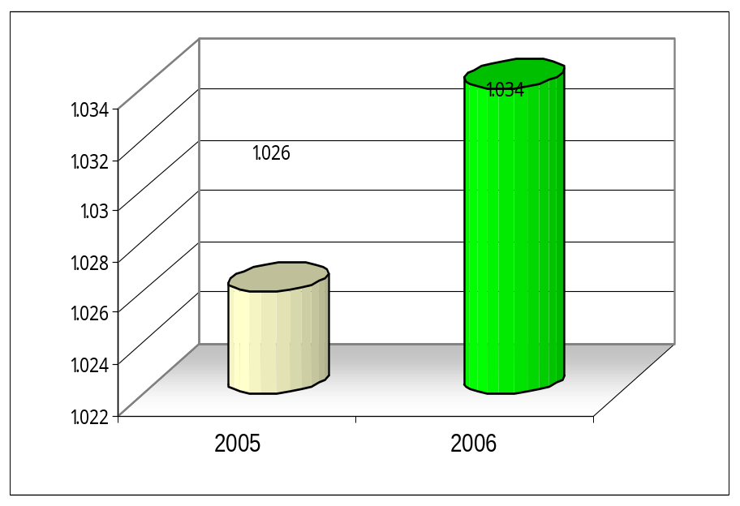

Interpretation
This means that bank Alfalah has Rs.1.026 and Rs.1.034 in its Current Assets to meet its every Rs.1 Current Liabilities in the years 2005 and 2006 respectively.

Analyses
The ratio has increased in 2006 by Rs.0.008 due to increase in Current Assets and less increase in Current Liabilities. It has resulted due to the following reasons.
- High level of Cash
- Increase in Account Receivable
- Decrease in bills payable
- Decrease in Short Term Finances
Any how the bank Alfalah is in a good position to pay its short term liabilities.
2. Absolute Liquidity Or Super Quick Ratio
It shows the the comparison of the absolute liquid assets of a firm to current debts. Absolute liquidity is represented by cash and near cash items.
Absolute Liquidity Ratio = Absolute Liquid Assets / Current Liabilities
2005 = 34511439 / 231922580 = 0.15 : 1
2006 = 40591312 / 250994656 = 0.16 : 1
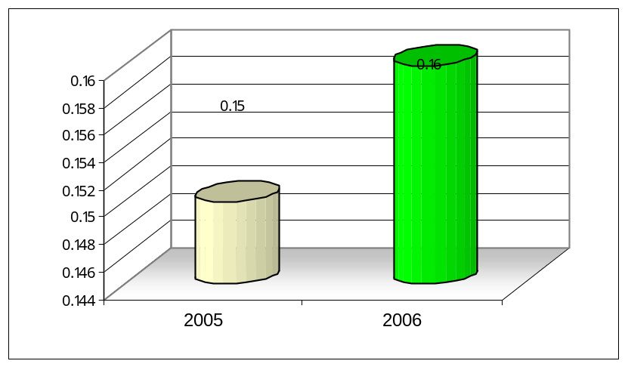

Interpretation
This means that bank Alfalah has Rs. 0.15 and Rs. 0.16 as absolute liquid Assets to meet its every Rs.1 current debts in the years 2005 and 2006 respectively.

Analyses
The ratio has increased in 2006 by Rs.0.01 because increase in cash and near cash items is more as compared to increase in Current Liabilities. This shows an increased liquidity of bank Alfalah limited. It has resulted due to the maintenance of high level of cash at BAL.

5.11 Leverage Ratios
Another important group of detail ratios are Leverage Ratios. Leverage Ratios measure the use of debt and equity for financing of assets

1. Debt-to-Equity
It indicates the extent to which the debt financing is used relative to Equity financing. This ratio is used to determine an entity’s long-term debt-paying ability. It helps to determine how well the creditors are protected in case of insolvency of a company. It compares the funds provided by creditors to the funds provided by shareholders.

Debt to Equity Ratio = Total Debt / Share holders Equity
2005 = 240849667 / 6738063 = 35.74: 1
2006 = 263443596 / 10572605 = 24.92: 1
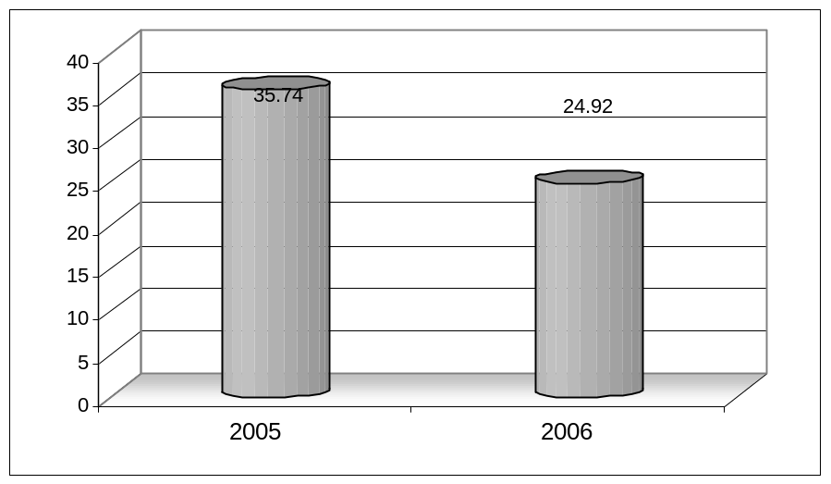

Interpretation
This means that for each Rs.1 brought by shareholders, the Creditors brought Rs.35.74 and Rs.24.92 during the years 2005 and 2006 respectively to finance the BAL.

Analyses
The debt to equity ratio of BAL is too high which shows a great risk for creditors in case of insolvency and also not a good sign for BAL in case of attracting and satisfying the creditors.
The ratio has decreased in 2006 by Rs.10.82 due to the fact that the increase in the debts is less as compared to increase in Share Holder’s Equity due to decrease in bills payable and tax liabilities.

2. Debt-To-Total-Assets
The Debt to total assets Ratio measures the level of debt in relation to our investment in assets. The Debt Ratio tells us the percent of funds provided by creditors and to what extent our assets protect us from creditors. A low Debt Ratio would indicate that we have sufficient assets to cover our debt load. Creditors and management favour a low Debt Ratio

Debt to Total Assets = Total Debt / Total Assets
2005 = 240849667 / 248313793 = .969: 1
2006 = 263443596 / 275685541 = .956: 1

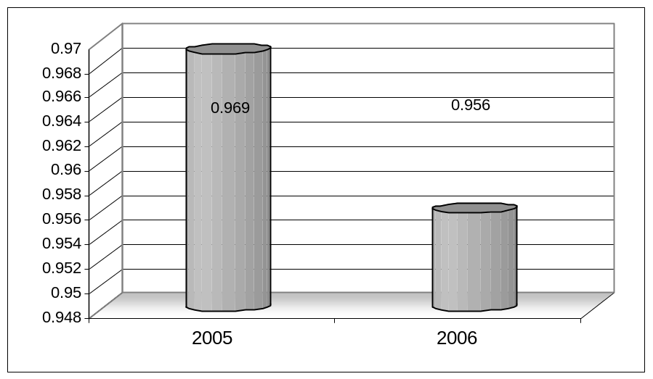

Interpretation
This means that for each Rs 1 invested in the Total Assets of the BAL,
Rs 0.969 and Rs 0.956 have been brought by the creditors during the years 2005 and 2006 respectively.

Analyses
A low Debt Ratio would indicate that we have sufficient assets to cover our debt load. Creditors and management favour a low Debt Ratio, whereas here we see that the BAL debt ratio is high some how.
The decrease of 0.013 in 2006 has occurred due to the fact that out of the total assets i.e. Rs.275685541, Rs.263443596 has been provided by the creditor while the rest of the difference i.e. (275685541-263443596 =12241945) has been invested by the share holders, so the ratio is lower in 2006 because of high investment by shareholders and ratio is high in 2005 because of low investment by shareholders as compared to 2006.

5.12 Profitability Ratios
Profitability Ratios measure the level of earnings in comparison to a base, such as assets, sales, or capital. Analysis of profit is of vital concern to stockholders as they derive revenue, in the form of dividends, when paid from profit. Profits are also important to creditors as they are source of funds for debt coverage.

Net Profit Margin
Profit Margin measures the percent of profits you generate for each dollar of sales. Profit Margin reflects your ability to control costs and make a return on your sales. Management is interested in having high profit margins.

Net Profit Margin = (Net Profit / Net Sales or total income) * 100
2005 = (1702094 / 14515344) *100 = 11.73%
2006 = (1762691 / 24416109) * 100 = 7.21%

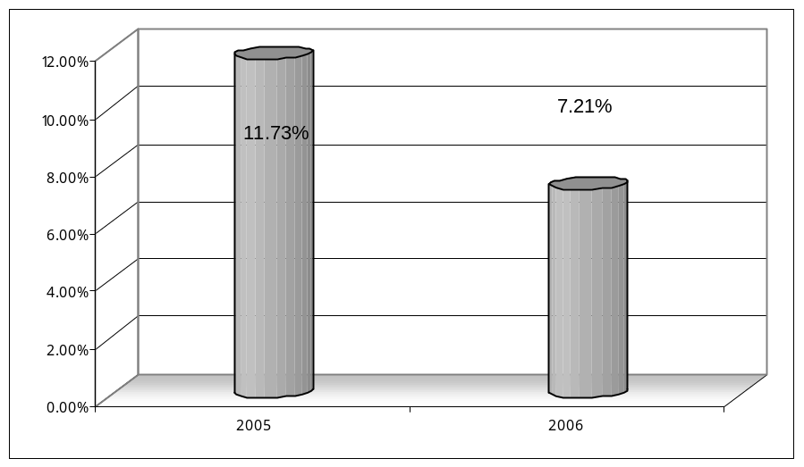

Interpretation
This means that the BAL earned Rs.11.73 and Rs. 7.21 as net profit for each Rs 100 for 2005 and 2006 respectively.

Analyses
The ratio has got down tremendously by 4.52 % in 2006; it may be due to the following reasons;
- The management has been unable to control costs.
- The Administrative and selling expenses have not been controlled by the management.
It measures the overall effectiveness in generating profit with available assets i.e. the earning power of invested capital. It is used to evaluate enterprise performance.

Return On Assets = Net Profit / Total Assets
2005 = 1702094 / 248313793 = 0.00685: 1
2006 = 1762691 / 275685541 = 0.00639: 1

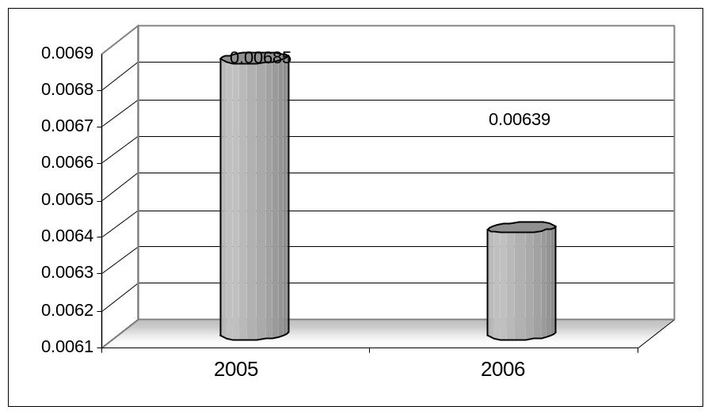

Interpretation
This means that BAL is able to earn Rs. 0.00685 and Re.0.00639 return on its each Rs.1 invested capital in 2005 and 2006 respectively.

Analyses
In 2006 the ratio has decreased by .00046, it is due to the following reasons;
- The management has not been able to control costs
- The Administrative and selling expenses have not been controlled by the management.
- While net profits have not been increased as much as assets increased, so assets have not been efficiently utilized.

3. Return on Equity
It measures the earning power on shareholder’s book value investment. A high return on equity often reflects the firm’s acceptance of strong investment opportunities and effective expense management. Higher the ratio more the risk for entity, and more returns for shareholders.

Return on Equity = Net Profit / Shareholder’s Equity
2005 = (1702094 / 6738063) * 100 = 25.26 %
2006 = (1762691 / 10572605) * 100 = 16.67 %

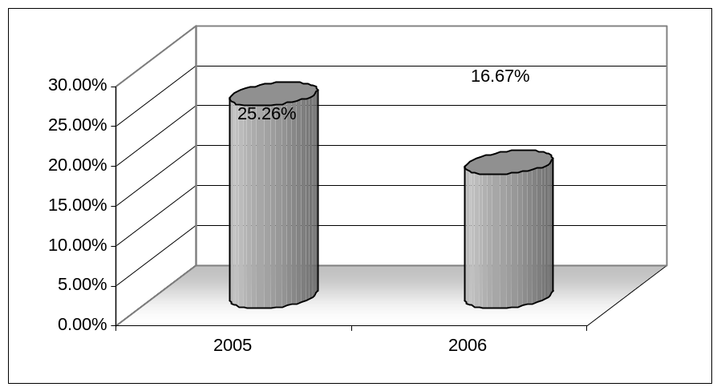

Interpretation
This means that BAL has been able to grant a return of 25.26% & 16.67% to all shareholders on their equity during, 2005 & 2006 respectively. It is a high return for shareholders & thus too much attractive for investors.

Analyses
In 2006 the ratio has got down by 8.59%, it is due to the following reasons;
- The management has simply assumed higher risks thus resulting in higher returns.
- There is too much less increase in net profits as compared to owners equity in 2006 due to inefficient control on costs, higher administrative and selling expenses, higher taxes.
- A lower receivable turn over and lowerer inventory turn over.

Other Ratios
1. Cash to Deposits Ratio = (Cash / Deposits) *100
2005 = (24798070 / 222345067) *100 = 11.15 %
2006 = (27859360 / 239509391) *100 = 11.63 %
2. Advances to Deposits Ratio = (Advances / Deposits) *100
2005 = (118864010 / 222345067)*100 = 53.46 %
2006 = (149999325 / 239509391)*100 = 62.63 %
3. Investment to Deposit Ratio = (Investment / Deposits) *100
2005 = (57416255 / 222345067) *100 = 25.82 %
2006 = (56502210 / 239509391) *100 = 23.59 %
INTERPRETATION AND ANALYSIS
The BAL cash to deposits ratio has increased by 0.48 % in the financial year 2006. This shows an increased liquidity of bank Alfalah limited.
BAL advances Rs 0.53 and 0.62 for its each Rs. 1 deposit in 2005 and 2006 respectively. The advances to deposits ratio has increased by 9.17% in the year 2006. It means that BAL focus is more on advancing loans than opening accounts in the year 2006.
The investment to deposits ratio has decreased by 2.23 % in the financial year 2006. It shows that bank is concentrating more on advances than investment. It means that the bank has found more proper areas for advances of loans, which in other words shows the increased reputation of bank Alfalah.
5.14 GROWTH RATIOS
- Assets Growth Ratio =
(Current year assets – previous year assets / previous year assets) * 100
2005 = (248313793 - 154834457 / 154834457) * 100 = 60.38 %
2006 = (275685541 - 248313793 / 248313793) * 100 = 11.02 %
- Investment Growth Ratio =
(Current year investment – previous year invest / previous year invest) * 100
2005 = (57416255 – 35503678 / 35503678) * 100 = 61.72 %
2006 = (56502210 – 57416255 / 57416255) * 100 = - 2.11 %
- Advances Growth Ratio =
(Current year advances – previous year advances / previous year advan) * 100
2005 = (118864010 – 88931155 / 88931155) * 100 = 33.6 %
2006 = (149999325 – 118864010 / 118864010) * 100 = 26.2 %
- Deposits Growth Ratio =
(Current year deposits – previous year deposits / previous year deposits) * 100
2005 = (222345067 – 129715230 / 129715230) * 100 = 71.4 %
2006 = (239509391 – 222345067 / 222345067) * 100 = 7.72 %

BALANCE SHEET
As at December 31, 2006
 | 2005 | 2006
 | Rupees in ‘000’ | Rupees in ‘000’
Assets
Cash and balances with treasury banks | 24,798,070 | 27,859,360
Balances with other banks | 9,713,369 | 12,731,952
Lending to financial institutions | 27,050,493 | 12,456,653
Investments | 57,416,255 | 56,502,210
Advances | 118,864,010 | 149,999,325
Operating fixed assets | 6,620,067 | 10,502,290
Other assets | 3,851,529 | 5,633,051
Total Assets | 248,313,793 | 275,685,541
Liabilities
Bills Payable | 3,733,124 | 3,091,135
Borrowings from financial institutions | 5,844,389 | 8,394,130
Deposits and other accounts | 222,345,067 | 239,509,391
Sub-ordinated loans | 3,223,355 | 3,222,106
Deferred tax liabilities | 484,066 | 1,921,338
Other liabilities | 5,219,666 | 7,305,496
Total Liabilities | 240,849,667 | 263,443,596
Net Assets | 7,464,126 | 12,241,945
Represented By:
Share capital | 3,000,000 | 5,000,000
Reserves | 1,851,218 | 2,749,533
Unappropriated profit | 1,886,845 | 2,823,072
 | 6,738,063 | 10,572,605
Surplus on revaluation of | 726,063 | 1,669,340
 | 7,464,126 | 12,241,945

.

PROFIT & LOSS ACCOUNT
For the Year Ended December 31, 2006
 | 2005 | 2006
 | Rupee in 000 | Rupee in 000
Mark-up/Return/interest earned | 12246811 | 21191470
Mark-up/Return/interest expensed | 7204992 | 15232886
Net Mark-up/Interest income | 5041819 | 5958584
Provision against non-performing loans and advances | (402298) | (697690)
Bad debts written off directly | (512) | (1537)
Net Mark-up/Interest Income after provisions | 4639009 | 5259357
Non Mark-up/Interest Income
Fee, commission and brokerage income | 1158747 | 1804998
Dividend income | 52014 | 37393
Income from dealing in foreign currencies | 290091 | 386997
Gain on sale of securities | 239551 | 180751
Unrealized (loss) /gain on revaluation of investments | 23163 | (27599)
Other income | 504967 | 842099
Total non-mark-up/interest income | 2268533 | 3224639
 | 6907542 | 8483996
Non Mark-up/Interest Expenses
Administrative expenses | 4313023 | 5874745
Other provisions/write offs | 10125 | - - - - - -
Other charges | 21104 | 43306
Total non-markup/interest expenses | 4344252 | 5918051
Profit before taxation | 2563290 | 2565945
Taxation:
- Current | 592635 | 476226
- Prior years | 1037 | (100874)
- Deferred | 267524 | 427902
Profit After Taxation | 1702094 | 1762691
Unappropriated profit brought forward | 860300 | 1886845
Transferred from surplus on revaluation of fixed assets | 24870 | 26074
Profit available for appropriation | 2587264 | 3675610

Section – Vi

RECOMMENDATIONS
The Human Resource Management given are primarily based on the analysis for the improvement of bank’s efficiency, if these were followed it will give positive effects on the profitability, and the role it plays in the development of the province of the bank.

6.1 Better Training Program
It has been notified that the training programs of BAL is not adequate. Special marketing training should be given to employees for motivating customers. The training programs of bank should include modern techniques to improve decision-making and inter-personal as well as individual needs of an employee.

6.2 Enhanced Customer Services
Constant improvement in customers’ services is needed in today’s competitive environment. Personalized banking should be introduced to attract more customers. Equal respect should be given to all customers.

Computerized Telephone Banking System
The satisfaction with convenient, secure and time saving way of banking. Just on phone call the customers can always remain in touch. This latest computer service, which truly brings banking to home, offices and can ensure the security of account by providing with a user ID. With the help of this facility one can get the facilities of account balance, transaction history and foreign currency exchange rates etc by just one phone call.

6.3 Better Communication
The management of BAL should concentrate on improving upward communication to have better feedback system involvement in bank operations.

Introduction of Management by Objectives (MBO)
The concept of MBO should be introduced in the bank where the subordinates should be expected to formulate objectives for themselves.
This will ensure the setting up of objectives according to the capabilities of individuals. In addition to this, it will also help in achieving the goals because they are involved in the process of goal setting.

6.4 Proper Job Analysis
A detailed and systematic study of the job should be done to know the nature and the characteristics of the people to be employed. This will help in identifying the training needs, evaluating the job and in appraising the performance of the employees.

6.5 Electronic Data Processing Audit
In BAL no audit is carried out on the bank computer system. There should be Electronic Data Processing (EDP) audit so that any material discrepancies resulting from fraud or error can be deducted.

Introducing Career Planning
As a matter of personal policy, personnel department should prepare a career plan showing their future growth potential, depending on the job performance and evaluation which should be made known to the employees. In this regard, the employee should be given opportunities to show their performance.

Better Working Conditions
The working area is comparatively smaller as compared to the needs of the branch. As a result there is a lesser working space provided to employees. They have to work about eight hours and sometime even longer. The congested place effects their efficiency at work. It is suggested that better working conditions should be provided for effective and efficient output.

6.6 Promotion and Publicity
BAL relies heavily on personal banking, thus it does not give proper attention to the more sophisticated methods of promotion. Although billboards are displayed in different parts of the city, yet no proper advertisements have ever appeared in the dailies. The web site too does not give complete information and unique features, which give its edge over the market. So they should adopt strong strategies for promotion and publicity of their services they offer.

International Banking
BAL should expend its branches not only in Pakistan but also outside the country to fulfill their mission statement.

6.7 Market Visits
A very useful mode of contact is through personal market visits. Such visits have other important by products such as information about the customer financial and business position, about his market reputation and creating a feeling of importance in the mind of client. Such visits should be properly planned and documented with regularity and consistency. The BAL assigns this task to its new recruited employees and rely on their reports. But market specialists should also be send to market for analysis.

6.8 SEPARATION OF ACTIVITIES
There is no separation of activities as such. A function of clearing is partially done in deposit department and partly in account department. This creates confusion and conflict in decision-making. To avoid such confusions, the functions of clearing be done in one department. This separation of activity will help greatly in reducing confusion also added in efficiency and effectiveness.

6.9 Use of Motivators
To motivate employees, individuals must have a job with a challenging content that is a job with responsibilities for achievement, recognition, advancement and growth. Such motivators should be used for efficient working.

Latest Computer Equipment
Latest software and hardware should be introduced in the bank so that the data processing speed of the computers can be enhanced.

Introduction of Forecasting Techniques
Advanced qualitative techniques of forecasting and inventory maintenance should be introduced so that the management should be aware of its future needs and can make better arrangements to meet these needs.

Encourage Small Depositors
Along with big depositors, small depositors should be given proper attention and care to encourage saving in the country.

Awareness to Employees
All employees of BAL at every level must be aware of basic mission, values & objectives of the organization, so that they can perform best to their abilities and ensure that BAL continue to be recognized favorably at home & abroad.

Motivate Saving Habits
A big portion of the home remittance is send by Pakistan working capital through BAL. A big portion of that amount is wasted by purchasing luxury items. BAL should motivate the people towards savings by offering the deposits through various investment schemes & the rate of profit should be increased by 1% to 2% then other banks.This will a profitable step for the bank.

6.10 Employees Training and Development
Refresher courses for the staff are most important in any international organization. Every employee should have these courses according to their requirement. Foreign experts can also be called for this purpose.

Action/Implementation Plan
Using the organizational analysis of the study, some critical issues are evident in the bank. Currently the bank enjoys a market leader status in its own segment. Growth possibilities are slim because deposit mobilization has reached its peak. New deposits can only be taken away from competitors and this would require a value package to the customers, which includes value added packages and extra ordinary services. However, this will reduce the profitability of the bank.
Moreover, because of a general economic slump, the proposed increase in deposits at term not favorable to bank’s profitability would increase pressure on advances at a period when demand for advances has slowed. BAL Haripur branch employees currently have poor inter-relationship amongst themselves because promotion prospects are dim. The reason for dim promotion prospects is the inability of the branch to give extra services to their clients. The reason for this is the lack of industrial and commercial activities. Consequently the employees in the bank are concentrating only in the business of account maintenance and deposit mobilization, which is unfavorable to the branch.
To overcome these problems a plan is presented here on the bases of recommendations i.e., E-Banking, which include electronic fund transfer, PC banking, Internet banking, Tele-banking etc. If these plans were implemented then it will help the bank to compete with leading foreign and local banks like Emirates, Standard Chartered Grind lays, MCB, Metropolitan, Askari etc in their geographic territory. As well as these plans enables the organization to be effective (in terms of less paper work and time saving), competitive and hopefully profitable and to boost the business by catching new customers and keeping the potential customers to do business for long period of time.
The highlights of the implementation plan are as follows:
Electronic Funds Transfer (EFT): The first thing in the E-BANKING is the Electronic funds transfer which also includes the ATM, the most visible form of EFT. Others are standing instructions performed for utility bill payments and so on. Another well-known form is SWIFT, the international payment system. The important point to highlight is that funds transfer takes place electronically without any paper-base transactions involved. In Pakistan, the number of installed ATMs is still comparatively few due to high installation and operating costs, while use of SWIFT is not as prevalent as it should, though most of the major banks are members.
EFTPOS (EFT Pont of Sale): is an electronic payment method, which involves goods or services being paid for, at the point of sale. The transaction may be initiated either by the EFTPOS card being swiped through a card reading device, prior to the authorization of transaction by means of a Personal Identification Number (PIN) being inputted into a hand-held pad by the customer, or else through the card swiped being followed by the customer signing a paper voucher.
PC or Home Banking: is a service in which customers can use their personal computers at home, or at their office, to access their accounts for transactions, by subscribing to & dialing into the bank’s own intranet proprietary software system, by use of password. This virtually establishes a bank branch in the customer’s home and offers 24 hour service seven days a week for the test marketing purposes this service is initially given to the corporate customers.
Internet Banking: Simply one form of PC banking, not only offers customers 24 hour access, but also the ability to bank from multiple venues, since
- Proprietary software need not reside on each machine (a browser is used),
- The customer accesses the bank from its web site.
A number of banks in Pakistan, particularly the foreign ones, are planning initiatives in this area since their parent organizations already offer these services abroad. Tele-banking can be considered as a form of remote or virtual banking, which is essentially for the delivery of branch financial services via telecommunication devices where the bank customers can perform retail banking transactions by dialing a touch-tone telephone or mobile communication unit, which is connected to an automated system of the bank by utilizing Automated Voice Response (AVR) technology.
Tele –Banking: Tele-banking service provides yet another alternative to almost all of the functions available on the Automated Teller Machines except withdrawal and deposit of cash. The facilities available include checking account balance, funds transfer between current, savings and credit car accounts and bill payments. As far as the customers are concerned, it provides increased convenience, expanded access and significant time saving. On the other hand, from the bank’s prospective, the costs of delivering telephone-based services are substantially lower than those of branch-based services.
No doubt technology does not come economically. If one looks at the foreign banks almost all use foreign application packages. These are generally integrated systems implemented over a Wide Area Network and provide online real time connectivity of their branch network to a central system. This also provides to bank the capability to provide better customer service via inter-branch transactions, ATM service at any location, customer-profiling etc. A centralized database provides better portfolio management, transaction reconciliation, integrity of data, management reporting and decision support.
Banks need to look outwards, rather than inwards to overcome their insecurity and gear themselves to compete on a global scale. Organizations can no longer stick their heads in the sand, ostrich-like, and pretend that the world in not shrinking and competition from other markets is not at their door. More important, many of the local organizations have to bridge the cultural gap towards the implementation of technology.

REFERENCES
- Siddiqi, Asrar H. (2003). Practice & Law of Banking in Pakistan. Karachi: Decent Print Enterprises. P.2-3
- Rose Peter.S. (1999).Commercial Bank Management. Boston:Megraw Hill Irwin.P.4-5
- (2004, January 6). Will Government Survive. Dawn, P.4
- (2004, August 17). Will Government Survive. Business Recorder, P.1.
- Bank Alfalah Limited, (2007). Employee Hand Book. Karachi, P.5.
- Bank Alfalah website www.BankAlfalah.Com
- Web Master.(2007)Technology and Immediacy of Information(on-line)
Available at:
http://www.quickmba.com/strategy/vision/
- Internet Site http://www.Pacra.com
- Web Master. (2001) Technology & Immediacy of Information (On-line) Available at:
www.bankalfalah.com.pk
10. The Bank Alfalah. (1998) Recruitment Policy
11 Van Horne, James.C & Wachowicz,John.M (1998) . Fundamentals of Financial Management. New Jersey: Tenth Edition, Prentice Hall Inc, Upper Saddle River. Page No: 126
12. Fundamental Concepts of FASB (Financial Accounting Standards Board
13. The Bank Alfalah. (1998) Branch Operation Manual Karachi.
14 The Bank Alfalah. (2000) Foreign Exchange Manual Karachi

BIBLIOGRAPHY
- Van Horne, James.C & Wachowicz,John.M (1998) . Fundamentals of Financial Management. New Jersey: Tenth Edition, Prentice Hall Inc, Upper Saddle River. Page No: 121
- Siddiqi, Asrar H. (2003). Practice & Law of Banking in Pakistan. Karachi: Decent Print Enterprises. P.42
- Van Horne, James.C & Wachowicz,John.M (1998) . Fundamentals of Financial Management. New Jersey: Tenth Edition, Prentice Hall Inc, Upper Saddle River. Page No: 126
- Siddiqi, Asrar H. (2003). Practice & Law of Banking in Pakistan. Karachi: Decent Print Enterprises. P.2-3
- Rose Peter.S. (1999).Commercial Bank Management. Boston:Megraw Hill Irwin.P.4-5
- The Bank Alfalah. (1998)Branch Operation Manual Karachi.
- The Bank Alfalah. (2000) Foreign Exchange Manual Karachi
- Fundamental Concepts of FASB (Financial Accounting Standards Board)
- The Bank Alfalah. (1998) Recruitment Policy
- (2004, January 6). Will Government Survive. Dawn, P.4
- (2004, August 17). Will Government Survive. Business Recorder, P.1.
- Bank Alfalah Limited, (2003). Employee Hand Book. Karachi, P.5.

Brochure “Schedule of charges”
x

