PREFACE

Assignments are short approach towards practical work. In our course of MBA assignments are essential part of our subject completion. To full fill the requirement we got assignment in our subject INVESTMENT ANALYSIS on “Analysis of security investment”.

To complete the task I selected Pakistan Tobacco Company (PTC) common stock shares. As I was internee there so its easy to me do work on it because I have a lot of information about PTC.

It’s of all I visit Invest Cap brokerage house to get information about how to open an account with them. I study Annual report of PTC and get relevant data from that. Internet online data also helps me in my assignment.

I tried my best to complete the task .In end I thanks to Almighty God who give me confidence to do my job efficiently and effectively, and I also grateful to Miss: Saroosh Aziz who guide us in difficult problems. Thanks

PAKISTAN TOBACCO COMPANY

An Analysis & Evaluation

Of

Company’s Operations



INSTITUTE OF MANAGEMENT STUDIES

UNIVERSITY OF PESHAWAR

Session: 1999-2002
PAKISTAN TOBACCO COMPANY

An Analysis & Evaluation

Of

Company’s Operations

Internship report submitted to the Institute of Management Studies
In partial fulfillment of the requirements for the
Bachelors Degree of Business Administration

JUNE 2003

INSTITUTE OF MANAGEMENT STUDIES

Internship Report On
PAKISTAN TOBACCO COMPANY

Senior Supervisor:
Signature
Name Designation
Organization
Date

Junior Supervisor:
Signature
Name
Designation
Organization
Date
LIST OF ACRONYMS

AKF Akkora Khattak Factory
A/R Account Receivable
A/P Account Payable
BMS Bailing Material Store
BAT British American tobacco
BSO Business Support Officer
CMD Cigarette Manufacturing Department
CBC Carbonated Board Container
CC Carbon Copy
CBA Collective Bargaining Agents
CPMH Man Cigarette Per Hour
CSA Central Stock Average
DAC Dark Air Cured
DPLV Deferred Purchase Leaf Vouchers
ECB Executive Committee Board
FCV flue crude Virginia
GPM Gross Profit Margin
G.R sheet Goods received Sheet
GLT Green Leaf Thrashing
GPM Gravity Feeding Pipe
HLPS High Lid Pokers
ITF Inventory Turnover in Days
JPGL John Player Gold Leaf
LRR Leaf Reception Room
LTC Lackson Tobacco Company
MRP Material Recourses Planning
MOM member of management
MMD Material Management Department
OLE Optimum Labor Establishment
PTC Pakistan Tobacco Company
PTB Pakistan Tobacco Board
PSD Particle Size Distribution
ROI Return On Investment
ROE Return On Equity
RTD Receivable Turnover in Days
SMD Secondary Manufacturing Department
SMS Shipping Material Store
USP Unapprised Tobacco Sorter
WP White Patta
WMS Wrapping Material Store

Chapter # 1

Introduction

Chapter objectives

- To understand the background, purpose and the scope of the report
- To study the methodological tools used in the report

  - Background of the study
Developing countries and economies in transition face numerous challenges in their industrial development and modernization. Industry needs a supportive climate for growth. Managers must make an industry more competitive to sell more of what they make. The industrial base must be expanded to generate increasingly more productive jobs-and all this in an era of global volatility and constant change.
Pakistan Tobacco Company is the biggest manufacturing company in Pakistan.
It was established in 1947 as Imperial tobacco closed business in Pakistan. Pakistan Tobacco Company is the subsidiary of BAT. It is engaged in the manufacturing and selling of high quality of cigarettes.
Over the years the company has maintained its position in the age of competition and has tried to increase the demand for their products. They seek innovation and improvement in every part of their business through a system of ideas, suggestions, feedback and appreciation. Pakistan Tobacco Company is determined to furnish its customers with high quality products and excellent services.
1.2 Purpose of the study
The study is intended to analyze Pakistan Tobacco Company in terms of its strong and weak points and other factors affecting the organization either positively or negatively. Special emphasis is placed on financial position and given projects, which was the main focus of work during the internship period.
The purpose of the study and report is to fulfill the requirements of Bachelors in Business Administration at Institute of Management Studies University of Peshawar.
1.3 Scope of the study
The study is applicable only to Pakistan Tobacco Company, Akkora Khattak factory.
It encompasses the operations of different departments, projects carried out during the study, analysis and recommendations.
    - Limitations of the study
The span of the operation of Pakistan Tobacco Company is too large to be covered completely in two months. Time Constraints, thus, constitutes a major constraint for this report.
    - Delimitation of the study
This report is useful for the students of management in general and for those interested in finance particular. Pakistan Tobacco Company and other interested parties concerned in financial decision-making can use it as guideline.
  - Methodology of the study
The study utilizes primary and secondary data.
    - Primary Data
The first-hand data, .i.e. the data collected for the first time is called primary data. Primary data for this report was collected through unstructured interview and participative and semi participative observation.
    - Secondary Data
Secondary data is the one collected from other sources and already processed through mathematical and statistic techniques. Secondary sources for the study are official Pakistan Tobacco Company and BAT journals and websites.

1.5 Scheme of the Report
The report consists of following sections.
    - Section I
Section I is aimed at providing a perceptual framework for the report. It includes background of the study, purpose, scope, limitation, delimitations, methodology and scheme of the study.
1.5.2 Section II
Section II gives an overall review of Pakistan Tobacco Company and BAT. This section also covers the objectives, functions and processes of departments.
1.5.3 Section III
Section three is based on analysis of Pakistan Tobacco Company Akkora in general (SWOT) and financial analysis project carried out during internship in particular.
1.5.4 Section IV
Section IV comprises of findings based on the analysis, its recommendations and implementation plan.

Chapter # 2

Historical background
Chapter objectives

- Overview of the BAT history.
- Quick glance of BAT products.
- To study PTC history, mission and objectives.

2.1 British American Tobacco History
The business was originally formed in 1902, when - to end an intense trade war – the Imperial Tobacco Company of the United Kingdom and The American Tobacco Company of the United States agreed to form a joint venture, the British-American Tobacco Company Ltd. The parent companies agreed not to trade in each other’s domestic territory, to assign brand territory, to assign brand rights to each other for use in their respective home markets, and to assign trademark, export business and overseas subsidiaries to the joint venture. The American Tobacco Company controlled two-third of the share and Imperial the remainder.
The British American Tobacco began business life in countries as divers a Canada, China, Japan, Denmark, Germany, New Zealand, South Africa and Australia –but not the UK and USA. By 1910, its operations had extended to the West Indies, India, Ceylon (Sri Lanka), East Africa, and Java, Malaysia and Nigeria.
In 1911, the American Tobacco Company was adjudged in the USA to be a monopoly, and the complex group was obliged to break-up including divesting its shares in the British-American joint venture.
British American Tobacco got listed on the London Stock Exchange in 1912 and British investors acquired most of its American parent’s shares. The company was now free to conduct its business independently throughout the world, except for the UK; where there were still territorial agreements with Imperial. Imperial retained its one-third interest, although these ties were eventually cut during the seventies, in 1914. British American Tobacco acquired the Brazilian tobacco company Souza Cruz, which today is Brazil’s leading tobacco manufacturer. British American Tobacco moved into the US market in 1927, by purchasing Brown & Williamson, then a small company in North Carolina and now USA’s third largest tobacco company.
For British American Tobacco, the thirties were a period of growth. Independent distribution networks were developed and became fully-fledged subsidiaries. Local leaf growing and manufacturing operations were established in India, Indo-China, Argentina, Mexico and Nigeria. The company achieved a market share of over 50 per cent in China, although these operations were nationalized between 1949 and 1952.
The three decades from the sixties were a period of diversification with a gradual expansion into paper and pulp, including Wiggins Teape and Appleton Papers; Cosmetics, where British American Cosmetics became a UK industry leader; retailing, where acquisitions in the seventies included Argos in the UK and Saks Fifth Avenue in the USA; and later financial services, where in the eighties the Group owned Eagle Star, Allied Dunbar and Farmers Group.
By 1990, BAT industries, the holding company formed in 1976, had decided to focus on tobacco and financial services and disposed off almost everything else.
However, the nineties saw a radical change and opportunities for both tobacco and financial services. Significant new trading potential for tobacco emerged – as for other consumer goods – with increasing economic liberalization and the break-up of state monopolies, especially in Central and Eastern Europe and the Far East.
In 1998, the financial services businesses were merged and British American Tobacco became a separately quoted company on the London Stock Exchange.
1999 saw the merger with Rothmans International, the world’s fourth largest tobacco company, and, in February 2000, Imperial Tobacco Company of Canada became a subsidiary, following the restructuring of Imasco Limited.
In 2001, the Group announced major investments in South Korea, Turkey, Vietnam, Nigeria and Egypt. they will be investing US$ 500 million in these markets over the next few years.
In 2002, with a century’s experience in international tobacco markets and expertise in all aspects of the business, British American Tobacco is facing the future with confidence.

2.2 BAT at Glance
The bat is the world most international tobacco group. It has business in 180 countries with a market share of 15.1 percent. It has over 300 brands in its portfolio and makes cigarette chosen by one in seven of world one billion adult smokers. It holds strong position in each of its region and has leadership in more than 65 markets. The group has over 80 factories in 64 countries, processing some 660 million kilos of leaf and producing over 800 billion cigarette a year. The company included associated companies employing over 80,000 people worldwide.
2.3 Major Brands
BAT has particular emphasis on its four international drive brands.
2.3.1 Lucky Strike
It is the best selling international brand and the premier global brand for the key ASU 30 category. Its volume in 2001 increased by a record 4% showing growth in key international markets such as France, Germany and Spain.
2.3.2 Kent
Kent is the premier freestanding lights brand and its role is to strengthen the portfolio in the critical premium, lights and ASU 30 segments. The original 4 markets that relaunched Kent in 1999. (Russia, Chile, Romania and Hong Kong) has show impressive volume growth up over 50% in 2001.
2.3.3 Dunhill:
In 2001 fuelled by its outstanding performance in South Korea, Malaysia and Taiwan, Dunhill achieved the highest ever volume in the history of the brand with 14% growth over 2000.

2.3.4 Pall Mall
It is the leading mid price brand of BAT. In 2001 Pall Mall experienced significant growth with volumes up 21%. It showed strong performance in Germany, Russia, Hungary, Italy, Ukraine and Romania.

2.4 Pakistan Tobacco Company
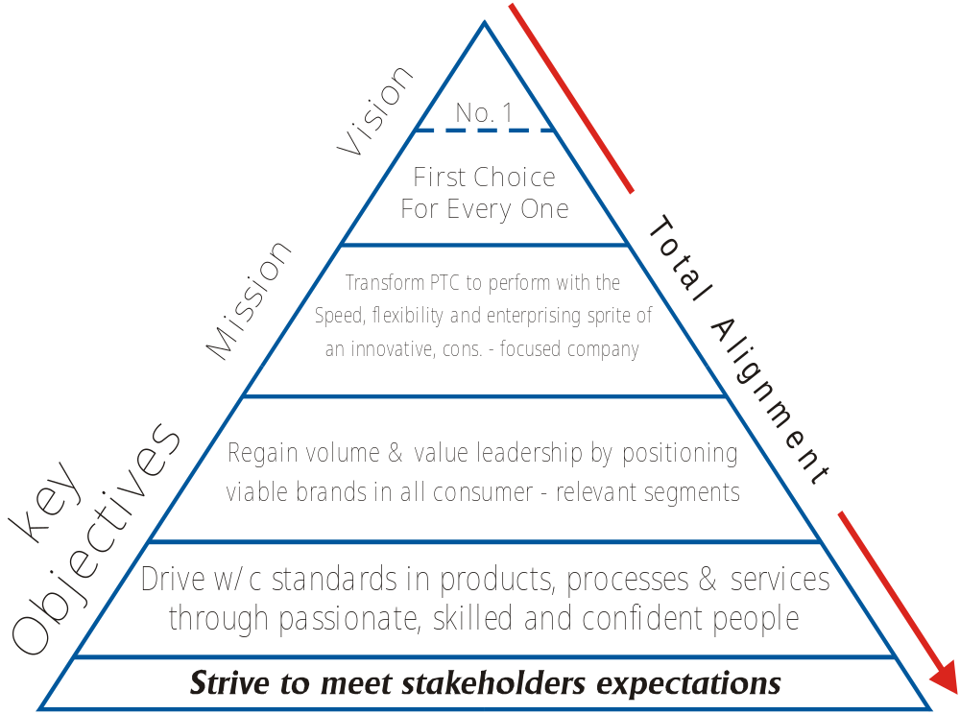

Pakistan Tobacco Company was established in 1947. It took over the business of the Imperial Tobacco Company (India), operational since 1929 in the territory that formed Pakistan, Pakistan Tobacco Company was the first multinational to set-up business in Pakistan. The company is a member of the British American Tobacco which employees over 100,000 people operating from 60 countries.
Manufacturing operations commenced from a small pilot production plant set up in a warehouse in Karachi Port with monthly production of 30 million cigarettes against sales of 160-the gap being made up by imports. First full-fledged factory was established in 1955 at Jhelum. The same year Pakistan Tobacco Company became a public limited company.
At the time of birth Pakistan in 1947, all tobacco was imported into the country. In 1952, a development project for tobacco leaf was initialed in the North West Frontier Province (N.W.F.P.), which progressed rapidly. A redrying plant was set up at Akkora Khattak and cultivation of Virginia Tobacco Commenced. After the birth of Bangladesh and consequently, withdrawal of Dacca & Chittagong factories, a new cigarette factory was set up at Akora Khattak (N.W.F.P.) in 1975 to meet the increasing demand, Pakistan Tobacco Company’s journey on the road progress and prosperity continues with some major new development/investment projects over the last few years.
Projects commenced are:
- Modernization of GLT (redrying) plant.
- Upgrading of Primary and Secondary manufacturing facilities at Akora Khattak and Jhelum factories.
- The acquisition of modern high-speed LOGA/MAX cigarette making machines.
Pakistan Tobacco Company, by spearheading the campaigned for modern agricultural and industrial practices, has played an extremely significant role in the progress and development of the country. Pakistan Tobacco Company is the first foreign investment in Pakistan to pioneer the manufacture of cigarette and cultivation of Virginia tobacco in the country. Through their advanced techniques and farming practices, Pakistan now ranks third in Asia in terms of tobacco yields Kgs/Ha.
Pakistan Tobacco Company is strongly committed to being a good corporate citizen. Over many years we have been:
- Donating to a number of deserving causes.
- Educating growers in the latest techniques & promoting modern technology in agriculture, which has benefited not only tobacco growers but also all agriculturists in the region.
- Planting trees through our A forestation program.
- Sponsoring and promoting sports activities.
- Running free mobile dispensaries.
- Playing a significant role in the eradication of poppy cultivation by providing alternate income sources to the inhabitants of ancestral poppy cultivation areas.

2.5 Production Capacity of Akkora Khattak Factory
Akkora Khattak Factory produces cigarettes according to the requirement of the PTC and markets. Production of AKF is increasing year after year. Year wise production schedule is as under
YEAR WISE CIGARETTES PRODUCTION OF AKF (Table 2.1)
Year | Production (million)
1989-1990 | 7,923,154
1990-1991 | 7,347,046
1991-1992 | 7,587,321
1992-1993 | 8,241,181
1993-1994 | 8,422,466
1994-1995 | 8,316,225
1995-1996 | 9,750,479
1996-1997 | 8,757,498
1997-1998 | 9,750,479
1998-1999 | 11,114,478
1999-2000 | 9,729,595
2000-2001 | 13,261,000

(Source: Finance documents of AKF)
PAKISTAN TOBACCO COMPANY – AKF

ORGANOGRAM

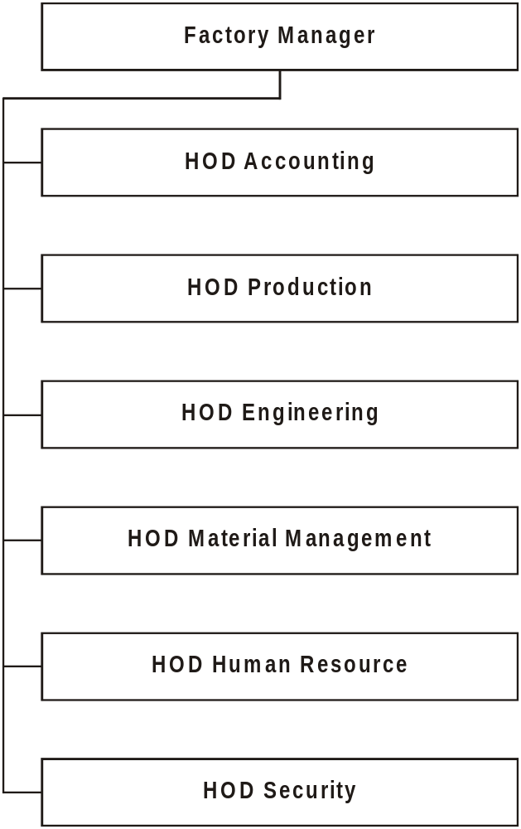
(Source: Database HR Department) Figure 2.1

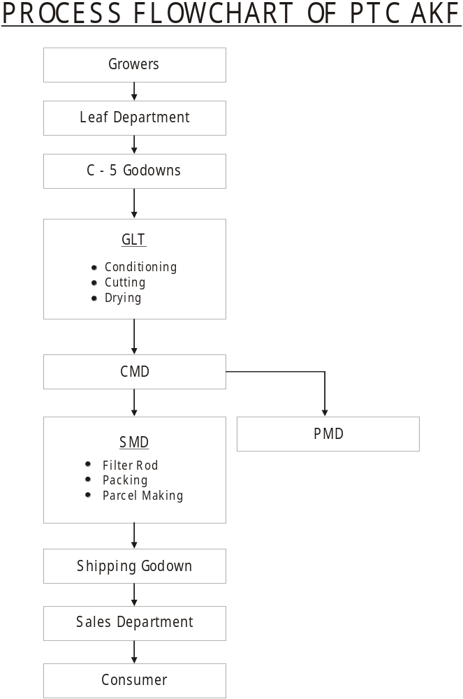

(Source: Database HRD) Figure 2.2

Chapter # 3

Departmentation
Chapter objectives:

- To study the PTC departments concepts.
- To understand the departments.
- Overview the structure, functions, and process of each department.

3.1 Green Leaf Threshing
Leaf Area and GLT both perform some specific functions, which are closely, connected with the basic raw material the Tobacco. One performs the buying and other the elementary process. As clear from its name, Leaf Area which are comprised of depots all over the tobacco growing regions of NWFP and some areas of Punjab. These depots perform many functions for the GLT. They first survey the tobacco grown in that region and assign the quality grades to each farm, which is done through checking the tobacco. The leaf teams visit almost all of the farms to know that which grower is growing quality tobacco. This survey will help them in buying; the reason is that they will know that which farmer has the best product. When the buying season starts they will start buying the tobacco in light of the survey and the company targets provided to them. They will try to buy the best tobacco from each grower. The limit of buying from one farmer or grower is 2200 Kgs. This limit can alter a bit giving consideration to the quality of the lot. The quality inspection is done by the leaf area manager who assigns the lot its due price. The limit to be assigned to each Virginia tobacco these years is going in between 40 to 43 Rupees/Kgs. He cannot assign lower or higher price than that. The grower who will bring his tobacco for sale will have to get a contract because if they do not have any contract they cannot sell it to the PTC. The money will be paid to the leaf areas depots who will than distribute the money correctly to all the growers.

ORGANOGRAM OF GLT

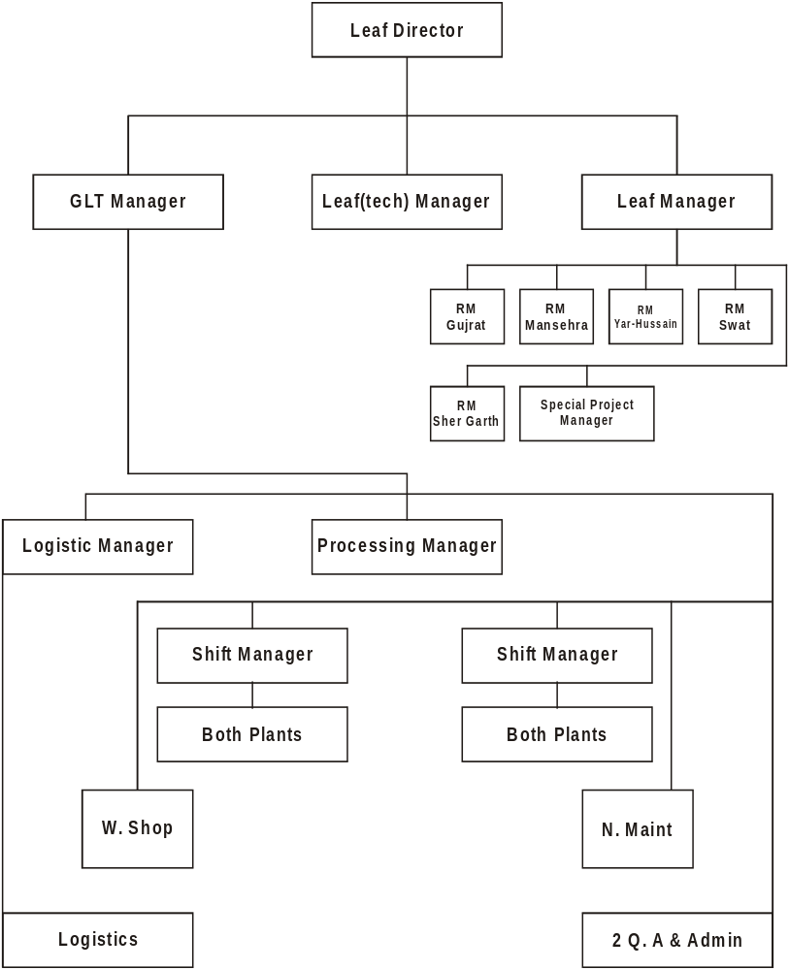
(Source: Database Green Leaf Department) Figure 3.1

The different tobacco purchased by the leaf area is divided into mainly five (5) kinds and more or less as many grades. The kinds are as follow,
- FCV (Flue Cured Virginia) Main
- DAC (Dark Air Cured)
- WP (White Patta)
- BURLEY
The kind of tobacco PTC buys the most is the Virginia, which is used in all of the brands of Cigarettes manufactures in PTC. It is graded in almost seven categories, which are from PAK1 to PAK7. These grades depend on the moisture, moldiness and the amount of cure given to the tobacco. If it is too cooked or its uncooked it will be graded lower and the prime and correctly cured Virginia will be graded the highest and will fetch higher price to the tobacco grower. These steps ensure the quality, which PTC claims and this encourage, the growers to produce the best quality.
After the buying is over the depots will send the purchased tobacco for processing to PTC. When the tobacco enters the gates of PTC the function of GLT starts. As the truck enters the gate of PTC which is known as the marshalling area of the GLT the clerk will prepare the LD56 which is the first document which contains the complete description of every thing. After that the GLT quality team checks the quality of tobacco and than Re grade and Re weight the tobacco. It is than stored in the Un prized tobacco godown. The Un prized tobacco is that tobacco which is in raw form and still to be processed.
When GLT starts processing, it means that the very first process of making cigarette starts. In this step the GLT orders tobacco from the UTS (Un prized Tobacco Store). This is done against the leaf document no 61 or LD61, which is the computer copy of LD57. The LD57 is that document which is procured after the final weight and grading of the tobacco. The tobacco comes with the two copies of LD61. The tobacco thence arrives is checked and unwanted grades or worn out tobacco thence arrives is checked and unwanted grades or worn out tobacco is rejected. From that on the process of GLT starts.
The basic purpose of GLT is to separate lamina (leaf) from the stem (midrib) and that what’s the final product of GLT.
This is considered to be the first step towards making of quality cigarettes. Its basic purpose is already mentioned it also maintains the required amount of moisture in the tobacco, which is the most important factor in the whole usage or the life cycle of tobacco. This is kept accordingly.
The lamina is the most important out come of the GLT process. The higher the yield of lamina the happier the GLT is. If it’s only one % higher than expected that means surplus of almost 15 million rupees.
There are two plants in GLT and each one has different capacity to perform. With installation of new plant the capacity of GLT has increased dramatically. This year it will be used for the first time.
The whole process is mechanized in GLT, which are made up of different machines the details go like this.
3.2 Feeding Point
This is the very first part of the GLT operations. It consists of conveyers. The main plant is supplied through these different conveyers for different operations. There are dusts units installed in the feeding area, which are mainly removed manually.
3.2.1 First Conditioning Cylinder
To maintain the required amount of moisture in the tobacco that is 16% and provide heat to the tobacco for further processes this cylinder is used. In this cylinder there are spikes and baffles, which make the tobacco leaf open for further processes and without damaging the structure of the leaf.
3.2.1 Sand Reel
It contains different meshes and reels, which are there for the remove any scrape, or unwanted material from the tobacco. It’s the tiny wholes in the reel allows the scrape to be removed out.
3.2.1 Conveyer
The main purpose of this conveyer is to convey the tobacco to the conditioning cylinders.
3.2.2 Second Conditioning Cylinder
To condition the tobacco to the required limit it is done trough this cylinder. Mainly it keeps the moisture (which is a very important factor in the whole life chain of tobacco) to the required limit, which is normally 18%. There are sensory panels fitted in this cylinder, which determine the amount of moisture in the whole lot.
3.2.3 Auto Feed
The Auto Feed is used to provide even number of tobacco to the threshers so that the volume of supply remains constant.
3.2.4 Threshers
It is the most important of all the GLT processes. It’s the place where the lamina is separated from the stem. In GLT the whole threshing process is divided into five major stages after these stages the tobacco is assume to be separated completely into two parts.
These stages are as following:
- First Stage : 50%
- Second Stage : 20%
- Third Stage : 10%
- Fourth Stage : 10%
- Fifth Stage : 10%
3.2.5 Multi Separator or Classifier
It blows hot air into the lamina from below and only lamina parts are able to flat in air where they are sucked up by an air pump, which is located on top of the Classifier.
3.2.5. Shaker
It selects the stem parts only
3.2.5. Sucker
It sucks only lamina parts
3.2.5. Dryer
The drier has been divided into three main zones, which are:-
- Dryer Zone
- Cooler Zone
- Reorder Zone
In first zone blowing hot air into it dries the lamina. It has 8 sections.
In second zone blowing chill air into it reduces the temperature.
To remove all of moisture from the tobacco this zone is used because if it’s packed with out it the tobacco will rot in space of days.
3.2.6 Press
At this point the end product (tobacco bales) is pressed into form of bales in large C-48 cases. By introduction of the new Fish burn Press the quality and the quantity of the GLT end product in the current year will increase dramatically. It will enable GLT to press the tobacco according to international standards.

PROCESS FLOW OF GLT

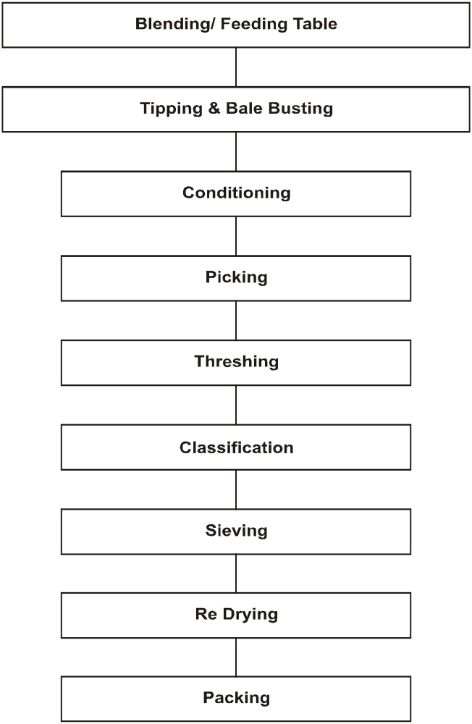

(Source: Database GLT) Figure 3.2

3.3 Quality Control in GLT
Quality means production according to the pre-determined standards. The quality control Department of GLT Factory maintains the quality of the prized Leaf. For this purpose, it takes tobacco from different points in the GLT factory. This tobacco is tested and the Test-results are compared against the standard.
The following tests are conducted in the Quality Control section of the GLT Factory:
- Particle Size Distribution Test (PSD): To determine the ratios of different Lamina sizes after threshing in GLT, at different stages.
- Moisture Test: To test the moisture of the Tobacco at different stages.
- Sand Determination Test: To determine the percentage of sand in Green Leaf and final product.
- Foreign Matter Test: Every thing in the tobacco other than Tobacco itself and sand is called Foreign Matter. Foreign Matter Test is conducted to determine the number of pieces of Foreign Matter in the tobacco.
- Stem Sizing Test: The normal size of Stem ranges from 1.5” to 2”. This test is conducted to determine that the stem has been cut in the right size.
- Lamina on Stem: To determine the size of lamina on the Stem.

PRIMARY MANUFACTURING DEPARTMENT
ORGANOGRAM
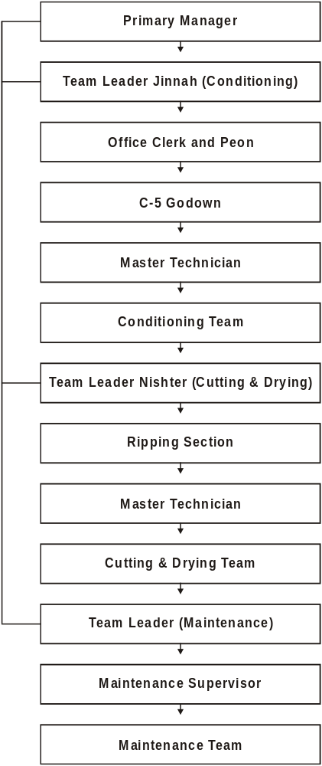
(Source: Database HRD) Figure 3.3
3.4 Primary Manufacturing Department
The process of manufacturing cigarettes starts from PMD. In PMD there is a Leaf Reception Room (LRR) where tobacco comes from excise bounded godown-C’5.
In LRR, the tobacco received from C’5 is re-weighed so that any change in the weight of tobacco that might have been caused due to absorption of moisture during its stay in godown may be adjusted. The excise duty is then paid on that amount of tobacco. C’5 delivers tobacco to LRR according to the requisition received.
After physical inspection in the LRR, the lamina and stem are issued to M/C according to its requirements. In M/C they are processed on two separate plants.
3.4.1 Lamina
The bales are loaded on a conveyer and taken for cutting to bale slicer. Each bale (is cut into three pieces. Then casing is used for moisture retention and addition of sugars
Each brand has its own formula for the preparation of casing. These chemicals include Gralantor, Kookie, and Durlock etc;

After casing, the lamina is kept for 2 hour in the blending bin, and then it is passed through a conveyer to the airlift where the required form of tobacco is flown upwards and then taken through the sieve conveyer to Rc-4 cutter.
After cutting the lamina is passed through a dryer. After drying it is transferred to FP Silos in the Cut Tobacco store.
3.4.2 Stem
The stem received from LRR is transferred though sieve conveyer to Stem airlifts where the Foreign Matter is separated. Then it is taken to GFP (Gravity Feeding Pipe) for conditioning. Then it is kept in the blending bin for 3 hours. From blinding bin stem goes in to KT cutter. Where stem is cut at 160cut per inch, then the cut stem goes to high velocity steam tube which expand stem then it goes to gas roaster where it’s dried to16.5% moisture and then it is stored in CPS Silos from where it added back to lamina as per requirement.
ORGANOGRAM OF SMD (SECONDARY MANUFACTURING DEPARTMENT)

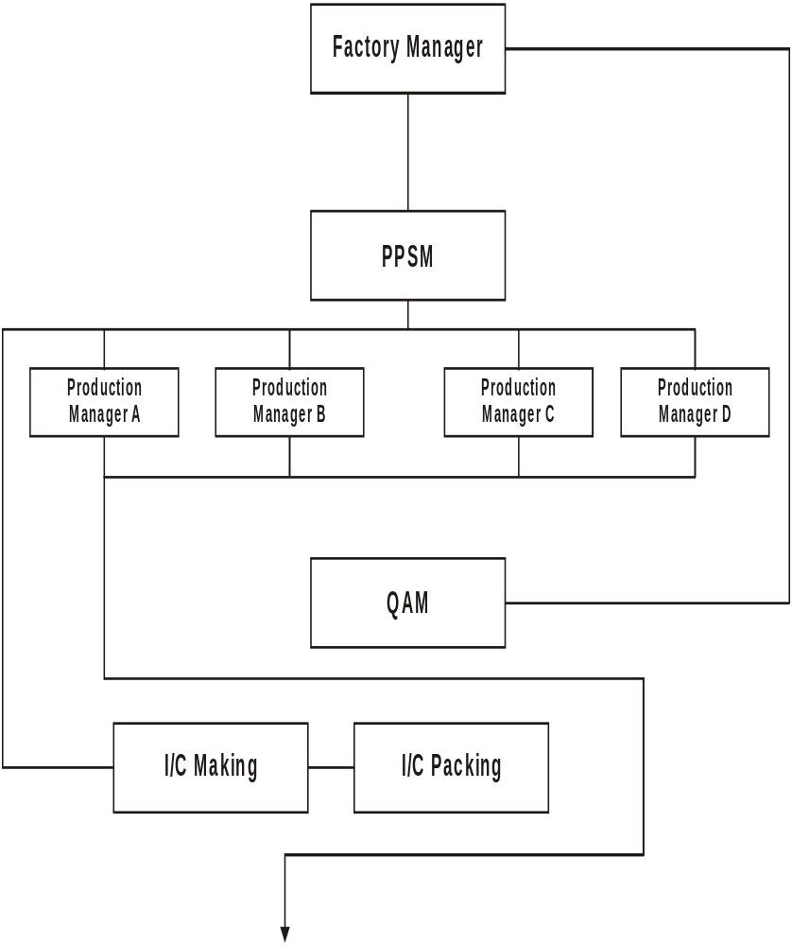
(Source: Database HRD) Figure 3.4
3.5 Secondary Manufacturing Department
SMD is the department in which the actual manufacturing of the cigarette takes place. Two types of materials are used in the manufacturing process.
- Tobacco
- Wrapping Material
Tobacco is issued to the SMD through CTS. Tobacco is sucked through suction pipes to the SMD. The tobacco for each blend of cigarette is different and stored in CTS, which are color-coded. Each color represents different blends of tobacco. The different brands of cigarettes manufactured in SMD are Gold Flake (SX) Capstan (AY), Wills (NT), Embassy Kings (CH), Embassy Filter (CL), wills Kings (BP), No. 6.
The wrapping material are issued to SMD from the material issued from MMD include.
3.5.1 Filter Rod Manufacturing
- Acetate Tow
- Till box
- Gum or Adhesive
- Plug Rap
3.5.2 Packing Material
- Shell Slides
- Flats
- Inner Collor Board
- Aluminum Foil
- Adhesive
- Poly prop
- Tear off ribbon
- Parcel Paper
- CBC Carbonate board center
- End Labels
- Hang lets
- Tipping Paper

3.6 Team Setup in SMD
In order to achieve the functional objective and make the working more efficient, SMD has been divided into different formation of teams. Each team has a team leader who acts like a bridge between workers and management. There are certain targets for each team on the achievement of which they are appreciated and motivated in the shape of bourses and other incentives. But incase of not achieving its target, is a matter. If regret and shame for the whole team, thus increasing the efficiency and productivity of the teams.
There are a total of 7 teams in the SMD department. Tipu Team works for the manufacturing of the filter rod while the other six teams manufacturing the cigarettes. These teams are Ghazi, Karwan, Neelab, Khyber, Abaseen and Inqualab. There are tow kinds of Cig makers used in the SMD, the old ones and the new ones. The old makers are MARK8, which are quite old machines and are capable of making 2000 sticks/minute. There are total four machines of this kind running in the SMD. The new machine, which has recently started working, is the LOGA, which is capable of making 6000 sticks/minute. The company has already bought a new version of MARK8, which is MARK9; but that is not installed yet it has the capability of making 4000 sticks/minute. The company has a valiant plan of phasing out the old Mark8 and to introduce all new Mark9 in its place. This is a great step in reduction of variable cost.
The filter rod department prepares the filter rod. The material department supplies the raw materials, which are mainly acetate Tow, plug warp, till box, hot melt and adhesives. The filter rod is manufactured in two size regulations, one is a 54mm and other is 66mm. The filter rod thence produced is sent to the SMD through filter rod treys. There is an addition to the makers, which then adds the filter rod with cigarettes.
When cigarettes are made they are sent to packers, which packs them in the packets and send them for further processes. These are also two sizes of packets and two kinds of packer machines. HLPs (High Lid Packers), which are, total seven in numbers and each packs 250 packets/minute. The HLPs comes with different models and different work capacity. The likes of 120, 180 and 250 are there. There are separate machines for the packing of the shell slides packs, which are DUPLEXs. These are total seven in number and they pack 240 packs per minute.
After the cigarettes are packed in packets they are than send to the percales that packs them in shape of outers. The outers thence prepared are packed into CBCs. They are then taped and air tightened and sent to the shipping godown.

3.7 Wastages
Wastages are an integral part of the manufacturing process. It is rather impossible to even risk of a perfect manufacturing process free of wastages. But what is possible is to make sure that the amount of wastages shall be reduced to the minimum possible quantity.
In the manufacturing process the wastages can occur in two forms.
- Wastages of tobacco
- Wastages of wrapping material
In tobacco is wasted in the form of dust or the blended mixture of stem and lamina. The dust is disposed off or sold and where as the stem and lamina is again put into the PMD process. The wastages of the wrapping material are the most common and frequent form of wastage occurring in the SMD. Since these wastages cannot be put into process again therefore, it is necessary to identify them in time and reduce the volume of these wastages.
3.7.1 Identification of wastages
In order to explain this topic fully it is important to understand some technical terms.
3.7.2 Perfect required
It is that quantity of material used, which is derived or calculated not heretically. Suppose we say that I tear off noon is used to make 1 pack of 10 cigarettes. So how may tear off ribbon will be required to make 1000 cigarettes.
3.7.3 Standard quality
In Standard quality we take into consideration the normal amount of wastages, which are bound to take place as a matter of normal routine. Such wastages are subtracted from the perfect quantity in order to get the standard quantity.
3.7.4 Actual used
It is the actual amount of wastage that has occurred in the production.

3.7.5 Calculation of wastages
In order to calculate wastages the following procedure is used in the SMD.
Opening Balance
Add : Receipts
Less :
The difference between this net usage and standard quantity gives us the wastages. If the amount of wastage is less than the standard quantity it shows that the process is working efficiently. But if the amount of wastages is greater than the standard quantity it means that there is some problem in the manufacturing process.
3.8 BOM Statement
BOM stands from Bill of Material. It is a statement, which shows the perfect requirement, the standard quantity and the percentage of wastages of each item used in the manufacturing process other than tobacco.
The BOM statement has three items
- The Description
- The Unit
- The Quality
The description shows the name of material, the unit shows that which unit is used for the item, where as the quality shows the amount of materials. A specimen of the BOM statement is shown below:-
Table 3.1
Description | Unit | Std | Scrap % | Perfect
Emboss Filter | Million | 1000 | 0 | 1000
Embassy Shells | Million | 101.112 | 1.10 | 100.000
Embassy slides | Million | 102.302 | 2.25 | 100.00
End Labels | Million | 8.333 | 4 | 8.000
PPP CL Red 305 x 1250 | Red | 1.240 | 4.50 | 1.184

(Source: Quality Control Section)

The BOM accuracy is calculated by the following formula.
BOM Accuracy % =

3.9 Quality Assurance Department
The goal of every business is to earn maximum profit through the satisfaction of the consumers. Quality of the product is the foremost consideration for the consumer satisfaction. Quality as defined in ISO – 8402, is “the totality of characteristics of an entity that bears its ability to satisfy stated and implied needs.”
Quality Control involves measurement and examination of the end products to find out its quality and improve it before it reaches to the customer.
Quality Assurance Department of PTC not only assures the best quality of cigarettes but it creates a base for the implementation of Total Quality Management (TQM) at all levels.

3.10 Quality Policy Of Pakistan Tobacco Company
The prime emphasis of quality policy of PTC is to make quality a way of life in all areas of operations for full customer satisfaction, brand loyalty and implementation of Total Quality Management (TQM) circles. The policy has been formulated with highly professional competence while keeping all aspects of organization and modern trends in mind. The quality of environment and ISO – 9000 is being the focus of the Quality Policy.

3.10.1 POLICY
Quality excel0lence is the foundation for the management of our business and
a keystone of our goal of customer satisfaction. It is therefore our Policy to:
- Consistently provide products and services that meet the quality Expectation of our customers.
- Actively pursue ever–improving quality through programs that enables each employee to do his or her job Right the first time.

3.10.2 Total Quality M a n a g e m e n t

BEST 2000 – a Total Quality Management Programme is the most Ambitious Change Management Programme ever initiated by our company. Total Quality is more than just Product Quality; it is quality of everything we do in our Business. It means understanding our Consumers, Customers, Stakeholders and Suppliers, agreeing with them what they want and empowering our employees to organize their own work to deliver the Required Products and Services to the agreed performance levels.

BEST 2001
(Building Excellence and Success Together)
Best 2000 is serving as the fundamental building block in directing company Energies to achieve our Mission Statement
“Together we will be the best in everything we do.”
Since its launch in 1997, BEST is helping us improve company team building, is providing means to continuously improve and break the vicious Cycles, which inhibit improvement activities and is assisting employees to Participate in driving the company forward.

MATERIAL MANAGEMENT DEPARTMENT
ORGANOGRAM

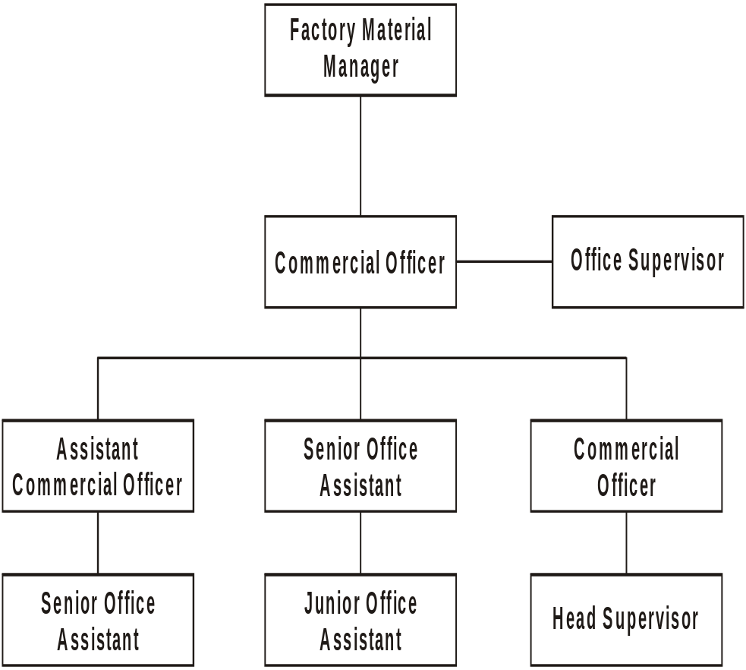

(Source: Database MMD) Figure 3.5

3.11 Material Management Department
The Material management department deals with all the incoming and outgoing material. The materials of to all the departments are issued through MMD. It purchases both the local and imported materials on behalf of the head office. It controls the inventory of manufacturing and marketing in terms of specification as well as quality. This department uses the FIFO (first in first out) method for inventory disposition. The MMD has been divided into three stores.
- Boiling Material Store (BMS)
- Wrapping Material Store (WMS)
- Shipping Material Store (SMS)
3.11.1 Boiling Material Store
This store mainly deals with the raw materials. The leaf and stem produced in the forms has to be packed in order to send in to GLT and from GLT to PMD. This packing material is issued by BMS called CBC’s. These packing containers are imported from Brazil and the BMS store ensure that cash CBC is sued 4 to 5 times in order to overcome its cost after which they are auctioned. It is also responsible for the auctioning of scrap material.
    - Wrapping Material Store
The department arranges all kinds of wrapping material used in the manufacturing process. The wrapping materials include both imported and local items, which are: -
3.11.2 Imported Items
- Cigarette Paper
- Tipping Paper
- Tear off Ribbon
- Gum or Adhesive
- Plug Rap
- Acetate Tow
3.11.2 Local Items
- Shells
- Flats
- Aluminum foil
- Slides
- Reels
There are two types of godown with this store is the custom boarded godown and the other is non-custom boarded godown. The arrivals in this department are dually GR sheeted which means that the correct amount of inventory in stores is on record.
3.11.3 Shipping Material Store:
All the finished goods are brought to this store from here the goods are dispatched to the market on demand it pays duties and other government levies on 14 day deferred payment scheme. This store is also called excise bonded warehouse.

3.12 Engineering Department
Engineering Department is concerned with all the Engineering items used in the factory.
The Engineering department is headed by FPSM (Factory Production & Services Manager). It provides Engineering services in the following areas:
- Boiler House.
- Electrical side.
- Air conditioning.
- Vehicles.
- Engineering store.
- Water pumps.
- Telephones.
- Generators.
- Compressors
Some of the above items/services are provided by the company’s own employees while others through the contractors registered with the company. The purchase of the Engineering items/services is the responsibility of the Engineering Department. A purchase up to Rs.25000 is recorded in the Petty Job Book.
For a job ranging from Rs.25, 000 to Rs.50, 000 a receipt Gen-50 is prepared. And for above 50,000 gen-56 and agreement on a stamp paper is prepared. A receipt- Gen-81 must be attached with each job. For a job up to Rs.25, 000 only Gen-81 is prepared. The Machine spares are received either from SPM Lahore, Jhelum Factory or suppliers. Fixed Assets are supplied only through SPM, Lahore according to the indent Received from the concerned Department.
The following documents are prepared when an item is being purchased: SCE (Sanction for Capital Expenditure): When some Capital item is involved. SRE (Sanction for Revenue Expenditure): When Revenue items are involved.

3.13 Engineering Store
Engineering store deals only in engineering items. In this store, there are 17,000 items and each item has a specified location where it can be easily available.
Engineering items/spare parts have been divided into three categories:
- Local items.
- Foreign/imported items.
- Propitiatory items.
Spare parts are sub-categorized on the basis of their consumption:
i) Fast.
ii) Regular.
iii) Medium.
iv) Slow
v) Dead.
vi) New.
The Engineering store remains open from 7:00 a.m. to 4:00 p.m. A red seal is put at the door at the time of closing. If a department in the factory, after store hours need some item, the leader of the team needing such item comes along with a security guard and a worker or some supervisor, opens the store and makes entry in the Night Opening Register. While leaving the store, he should put the white seal, so that the incharge of the Engineering Store may know that such and such person of such and such department had opened the store and has taken such and such item.

3.13.1 Oil Store
It is a part of the Engineering Store. In this store, the oil used by the company vehicles is stored. The oil for use is issued on daily basis (from 9:00 a.m. to 10:00 a.m.). After or before this time, it can be issued only in exceptional cases.
3.13.2 Receipt of Items
When fresh engineering items are supplied to the factory, a B.S.O, in the Engineering store receives them. A Goods Received Sheet (G.R.Sheet) for such items is prepared. One copy of the G.R. Sheet is handed over to the person who passes the bill and one copy to the B.S.O. for store record.
3.14 Issuance of items
The proper computer record of the items in the store is maintained. When requisition for some items is received. First off all, the B.S.O. checks the record of that item with the help of computer. If the required items are available at stock, then he issues the required items and then files the copy of the requisition and the computer generated printout.
3.15 Stock checking
The account office, from time to time, sends a list of items to the Engineering Store. The items specified in the list are counted by a BSO of the Engineering Store with the help of a specified team’s member of the SMD. If any difference is found is reported to the Finance office along with a description.
3.16 Stock Adjustment
Sometimes there may be a mistake by the store hand while issuing an item. For example, received a requisition for item X, at the time of issue the store hand brings on item Z instead of item X and hands over it to the requisition holder. In this case, as per computer record, one number of items X is issued while actually item Z was issued. So, because of one mistake two discrepancies occurred. That is, item X is surplus by 1 while item Z short by 1. In such cases, a stock adjustment Performa is sent to Finance Department that shows the actual positions of the stock of this item and thus, the stock is adjusted.
3.17 Binning
All the G.R. Sheeted items are placed at their proper positions (bins) specified for each item. The process of keeping items in their specified bins is called binning. There are 17000 bins in the engineering store. The placement of items in their proper bins is a difficult exercise. Therefore, the person responsible for binning must be an experienced person.

3.18 Running Log
Running Log of Receipts and Transfers is printed at the end of the day or early in the morning on the following day which shows the CC .no; PT no; Receipt quantity and Bin number of the items. Running logs of current and one previous year are kept for record purpose.

HUMAN RESOURCE ORGANOGRAM

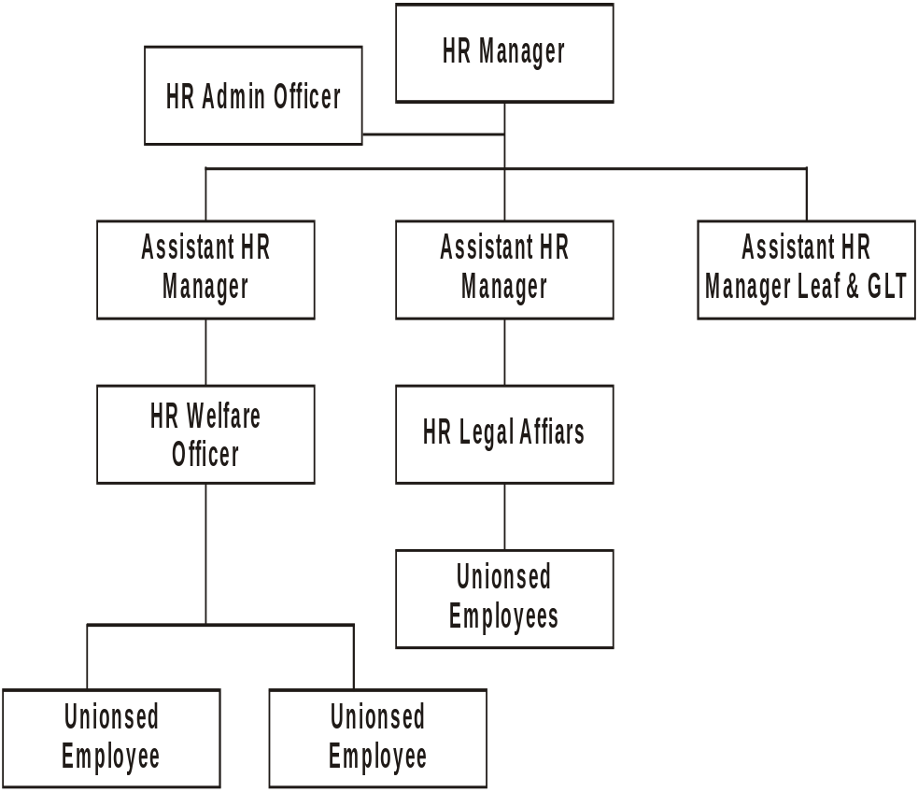

(Source: Database HRD) Figure 3.6
3.19 Human Resource Department
Human resource department is mainly concerned with the management of Human resource in the organization. The main functions of HRD are to resolve the workers grievances and care of disciplinary procedures, misconduct, faults and omissions, Industrial and Commercial Establishment standing order – 1968 and Industrial Relations Ordinance 1969.
At Akkora Khattak Factory Human Resource Manager Mr. Arif Bilal heads the HR Department. He has two Assistants Managers- one for Legal matters and one for Administrative.

3.20 Why HRM Is Needed?
The philosophy behind the concept of HRM is to utilize the abilities of workers to their maximum beneficial level so that efficiency of working is increased without additional workers to share the expenses. More efficiency with less manpower is the goal of HRM.

3.21 Areas Covered By Human Resource Department (AKF)

HRD covers the following areas in terms of functional responsibilities.
- Maintaining Industrial Relations.
- Keeping the service record of workers.
- Administration of the workers salaries.
- Organization of the workers facilities e.g., Transport Canteen and E, H & S facilities etc.
- Promotional and other developmental activities for workers.
- Manpower Planning.
- Recruitment of new workers, when required.
- Implementation of Labor laws.
- Dealing with CBA.
- Maintaining the record of budgetary expenses.
- All the manpower of the company (except management) comes under HRD.

3.22 Classification of Workers
The workers employed in PTC Akkora Khattak Factory and Leaf areas are classified into two categories:
- Permanent or non- seasonal workers.
- Temporary or seasonal workers.

3.22.1 Permanent Workers

Permanent workers are hired by HRD. The factory on permanent basis directly employs them. Therefore, they are required to meet all the requirements that the company has established for a worker.
New workers when hired are properly trained and closely watched at work during the early period of their job.

3.22.2 Temporary Workers
The temporary workers are hired by HRD as seasonal workers. They are on the job for six months in a year i.e. from July to December. At depots they are hired for buying tobacco and doing other jobs in the Leaf areas. At factory they are hired normally for GLT services.
If a temporary worker works for the whole season, he gets the benefit of special bonus. If he remains absent for 10 consecutive days, another worker for the rest of the season replaces him. If a seasonal worker remains absent for three consecutive seasons, his license is cancelled. The wage level and terms and conditions for the temporary workers are nearly the same as that of permanent workers.

3.23 Role of Labour Union in the Factory

There are three Labor federations at AKF. These are:
- Mutahidda Mazdoor Union.
- PakTobac Mazdoor Union.
- Pak Labor Union.
Elections of Unions are held after two years to determine the authority of a union to hold talks with the Management. The elected majority extends a Collective Bargaining Agent (CBA) as a representative to HR Department. If the CBA is sensible, it can prove very useful in maintaining a good environment in the factory. For Leaf area a separate CBA is elected from the workers union and Karkun union.

3.23.1 Biennial Agreement

THE CBA and Management sign agreement regarding the working conditions, wages and other affairs of the workers. The agreement remains valid for 25 months. After 25 months a new agreement is signed.
3.24 Policies of HRD - Pakistan Tobacco Company (AKF)

3.24.1 Hiring Policy
In PTC Akkora Khattak Factory, there are 36 grades. Out of these 36 grades, grade 1 to 10 includes general workers to senior supervisors and clerks. From 30 to 33 includes BSO’s (Business Support Officers) and from 34 to 36, MOM’s (Members Of Management).
The HR Department of AKF is concerned with the hiring of only those employees who fall into the category of grade 1 to 10. The minimum qualification that is required for a permanent employee is Metric plus Physical suitability.

3.24.2 Promotion Policy
The employees having a good performance can be promoted to the next higher post. There are two bases for promotion in PTC - the suitability and Seniority. Suitability means the suitability of the person in terms of his performance on the job and seniority means the time he has passed in PTC.
There are certain jobs to which eligible persons are directly promoted and do not require any further training. But certain jobs require special training for a particular period. So, when a person is to be promoted to these jobs they are provided with specified training.

3.24.3 Retirement Policy
There is a limit on the individual’s life for doing job. No individual can work throughout his life. Therefore, every organisation has kept an age limit for the

Individual’s job. When he reaches that limit he must be retired. In PTC, the age of compulsory Retirement is 58 years for workers and managers. First extension is given at the age of 55 years, second at 56, the third at 57 – subject to his performance and medical fitness.

3.24.4 Retirement on Medical Grounds
If a person becomes disable to perform his job, he requests the company to refer him to the Medical Board. The Medical Board examines the worker thoroughly and sends his medical report to PTC. If the report reveals that he is really unable to perform his job, then he is given retirement on Medical Grounds and is provided all the benefits as in case of ordinary retirement.

3.24.5 Voluntary Separation Scheme
PTC has a scheme of voluntary separation. Under this scheme, the permanent employees are provided the opportunity to get early retirement. The person getting early retirement is paid some percentage of his salary plus provident fund. The percentage of salary to be paid to them depends upon the years remaining to his retirement. The percentage applicable is given bellow:
Up to 5 years 75 %
6 to 8 years 40 %
9 to 10 years 36 %
11 to 15 years 25 %
16 to 20 years 18 %
21 to 25 years 15 %
26 to 30 years 13 %

Finance Department---AKF

Factory Financial Services Manager

Cost Accountant
Payroll, Cash, Variable Cost, Excise
Timed office; administration

Cost Accountant
Book Keeping, Production Expenses

Leaf Accountant

BSO
Payroll

BSO
Variable Cost, Excise

BSO
Crop Cost

BSO
Bank Payment Scheme

BSO
Ledger & Fixed Assets

BSO
Production Expenses

(Source: Database Finance Department) Figure 3.7

3.25 FINANCE DEPARTMENT
3.26 Leaf Section

The function of the finance department is to provide financial services to all the departments of the factory. Section in the Finance department dealing with the financial matters of the Leaf department is the Leaf Section.
The leaf section provides three main services to the Leaf department:
- Treasury functions.
- Leaf Budgeting.
- Crop Costing.

3.26.2 The Leaf Buying Payment System
Leaf constitutes the basic ingredient in the Cigarette manufacturing. It is an agricultural product and can be bought once a year. Therefore, great care must be taken to purchase the right type of tobacco and at the right price.
3.26.3 Buying Procedure
The Leaf is bought from growers at the Leaf depots. The growers are issued contracts at the start of the year, which specify the quantity of each grade of Leaf to be purchased from the contracting grower and the dates at which he has to bring this Leaf. At the date specified, the grower brings his Leaf bales and presents his contract. Now which price is to be assigned to it. The minimum rate to be paid is given by the
PTB (Pakistan Tobacco Board) while the maximum by the Leaf Department of AKF. Leaf Buying Manager of the Depot determines the exact rate on the spot through physical inspection according to the grade and quantity of the Leaf. After the price has been assessed, the specifications and price of each bale is written on a LD-73 form, through which the total amount payable is calculated. The form is prepared in triplicate. The distribution of LD-73 is as under:

- Accounts (yellow copy)
- PTB (Green copy)
- Grower (pink copy)
- Voucher book (white copy)
The payment is made usually after 7 to 30 days of sale on presenting the pink copy at the nearest bank branch.
3.27 The Payment System
The government of Pakistan has deputed a special type of Finance facility to the PTC, which is called DPLV (Deferred Purchase Leaf Voucher). According to this system, the total amount of financing available is negotiated with the State Bank on yearly basis depending upon the projected sales and hence the Leaf purchases. This facility is then distributed to three banks. The current distribution is as follows:
- - Habib Bank Limited 200 million
- - National Bank of Pakistan 150 million
- - Muslim Commercial Bank 150 million
According to DPLV system, the banks make payments to the growers although the company does not already have any amount in that Bank Account. This facility to the company is available from start of the season till 30th of September. The payment on this facility is due on 30th of March. Any payment on Leaf purchases after 30th September is to be made through a credit account (B account).
The Finance Department also keeps the record of the Leaf Purchases and Payments. Two Forms are used concerning the payment of Leaf Purchase.

3.27.1 The Payment Procedure
When the purchase is complete, the quantity and amount from the White Forms are entered into the computer. The computer generates three copies of Form-A, which contains the grower’s identity, amount and the date of payment. The Finance Department retains one copy and two copies are sent to the Depot, which, after signing, sends one copy to the Bank.
The grower presents his pink copy of the LD-73 Form to the bank. The Bank after tallying the information on the Form-A and LD-73 makes payment to the grower.

3.28 Leaf Budgeting

In the Leaf Section, budgets are prepared for the following:
3.28.1 Leaf Buying Budget
The buying forecast depends upon the projected sales given by the Marketing department, which is then broken up brand wise and hence, the quantity of each variety of tobacco required is determined. The average prices of different brands of tobacco are determined by taking into account the previous year’s prices plus the Inflation rate, which is advised by the Head Office. The details of quantity and grades of tobacco to be purchased are communicated to the depots. The job of the depot is to acquire the assigned quantity of the Leaf at or bellow the average price.
3.28.2 Buying and GLT Expenses
The Buying and GLT Expense budget includes the Budgets for the Leaf Depots. Leaf Depots expenses forms a major component of the buying expenses. The basis of these budgets are usually the last year’s expense adjusted for inflation according to the figure being advised by the HO and varies with the head of expense to which it is applied.
The Expense budget is first discussed with the Leaf Manager and the FSML (Financial Services Manager Leaf) for preliminary approval and then to the Budget committee for final approval. After this approval, it is consolidated with other departments to be presented to the ECB (Executive Committee Board). After approval from ECB, it becomes valid for use.
3.29 Buying And GLT Wage Budget

This budget is based upon two major factors:
- OLE (Optimum Labor Establishment).
- CBA agreement of settlement.
The Human Resource Department calculates the OLE by taking into view the desired capacity at which the plant is to be operated. It also takes into consideration the various parameters on the basis of which the overall factory performance will be evaluated. These includes:
- CPMH (Cigarette Per Man Hour).
- Million cigarettes per man.
Another major factor affecting the wage budget is the settlement agreement between the management and the CBA. In this agreement, the nature of division of labor and the benefits of work-force reduction are decided.
Another factor that affects the wage budget is the level of fringe benefits to the workers. This has an effect on the wage budget and the bottom line of the company.
3.30 Crop Costing

The crop cost has the following major components:
- Buying and GLT Expenses.
- Buying and GLT Wages.
- Leaf Purchase/Yield.

- Leaf Packing Material.
The crop costing procedure starts with budgeting of the Leaf Purchases based on he marketing projection. The projections are generally for the next five years.
3.30.1Crop Costing Procedure
The crop cost procedure starts with the Yield figures given by the GLT. These figures are an estimate of the GLT Plant as well as the type of Leaf being processed. The figure varies from leaf to leaf and within a process as well. The figure taken for calculation is usually 69 %( approximately), which means that 69% by weight of Tobacco processed is converted into Lamina. All the costs are added together. The value of stem and by-product are subtracted from the above-mentioned total. The answer is then divided by the total Lamina obtained to obtain the total cost per kg of the leaf purchased. These costs are entered into the computer and the printout of the details of these costs is sent to the HO. The HO enters it into Central Stock Averages (CSA) to update the average cost per kg of different variety of tobacco available with the company. The tobacco when issued to the PMD is transferred at the CSA to be used in the final product costing.
3.31 Leaf Debits to Head Office

The amount of prized leaf is charged to the HO through monthly debit notes. The HO is debited at the actual estimated value of the Crop Cost mentioned in the form L-27. The HO is credited at the time it is weighed in PMD. It is worthwhile to note that the debit was at the estimated value while the credit at the actual and hence there will be a difference in books. By the end of the year, a final adjustment debit note is prepared to update the Central Stock Averages.
3.31.1 Custom Duty
The Custom Duty is paid only on the imported materials. The following are the imported cigarette materials and their rates of excise:
Name of Item Rate of Excise Duty
- Cigarette Paper 35 %
- Tipping Paper 35 %
- Swift Adhesives/ Gum 15 %
- Aluminum Foil 35 %
- Polypropylene 35 %
- Viscose Tear Tape 35 %
The imported materials are received at the seaport and are brought to the bonded godown in the factory with a bill of entry. We call this bond the “Inbound Bill of Entry”.
When the materials are issued for use, the Inbound Bill of Entry is replaced by the “Ex-Bound Bill of Entry”.
At receipt of material, the Inbound Bill of Entry is sent to the Finance Department. The actual amount of material on the bill is in form of Pound Sterling. The amount is then converted into Rupees. 1 % Insurance and 1 % landing cost on the materials is calculated and is added to its cost. Now, this is the assessable cost of material. 35 % Excise Duty and 15 % Sales Tax is calculated on the assessable value of material.

3.32 Trial Balance System
The AKF’s Finance Department prepares a Trial Balance every month. The data for Trial balance comes from the following sources:
- The A.P System (Accounts Payable)
- Cashiers data
- Standard entry sheets
- Journal entries
- Accounts Current Ledger
- A – Account - Swat, Mansehra, Buner, Gujrat.
Out of the above six sources, 1 & 2 are punched into the computer daily while the rest are entered into the system at the fourth date of each month. The Trial balance data is transferred to the HO at the closing of 4th date so that at the morning of 5th, it may be available in the HO

Chapter # 4
Trend and Ratio Analysis
Chapter objectives

- To study the financial position of company
- Identify the critical areas

4.1 Financial Analysis
Financial statements are the instrument panel of a business enterprise. They constitute a report on managerial performance, attesting to managerial success or failure and flashing warning signals of impending difficulties. To read these financial statements, every -one can easily understand the position of business enterprise. It shows financial structure and operating function results. The financial affairs of a business may be interest to a number of stakeholders such as Management, Creditors, Investors, Politicians, Union Officials and Govt. agencies. Each of the group has somewhat different needs and accordingly each tends to concentrate on particular aspects of a Company financial picture.
There are various ratios, which provide results to all above parties. A ratio is a simple mathematical expression of the relationship of one item to another. Every percentage may be viewed as a ratio that is one number expressed as percentage of another.
For the calculation of financial analysis, data should be collected from reliable sources.
This section of the report includes analysis based on trend of last five-year data.

Pakistan Tobacco Company Limited Table 4.1

Balance Sheet Regular (Rs. In 000s) |  |  |  |  | Common Size (%)
 | 2001 | 2000 | 1999 | 1998 | 2001 | 2000 | 1999 | 1998

Current assets
Cash & Equivalent | 69063 | 95575 | 61234 | 33965 | 1.02 | 1.69 | 1.16 | 0.75
Trade debts | 48710 | 11717 | 91053 | 12210 | 0.72 | 0.21 | 1.72 | 0.27
Loans & Advances | 32725 | 35039 | 16060 | 21966 | 0.48 | 0.62 | 0.30 | 0.48
Prepayments & other receivables | 144363 | 344212 | 255292 | 304528 | 2.14 | 6.09 | 4.83 | 6.69
Stock | 3322753 | 2591731 | 2875207 | 2508748 | 49.17 | 45.83 | 54.39 | 55.11
Stores & spares | 140813 | 140909 | 172583 | 188961 | 2.08 | 2.49 | 3.26 | 4.15
Total Current Assets | 3758427 | 3,219,183 | 3471429 | 3070378 | 55.61 | 56.92 | 65.67 | 67.45

Fixed Assets
Plant & equipment | 2815068 | 2421086 | 1805236 | 1468203 | 41.66 | 42.81 | 34.13 | 32.25
Long term investment | 5000 | 5000 | 5000 | 5000 | 0.07 | 0.09 | 0.09 | 0.11
Long term deposits & prepayments | 21128 | 3168 | 6762 | 6567 | 0.31 | 0.06 | 0.13 | 0.14
Long Term loans | 9310 | 6984 | 1273 | 2141 | 0.14 | 0.12 | 0.02 | 0.05
Other long term Assets | 149077 | - | - | - | 2.21 | - | - | -
Total Fixed Assets | 2999583 | 2436238 | 1818271 | 1481911 | 44.39 | 43.08 | 34.37 | 32.55
Total Assets | 6758010 | 5655421 | 5289700 | 4552289 | 100.00 | 100.00 | 100.00 | 100.00

Current Liability
Creditor Accrued & Other Liability | 200000 | 445000 | 1416036 | 915762 | 2.96 | 6.58 | 20.95 | 13.55
Current portion of long term debts | 1747115 | 1050543 | 400000 | 436782 | 25.85 | 18.58 | 7.56 | 9.59
Short term finance & loans | 1869300 | 1729987 | 2149870 | 1785252 | 27.66 | 30.59 | 40.64 | 39.22
Total current liability | 3816415 | 3225530 | 3965906 | 3137796 | 56.47 | 57.03 | 74.97 | 68.93

Long term liability
Long term loans | 370000 | 212000 | 457000 | 412000 | 5.47 | 3.75 | 8.64 | 9.05
Total Liability | 4186415 | 3437530 | 4422906 | 3549796 | 61.95 | 60.78 | 83.61 | 77.98

Share capital
Issued, subscribed & paid up capital | 2554938 | 2554938 | 319367 | 319367 | 37.81 | 45.18 | 6.04 | 7.02
Revenue reserves | - | - | 547427 | 683126 | - | - | 10.35 | 15.01
Un appropriated profit & loss | 16657 | (337047) | - | - | 0.25 | (5.96) | - | -
Total Owner Equity | 2571595 | 2217891 | 866794 | 1002493 | 38.05 | 39.22 | 16.39 | 22.00
Liability + Owner Equity | 6758010 | 5655421 | 5289700 | 4552289 | 100.00 | 100.00 | 100.00 | 100.00

(Sources: financial statement)
Pakistan Tobacco Company Limited Table 4.2

Balance Sheet Regular (Rs. In 000s) |  |  |  |  | Indexed
 | 2001 | 2000 | 1999 | 1998 | 2001 | 2000 | 1999 | 1998
Current assets
Cash & Equivalent | 69063 | 95575 | 61234 | 33965 | 203.4 | 281.4 | 180.3 | 100
Trade debts | 48710 | 11717 | 91053 | 12210 | 398.9 | 95.9 | 745.7 | 100
Loans & Advances | 32725 | 35039 | 16060 | 21966 | 148.9 | 159.5 | 73.1 | 100
Prepayments & other receivables | 144363 | 344212 | 255292 | 304528 | 47.5 | 113 | 83.9 | 100
Stock | 3322753 | 2591731 | 2875207 | 2508748 | 132.5 | 103.3 | 114.60 | 100
Stores & spares | 140813 | 140909 | 172583 | 188961 | 74.5 | 74.5 | 91.4 | 100
Total Current Assets | 3758427 | 3,219,183 | 3471429 | 3070378 | 122.4 | 104.9 | 113.30 | 100
Fixed Assets
Plant & equipment | 2815068 | 2421086 | 1805236 | 1468203 | 192 | 164 | 123.09 | 100
Long term investment | 5000 | 5000 | 5000 | 5000 | 100 | 100 | 100 | 100
Long term deposits & prepayments | 21128 | 3168 | 6762 | 6567 | 322 | 48.2 | 103 | 100
Long Term loans | 9310 | 6984 | 1273 | 2141 | 435 | 326.2 | 59.49 | 100
Other long term Assets | 149077 | - | - | -
Total Fixed Assets | 2999583 | 2436238 | 1818271 | 1481911 | 202.4 | 164.4 | 122.7 | 100
Total Assets | 6758010 | 5655421 | 5289700 | 4552289 | 148.5 | 124.2 | 116.2 | 100
Current Liability
Creditor Accrued & Other Liability | 200000 | 445000 | 1416036 | 915762 | 190.8 | 115.7 | 154.7 | 100
Current portion of long term debts | 1747115 | 1050543 | 400000 | 436782 | 45.8 | 101.9 | 91.6 | 100
Short term finance & loans | 1869300 | 1729987 | 2149870 | 1785252 | 104.8 | 97 | 120.5 | 100
Total current liability | 3816415 | 3225530 | 3965906 | 3137796 | 121.7 | 102.8 | 126.4 | 100
Long term liability |  |  |  |  |  |  |  | 100
Long term loans | 370000 | 212000 | 457000 | 412000 | 89.9 | 51.5 | 111 | 100
Total Liability | 4186415 | 3437530 | 4422906 | 3549796 | 117.9 | 96.9 | 124.6 | 100
Share capital |  |  |  |  |  |  |  | 100
Issued, subscribed & paid up capital | 2554938 | 2554938 | 319367 | 319367 |  | 800 | 100 | 100
Revenue reserves | - | - | 547427 | 683126 |  |  | 80.13 | 100
Un appropriated profit & loss | 16657 | (337047) | - | -
Total Owner Equity | 2571595 | 2217891 | 866794 | 1002493 | 256.5 | 221.23 | 86.5 | 100
Liability + Owner Equity | 6758010 | 5655421 | 5289700 | 4552289 | 148.5 | 124.20 | 116.2 | 100

(Sources: financial statement)
PROFIT AND LOSS ACCOUNT Table 4.3
INDEX
 | 2001 | 2000 | 1999 | 1998 | 2001 | 2000 | 1999 | 1998
Turn over | 19879795 | 15907028 | 14937845 | 14249644 | 139.5 | 111.63 | 104.8 | 100
Less cost of sale | 17896366 | 14431980 | 13648562 | 13414222 | 133.4 | 107.6 | 101.7 | 100
Gross Profit | 1983428 | 1475048 | 1289283 | 835422 | 237.5 | 176.6 | 154.3 | 100
Less: Marketing Exp | 983747 | 872522 | 682643 | 547493 | 179.7 | 159.4 | 124.1 | 100
Administration Exp | 356362 | 286752 | 264192 | 195620 | 182.2 | 146.6 | 135.1 | 100
Operating Profit | 643320 | 315774 | 342448 | 92309 | 696.9 | 342.1 | 370.9 | 100
Add: Other income | 6632 | 11159 | 11459 | 7938 | 83.6 | 40.6 | 144.4 | 100
Less: Other expenses | 56614 | 771467 | 53612 | 12342 | 458.7 | 6250.7 | 434.4 | 100
Less: Financial charges | 241151 | 409354 | 410028 | 369249 | 65.3 | 110.9 | 111.04 | 100
Profit Loss Before Taxation | 352187 | (853888) | (109733) | (281344) | (125.7) | 303.5 | 39.00 | 100
Taxation  Current for the year | (1517) | 30586 | 27966 | 27017 | (5.61) | 113.2 | 103.5 | 100
Profit/Loss After Taxation | 353704 | (884474) | (137699) | (308361) | (114.7) | 286.83 | 44.7 | 100
Accumulated (loss) brought forward | (337047) | -- | -- | -- | 100 | -- | -- | --
Transfer from revenue reserve | -- | 547427 | 137699 | 308361 | -- | 177.5 | 44.7 | 100
Unappropriated Profit/ Loss | 16657 | (337047) | 0 | 0 | (4.95) | 100 | -- | --
Carried Forward | -- | -- | -- | -- | -- | -- | -- | --
Earnings/Loss per share | 1.38 | (17.49) | (4.25) | (9.66) | (14.28) | 181.05 | 43.99 | (100)

(Sources: financial statement)

Financial Ratios Table 4.4

LIQUIDITY
 |  | 2001 |  |  |  |  | 2000 |  |  |  |  | 1999 |  |  |  |  | 1998 |  |  |  |  |  | 1997
Current Ratios |  | 0.98 |  |  |  |  | 1.04 |  |  |  |  | 0.88 |  |  |  |  | 0.98 |  |  |  |  |  | 1.15
Acid Test (Quick) |  | 0.03 |  |  |  |  | 0.06 |  |  |  |  | 0.04 |  |  |  |  | 0.03 |  |  |  |  |  | 0.06
Capitalization Ratio |  | 0.13 |  |  |  |  | 0.09 |  |  |  |  | 0.35 |  |  |  |  | 0.29 |  |  |  |  |  | 0.21

LEVERAGE
Debt to Equity | 1.63 |  |  |  |  |  |  | 1.55 |  |  | 5.10 |  |  |  |  | 3.54 |  |  |  |  |  | -
Debt to Total Assets | 0.62 |  |  |  |  |  |  | 0.61 |  |  | 0.84 |  |  |  |  | 0.78 |  |  |  |  |  | 0.68

COVERAGE
Interest Coverage Ratio |  | 1.47 |  |  |  |  | (2.16) |  |  |  |  | (0.34) |  |  |  |  | (0.84) |  |  |  |  |  | -
Receivable Turnover |  | 137.71 |  |  |  |  | 46.21 |  |  |  |  | 58.51 |  |  |  |  | 46.79 |  |  |  |  |  | -
Receivable Turnover in days |  | 2.65 |  |  |  |  | 7.90 |  |  |  |  | 6.24 |  |  |  |  | 7.80 |  |  |  |  |  | -
Payable Turnover |  | 33.11 |  |  |  |  | 29.2 |  |  |  |  | - |  |  |  |  | - |  |  |  |  |  | -
Payable Turnover in days |  | 11.6 |  |  |  |  | 12.25 |  |  |  |  | - |  |  |  |  | - |  |  |  |  |  | -
Inventory Turnover |  | 5.17 |  |  |  |  | 5.28 |  |  |  |  | 4.48 |  |  |  |  | 4.97 |  |  |  |  |  | 5.7
Inventory Turnover in days |  | 70.64 |  |  |  |  | 69.11 |  |  |  |  | 81.51 |  |  |  |  | 73.40 |  |  |  |  |  | 64.00
Total Assets Turnover |  | 2.94 |  |  |  |  | 2.81 |  |  |  |  | 4.30 |  |  |  |  | 4.65 |  |  |  |  |  | 2.98
Operating Cycle |  | 73.3 |  |  |  |  | 77.01 |  |  |  |  | 87.75 |  |  |  |  | 81.2 |  |  |  |  |  | -
Cash Cycle |  | 62.24 |  |  |  |  | 64.75 |  |  |  |  | - |  |  |  |  | - |  |  |  |  |  | -

PROFITABILITY
Gross Profit Margin |  | 0.09 |  |  |  |  | 0.09 |  |  |  |  | 0.08 |  |  |  |  | 0.05 |  |  |  |  |  | 0.05
Net Profit Margin |  | 0.02 |  |  |  |  | (0.06) |  |  |  |  | (0.01) |  |  |  |  | (0.02) |  |  |  |  |  | (0.02)
Operating Profit Margin |  | 0.02 |  |  |  |  | 0.02 |  |  |  |  | 0.02 |  |  |  |  | 0.01 |  |  |  |  |  | 0.001
Return on Investment |  | 0.05 |  |  |  |  | (0.16) |  |  |  |  | (0.03) |  |  |  |  | (0.07) |  |  |  |  |  | (0.06)
Return on Equity |  | 0.14 |  |  |  |  | (0.40) |  |  |  |  | (0.16) |  |  |  |  | (0.31) |  |  |  |  |  | 0.20

4.2 Trend Ratio Analysis
4.2.1 Profitability Ratios
Profitability Ratios allow us to measure the ability of a firm to earn an adequate return on sales, total assets, and invested capital it is also helpful for the controlling of cost in an organization with the help of these ratios, problems related to profitability can be explained, in whole or in parts, by the firm’s ability to effectively employ its resources. Profitability ratios are important for all parties that are concerned with that company if it is good, company will be earning goodwill and reputation.
Years | 2001 | 2000 | 1999 | 1998 | 1997
Gross profit margin | 9.97% | 9.60% | 8.63% | 5.86% | 5.53%
Operating profit margin | 2.23% | 1.98% | 2.31% | 0.65% | 0.07%
Net profit margin | 1.78% | (2.11)% | (0.91)% | (2.16)% | (2.21)%
Return on investment | 5.1% | (1.93)% | (0.91)% | (6.77)% | 6.58)%
Return on equity | 13.75% | (12.74)% | (15.66)% | (30.76)% | (20.45)%
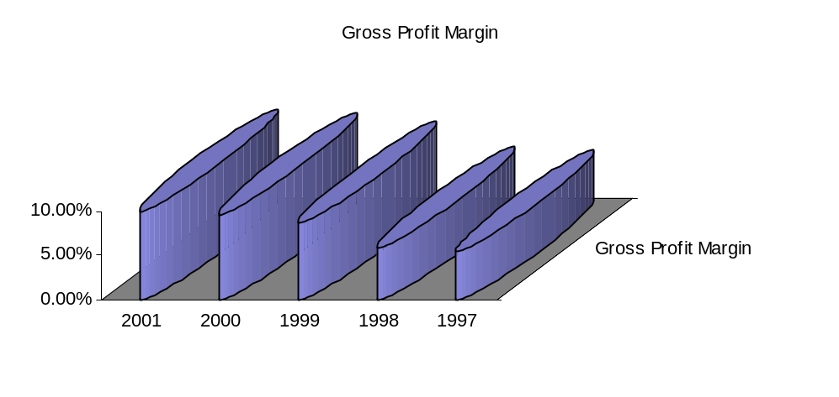4.2.1 Gross Profit Margin
Gross profit margin reflects the inventory management; cost of goods sold and pricing strategy of the firm. PTC improved its Gross Profit Margin significantly from 5.33% to 9.97% in 2001, which show the better pricing strategy (Decrease in price of Gold Flake and Capstan from Rs. 19 to Rs. 9.85)

4.2.1 Operating Profit Margin
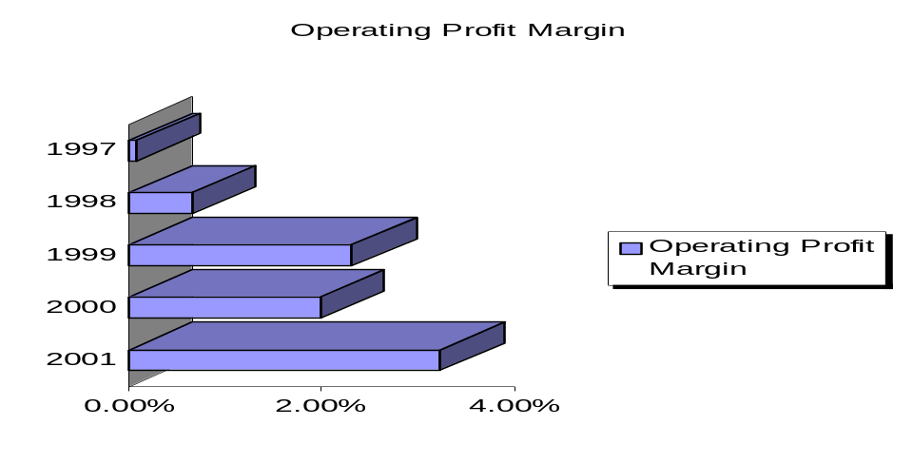Operating profit margin indicates the efficiency of marketing and administrative activities. Though there was a significant increase in the ratio for the last year, but fluctuation since year 1997 - 2000 was not healthy for the organization. Management took some concrete measures, which resulted in present improved scenario. The measure taken was, down sizing which brought a significant improvement in terms of operating profit.
4.2.1 Net Profit Margin
The net profit margin reflects management efforts at controlling assets, the markets acceptance of the firm products, the effectiveness of its marketing and sales efforts and the firms overall reputation. Net profit margin plays a very important role in the goodwill and reputation of any company. PTC’s Net profit margin was negative from 1997 to 2000. But in 2001 management was able to convert losses into net profit due to appropriate pricing policies, issuance of right shares, corrective administrative measures and decrease in financial charges.

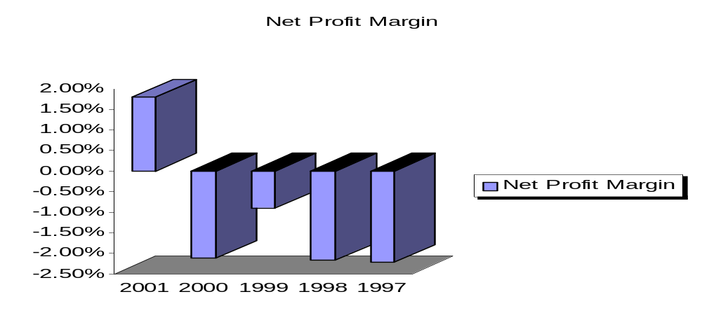4.2.1 Return on Investment
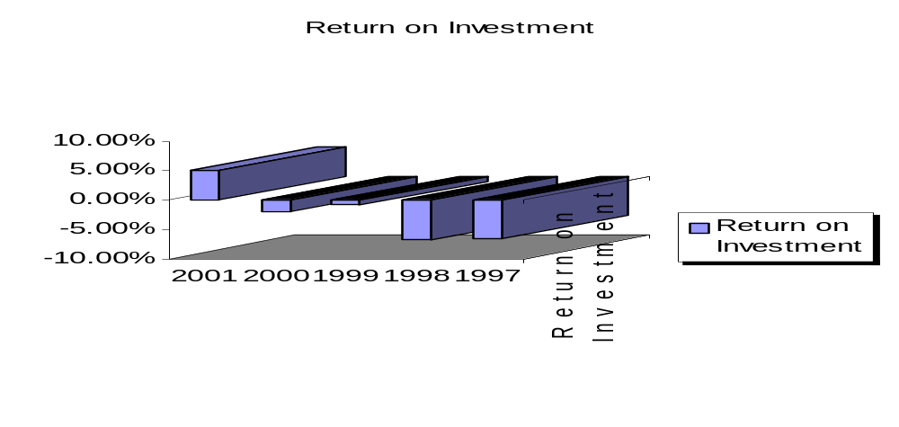An important test of management abilities is to earn return on investment. We can determine the position of the firm assets efficiency from return on investment ratio. But overall position of this ratio is not satisfactory except year 2001.
4.2.1 Return on Equity
This ratio reflects the manager efficiency to utilize equity of shareholders effectively. ROE of PTC suffered from 1997 to 2000. Even in 1998 it touched the lowest ebb of (30.76) % and shareholders loose their confidence. To support PTC, Parent Company purchased 30% share of the company and management introduced some financial reforms and administrative measures, which resulted positive ROE in 2001.

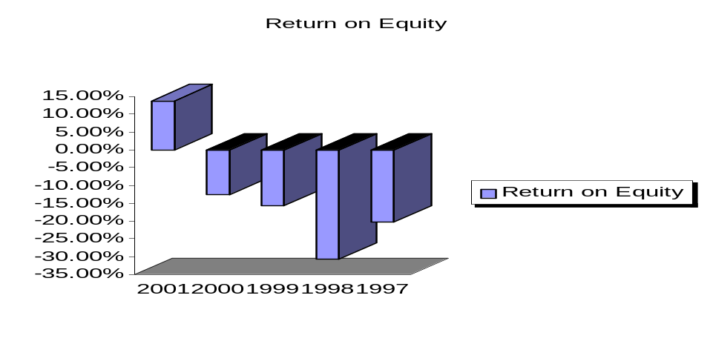4.2.2 Liquidity Ratio
The arrange creditors, although generally concerned with the firm’s overall financial strength, is specially interested in knowing if the firm will be able to meet its short term financial obligations. The two frequently used liquidity ratios are the current and quick ratio.
Year | 2001 | 2000 | 1999 | 1998 | 1997
Current Ratio | 0.98 | 1.04 | 0.88 | 0.98 | 1.15
Quick Ratio | 0.03 | 0.06 | 0.04 | 0.03 | 0.06
4.2.2 Current and Acid Test Quick Ratio
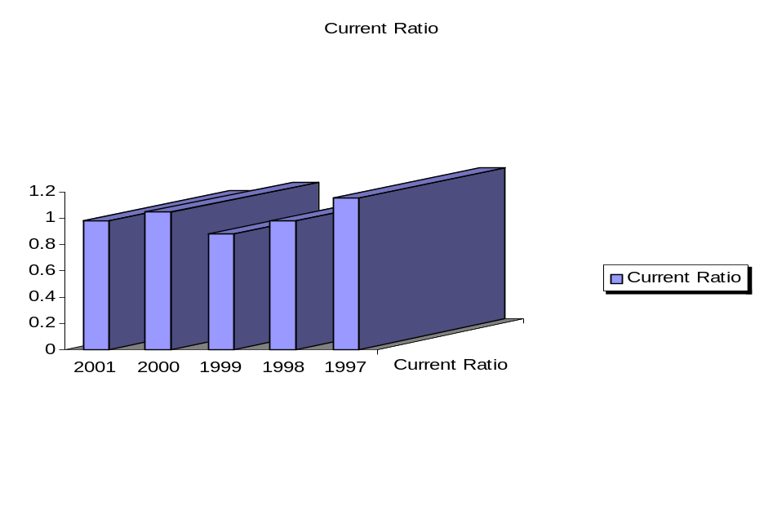Current ratio shows the firm’s ability to pay current liability and acid test quick ratio shows ability to meet emergency payments. Trends of both ratios are not satisfactory which can be due to mal management of A/R, A/P and inventory control.
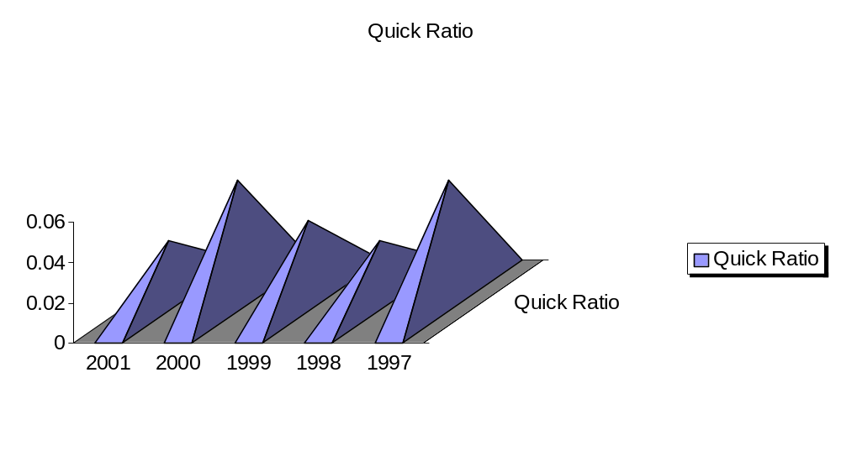4.2.3 Leverage Ratio
Leverage ratios accomplish two things, first they are a measure of the extent to which firm is financed through debt, secondly, they are indicators of the financial risk of the firm, this group includes the debt to total assets ratio and debt to equity ratio.
Year | 2001 | 2000 | 1999 | 1998 | 1997
Debt to Equity | 1.63 | 1.55 | 5.10 | 3.54 | -
Debt to Assets | 0.62 | 0.61 | 0.04 | 0.78 | 0.68
4.2.3 Debt to Equity
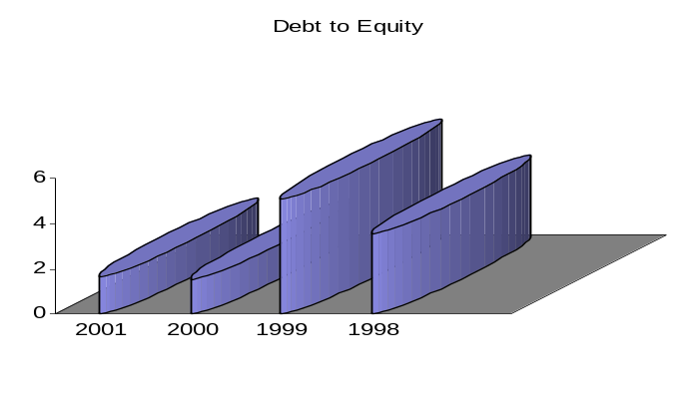High debt to equity ratio shows the confidence of creditors on organization. But on the other hand high debt also leads high financed leverage. Company performance in this ratio is not satisfactory, because the company can enjoy more debts with financial leverage due to low interest rate exit in the economy.
4.2.3 Debt to Assets
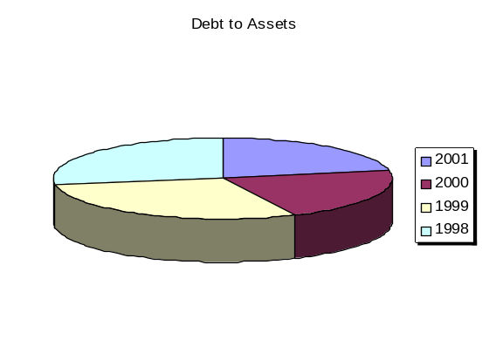This ratio shows the proportion of assets financed by the debts. In 1998 - 1999, this ratio was quite healthy but it declined in last two year. In 1999 84% of assets were financed by debt but now only 62% in 2001.Which also causes less financial charges appearing in profit loss statement.
4.2.4 Coverage Ratio
Year | 2001 | 2000 | 1999 | 1998 | 1997
Interest Coverage Ratio | 1.47 | (2.16) | (0.34) | (0.84) | -
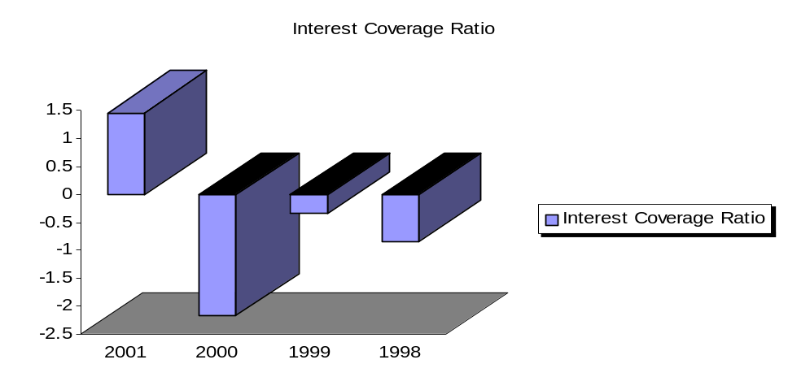This ratio serves as one measure of firm’s ability to meet its interest payments. Generally, high ratio means company could cover its interest payments without difficulty. In 2001 company is able to get a positive figure, which is healthy, a sign but from 1997 to 2000 it was negative due to losses incurred by the company.
4.2.5 Activity Ratio
Year | 2001 | 2000 | 1999 | 1998 | 1997
Receivable turnover | 137.71 | 46.21 | 58.51 | 46.79 | -
Receivable turnover in days | 2.65 | 7.90 | 6.24 | 7.80 | -
Payable turnover | 33.11 | 29.2 | - | - | -
Payable turnover in days | 11.06 | 12.25 | - | - | -
Inventory turnover | 5.17 | 5.28 | 4.48 | 4.97 | 5.7
Inventory turnover in days | 70.64 | 69.11 | 81.51 | 73.40 | 64
Assets turnover | 2.94 | 2.81 | 4.30 | 4.65 | 2.98
4.2.5. Receivable Turnover
The RT. provides insight into the quality of the firm’s receivable and how successful the firm is in its collection. The ratio also tells us the number of times receivable has been turnover into cash during the year. Company performance in this area is quite appreciable. In 1998 A/R was turning into cash just 47 times but in 2001 it runs to 138 that is a huge achievement of management.
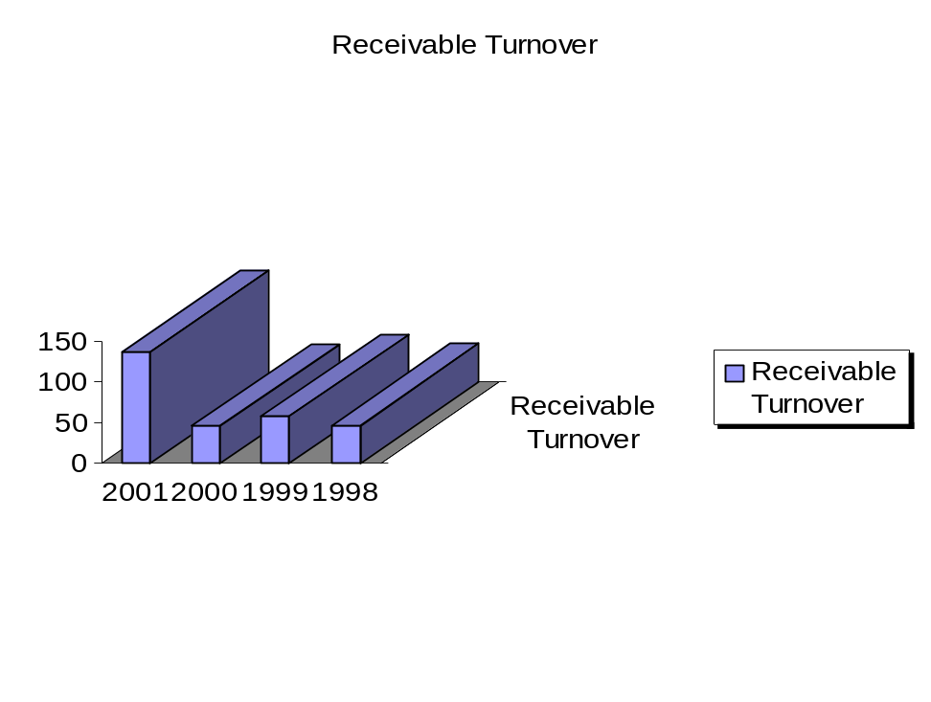
4.2.5 Receivable turnover in days
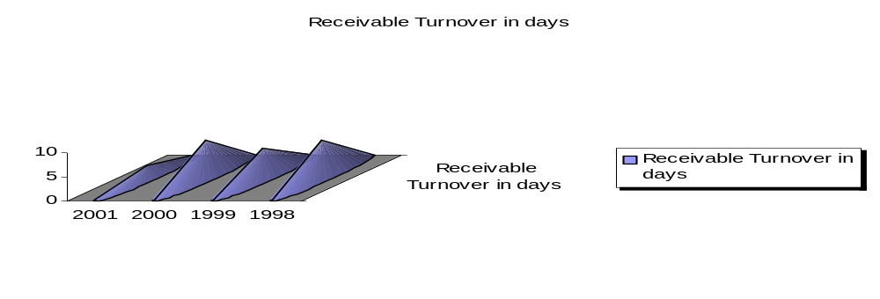RTD shows average collection period, which also show improvement from 8 collection days to 2 collection days.
4.2.5 Payable Turnover & Payable Turnover in Days
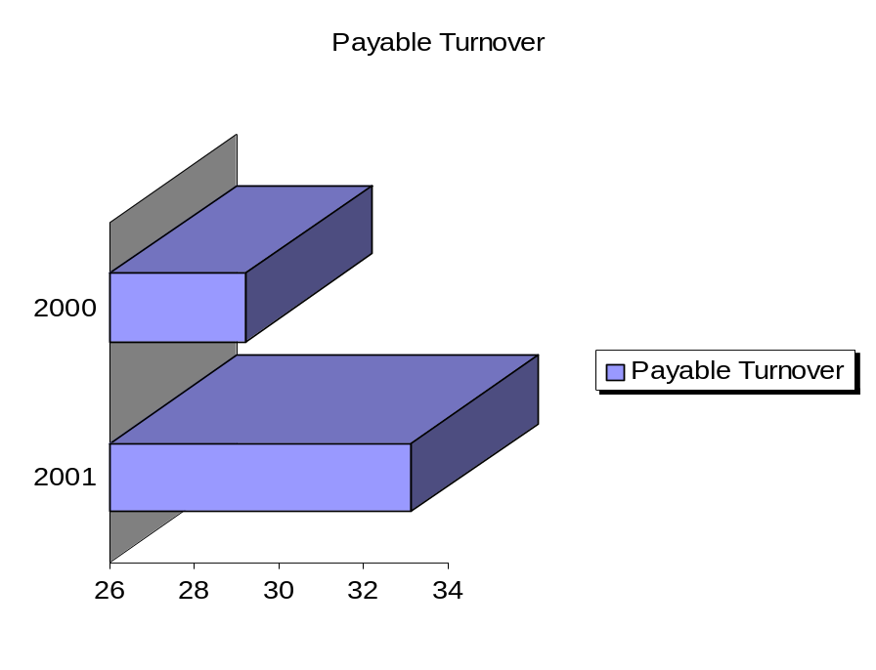Payable turnover refers to promptness of payments and payable turnover in days shows the number of day in which payment is made. Analysis shows that there is nothing wrong with these ratios but huge difference between A/R recoverable turnover in days and payable turnover in days can indicates very tight policy which can result negative result on sale.

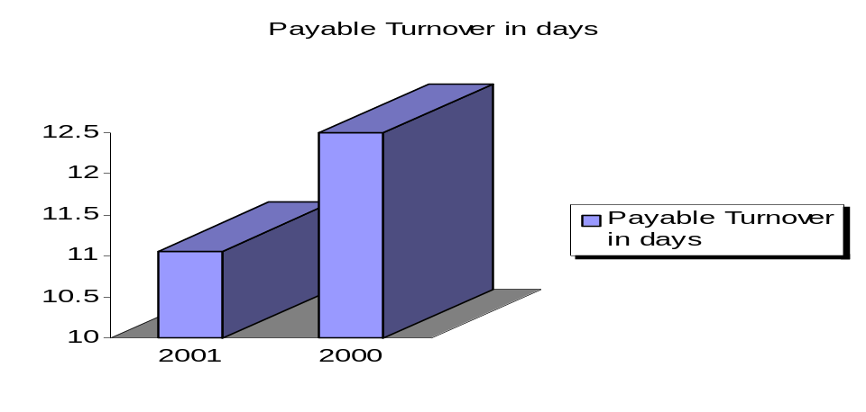4.2.5 Inventory turnover and inventory turnover in days
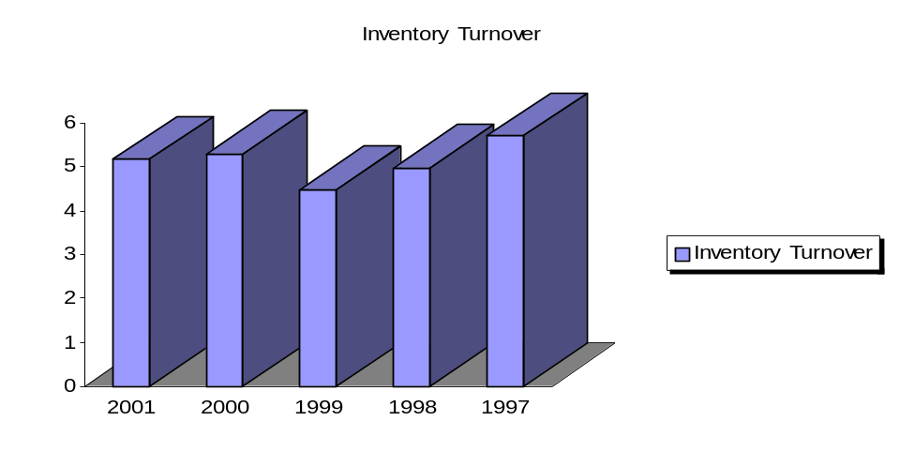Inventory turnover determine how effectively the firm is managing inventory, its ITD shows that how many days in average before inventory is turned into account receivable through sale. Inconsistent, fluctuating and decrease in inventory turnover and increase in ITD shows insignificant level of inventory.

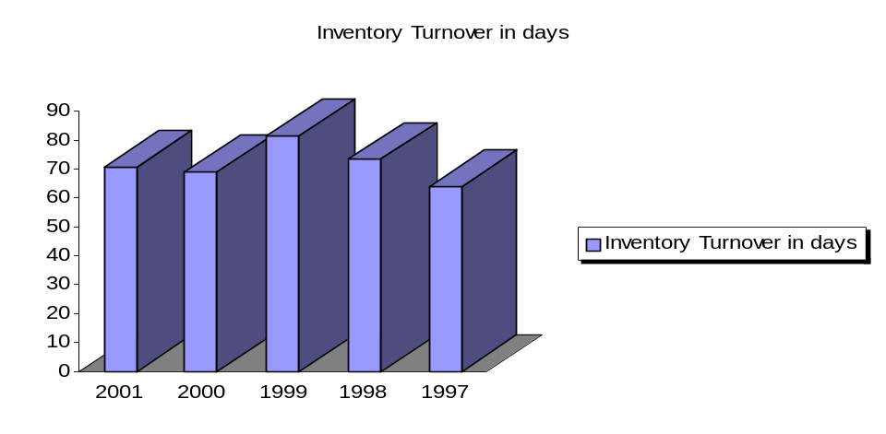
4.2.5 Assets turnover
The total assets turnover is a measure of the firm overall effectiveness in generating sale. Proportional change in assets is greater than proportional change in sales, which shows the decrease in assets efficiency in last few years. Assets are not fully utilized that is 50% decrease in the ratio in just two years, which is alarming for management.

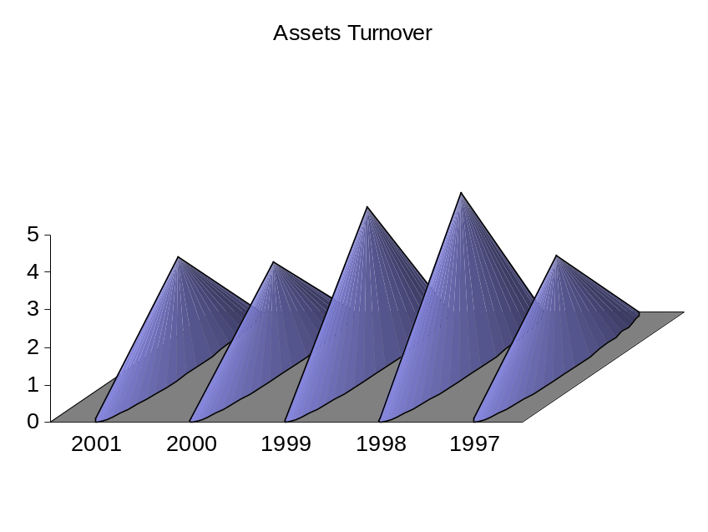
4.2.6 Operating Cycle & Cash Cycle
Year | 2001 | 2000 | 1999 | 1998 | 1997
Operating cycle | 73.3 | 77.01 | 87.75 | 81.2 | -
Cash cycle | 62.24 | 64.5 | - | - | -
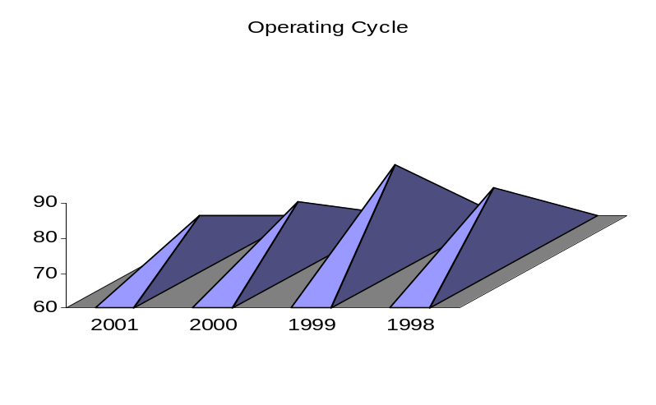Operating cycle is the length of time from the commitment of cash for purchase until the collection of receivable resulting from sale. Figure in operating and cash cycle here also prove the mismanagement in inventory A/R and A/P.
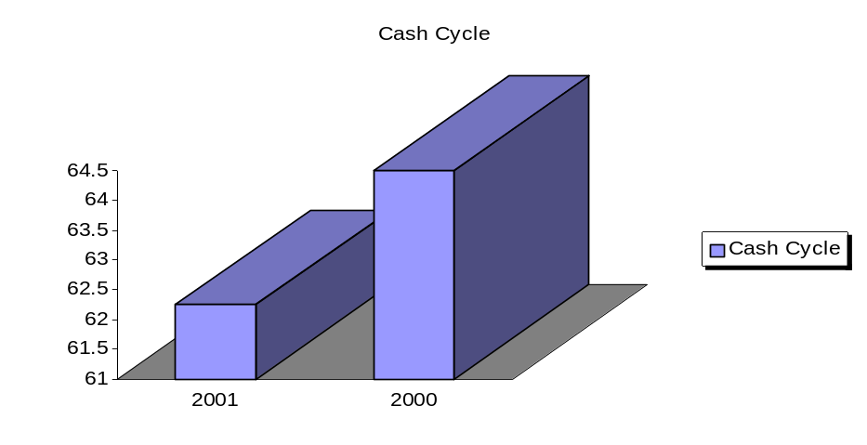
.

CHAPTER# 5
SWOT Analysis and Achievements in 2001
Objective
- To analyze the strength, weakness, opportunity and threats of PTC.
- To glance at the performance of PTC in 2001.

5.1 Strengths:
- Goodwill
- Working environment
- Economies of scale
- Application of most modern computer software (CS3, GALAXY)
- High remuneration
- Certified by MRP2
- Training and development programs
- Favorable relationship with union
- ISO 9000-9001 certified
- Subsidiary of BAT, having 94.6% of its shares.
- Ample financial resources provided by BAT for sustained growth of the business.
- Better technological skills than its competitors.
- Market leader.

5.2 Weakness:
- Advertising polices
- Downsizing and retrenchment
- High conversion cost
- Inconsistent profitability
- Losses from 1995 to 2000.
- Lack of government support.
- High wastage level than other BAT members.

5.3 Opportunities:
- High demand.
- Automation in GLT
- Export of premium brands
- New Markets (Afghanistan and Iran)
- No fierce competition.

5.4 Threats:
- Controversial product
- High tax rate
- Unfavorable political-economic factor
- Competition
- Govt. polices
- Dependency on nature (tobacco)
- Government policy to discourage smoking.
- World health organization.
- Anti smoking campaigns.
- As a result of high taxes, prices are increased as a result profit decreases.
5.5 Achievements 2001
Objective: Increase volume by 5 billion sticks
Actual: Sales of 27.1 billion sticks, an increase of 5.7 billion sticks. This was achieved despite price increases for the first time in 2 years.
As a result, PTC became the No. 1 in percentage volume increase and No. 2 in absolute volume increase in the worldwide group of British American Tobacco (BAT).
Objective: Become the 6th largest BAT company based on volume.
Actual: Achieved.
Objective: Generate a Profit after Tax for the first time in 7 years.
Actual: A profit after tax of Rs. 354 million ($5.9 million) compared to a loss of Rs. 884 million in 2000.
Objective: Achieve an upwardly revised Trading Profit of $8.0 million.
Actual: A trading profit of Rs. 643 million - and increase of 103% and the equivalent of $ 10.7 million - which is the highest trading profit in PTC’s history.
2001 was the year that gave the company every opportunity to demonstrate their guiding principles of Open-mindedness, Enterprising Spirit, and Strength from Diversity and Freedom through Responsibility. Throughout the BAT world, PTC was often mentioned and recognized as a leading company for its many successful initiatives.
There are few examples, which were the outcomes of PTC’s "Passion for excellence" and a "Dare to be different" attitude throughout the Company.
Based on sound management judgment rather than exhaustive research, 7 new line extensions were successfully introduced during the past 18 months. They contributed 7.7 billion sticks or 28.6% of PTC’s significantly enlarged sales in 2001 and are testimony to the fantastic ‘Enterprising Spirit’ and ‘Freedom through Responsibility’ at PTC.
Whilst enhancing company dominant position in the premium, high-price segments (JPGL), that also grew volume & value share in the mid-price and low-price segments. It has been extremely gratifying to see that Capstan not only regained value leadership but also volume leadership in the very important mid-segment (for the first time in many years).
In 1999, Gold Flake and Capstan combined were at 1.9 billion sticks and declining. In 2001, Capstan achieved 3.3 billion sticks (a growth of 104% versus 2000) and Gold Flake achieved 10.6 billions sticks (a growth of 59% versus 2000). Both brands together achieved 13.9 billion sticks.
Out of the Top 5 brands in Pakistan, PTC now has 4 of the top-selling brands (compared to previously having only 2).
All 4 PTC brands have been growing in volume & value in 2001 versus 2000. As a result, PTC’s volume share grew by 5.4 share points to 43% and value share grew by 5.6 share points to 50.5%.
Company overall product quality across all brands improved significantly. The product quality for JPGL & Capstan -- at a Manufacturing Quality Index of 80+ -- reached international quality standards and the brands are now comparable to similar products in the world.
The Government of Pakistan – company’s major stakeholder -- became the biggest beneficiary of joint success. PTC’s payments in excise & sales tax alone increased from Rs 9.9 billion in 2000 to Rs 12.3 billion in 2001. Increase of Rs 2.4 billion or 24%, will further aid the Government to implement or sustain needed social development & poverty reduction programs.
BAT Group Security rated PTC a "benchmark company" regarding safety & security as well as caring for -- and communicating with -- all stakeholders (i.e. Valued Business Partners). Despite very different political, religious and tribal views throughout the Company, all PTC colleagues truly pulled together -- all levels and in all locations -- and proved that they have "the right stuff". This speaks very well for ‘Open-mindedness’ and ‘Strength from Diversity’.
The financial reward for company efforts came in the shape of profits after tax for the first time in 7 years. This is not an ordinary achievement. The company claims that, together, we have transformed a loss-making corporation into a profitable Model Company.

Chapter # 6

Projects
Chapter objectives:

- To carry out the practical project.
- To identify the problem area.
- To provide high impact recommendations and action plan.

PROJECT A

6.1 Problem Statement
“Manning of piece rate workers in MMD.”

6.2 Project Objective
The objective of the report is to reduce the number of piece rate workers doing a particular job and to make sure that the efficiency is also maintained.

6.3 Problem Area

Area under consideration is the contractual employee working in MMD.

6.4 Project Analysis
It is very important that we must put the facts on the ground observed by us and provided to us by the concerned people before reaching to any conclusion. The comparison between these facts will not only be favorable in our analysis but shall also determine the irregularities in the system “if any”. It is important to mention here that this data has been collected in a very limited time of seven days. Thus any misleading information must be reconfirmed.
The data collected by us through observations, the budgeted, and the actual data are shown below:

Table 6.1
BM STORE
Actual |  | Budgeted |  | Observed
Sorting of WM. Waste | 2 | Sorting of WM Waste | 1 | WM waste | 5
Cleaning of store | 2 | Cleaning of shook shade area | 1 | Cleaning | 1
Clerical job | 3 | Clerk in shook shade area | 2 | Shook shade area | 2
Peon + cleaning | 1 | Loading/unloading of truck | 7 | Clerks | 3
 |  | BM Store | 2 | BM Store | 2
Total | 8 |  | 13 |  | 13

(Sources: Finance and MMD Department)

W.M STORE
Table 6.2
Actual |  | Budgeted |  | Observed
Clerk | 1 | Shifting of W M to cig factory | 13 | Refilling can ban | 8
FL Drivers | 2 | Clerks | 1 | Loading/unloading of trucks | 4
Peon | 1 | Folk lift operators | 2 | TCM drivers | 2
On press waste | 2 | Unloading of trucks | 6 | Clerk | 1
5 workers for issues per shift | 10 |  |  | Unloading clerk | 1
Loading/unloading of trucks. | 10 |  |  | Worker with quality inspector | 1
 |  |  |  | Workers with other contractor | 2
TOTAL | 26 |  | 22 |  | 19

(Sources: Finance and MMD department)

SHIPMENTS:

Table 6.3
Actual |  | Budgeted |  | Observed
Clerk on receipt | 1 | Workers on trucks | 6 | Loading of trucks | 10
Cleaning of Godown | 1 | Cleaning | 1 | Cleaning | 1
F.L drivers | 2 | Clerk | 1 | Clerk | 1
Worker for Fork lifter | 1 | For transfer of CBC’s | 10 | Peon | 1
Worker for loading of Turks | 10 |  |  | Receiving CBCs from SMD | 3
Worker for stamping and receipt. | 10 |  |  | Stamping  Arranging CBC  FL drivers | 1  2  2
TOTAL | 25 |  | 18 |  | 17
(Sources: Finance and MMD department)
By looking at the above figures the situation on hand is looking on little bit confusing. It is noted that except the traffic section there are differences in the actual data, the budgeted statement of the finance dept and the data which we have collected though our own observations. Thus in order to reach some solid conclusion we are emphasizing on the job process rather than the given data.

6.5 Action Plan
The action plan that we have suggested is based totally on the process of job and we are emphasizing on comparing it with our observed data. For example if there is a job and the number of workers on that job are six, so what we want to do in this project is that what can be the ideal number of workers that can perform that job, thus also giving due importance to efficiency. In this regard we have recommended three suggestions the details of which are described below.

6.5.1 Shipment
6.5.1 Observation:
In the shipment department there are three workers receiving CBC's from SMD and filling them on to the trolleys. Two persons are carrying the trolleys to their respective places. There are two folk lift drivers and ten workers for loading of the trucks, one clerk, one peon, one person for the stamping of CBC's and one for cleaning purposes. Thus the total numbers of workers in the department are twenty-one.

6.5.1 Alternative 1
Our first suggestion is regarding the transformation of the same workers. The number of workers receiving finished goods can be reduced to one because the inflow of goods in the shipment store is very slow. Two workers can manage the trolleys in the store for moving the CBC's into the inventory racks. Two folk lift drivers for two folk lifters, there shall be one clerk who will also do the stamping on the CBC's and ten workers for loading of the trucks, five on each truck, and they shall also be doing the job of cleaning. There is no need for a peon in this department. Thus the number of workers will come down to sixteen.

6.5.1 Alternative 2
In the second option we plan to bring minor changes in the process to reduce the workers. We suggest that if the CBC's coming from SMD are packed further in large packs of polythene they can easily lifted, placed and loaded with the help of folk lifters which will help in the reduction of the workers used in the loadings process. By adopting this procedure the number of workers in the shipment department will be as follows.
Three persons for the packing of CBC's, four folk lift drivers for four folk lifters, two workers for arranging CBC's in the trucks, one clerk also doing the stamping and one person for cleaning. Thus the total number of workers will come down to eleven.

6.5.2 BM Store
6.5.2 Observation:
In the BM store there are two workers in the main BM store, five workers in the WM waste area who are also used for the loading of trucks. There are two workers in the shook shade area, three clerks and one person for cleaning. Three clerks are also there in the BM store. In total there are thirteen workers.

6.5.2 Alternative
Our suggestion in this regard is that there should be four workers for the sorting of WM wastes and they shall also be used for the loading and unloading of the trucks. There shall be two workers in the shook shade area and two for cleaning purposes. There shall be only two clerks one in BM store and one for both the shook shade area and WM waste area. Thus the total number of workers will come down to ten.

PROJECT B

6.6 Problem Statement

“Process Mapping of Finance Department.”

6.7 Project Objective

The objective of this Project is to Map Flow Chart of each section in Finance Department.

6.8 Problem Area

Area under consideration is all section of Finance Department.

CASH SECTION Figure 6.1
CASH FROM SALES REVENUE:
- BAHAWALPUR
- FAISALABAD
- PESHAWER
CASH FROM SELLING:
- DUST
- OTHERS
CASH FROM AUCTION:
- W.M WASTE
- SPARES
- OTHERS

CASH
PAYMENT THROUGH BANK
PAYMENT TO LEAF GROWERS
ISSUANCE OF TRANSFER INSTRUCTION STATEMENT BY LEAF DEPOT (2 COPIES)
COPY TO BANK
COPY TO CASH SECTION
PAYMENT TO GROWERS
REIMBURSEMENT OF EXPENSE CHARGES
AMOUNT> 5000
PAYMENT THROUGH BANK
PAYMENT OF AMOUNT LESS THAN 5000

PETTY CASH
BSO’s MONTHLY SALARIES
VOUCHERS WITH BILLS FROM THE CLAIMERS
CASH PAYMENT ON PRESENTATION OF CHEQUES
CHEQUES TO BANK

CREDIT BSO’s & MOM’s TO PTC A/C
LEAF PURCHASE AND PAYMENT Figure 6.2

ISSUANCE OF BORN AGREEMENT

PRICE EVALUATION

PHYSICAL INSPECTION

ISSUANCE OF SIX BALE CARDS

DEPT

BANK

AKF

DEPOT

AKF FINANCE DEPARTMENT

REJECTED BY THE COMPANY

REJECTED BY THE GROWERS

GROWERS

PTB

FORM A

ISSUANCE OF COMPUTERIZED VOUCHERS (2 COPIES)

ISSUANCE OF TOKEN WITH FORM B
PRODUCTION EXPENSES Figure6.3
PRODUCTION EXPENSE

- TEAMS
- QUALITY CONTROL
- P.M.D
- C.M.D
- TRAINING CENTRE
- FILTER ROD
- PRINTING EXPENSE
- REPAIRS
- INSURANCE
- FACTORY PRODUCTION SERVICES
- MANAGER
- CREDIT PROCESS

INDIRECT EXPENSE
(SUPPORT RELATED)

MISCELLANEOUS EXPENSES

- FINANCIAL SERVICES MANAGER
- SECURITY ADMIN MANAGER
- EMPLOYEES RELATION MANAGER
- FACTORY PRODUCTION SERVICES MANAGER
- CREDIT (SUPPORT)

DIRECT EXPENSES (PROCESS RELATED)
- INSURANCE DONATIONS
- RENT:
- FACTORY
- LAND
- GODOWNS
- GODOWNS EXPENSES
- PIECE RATE WORKERS
- FACTORY MANAGER (SUPPORT)
- MATERIAL MANAGER (SUPPORT)

CS-3 SYSTEM

TRIAL BALANCE

GENERAL LEDGER

VARIABLE COST Figure 6.4

ON IMPORTED ITEMS (RAW MATERIAL)
ON ARRIVAL OF TOBACCO IN L.R.R IN PMD
ON USED TOBACCO

CUSTOM DUTY
TOBACCO EXCISE DUTY

TOBACCO CESS
VARIABLE COST
ON SHIPMENT OF FINISHED GOODS TO THE SALES GODOWN
SALES TAX + CIG. EXCISE DUTY
DISPOSAL OF ASSETS Figure 6.5

DISPOSAL OF ASSETS

2 TYPES

FA 1 RAISED BY THE CONCERNED DEPARTMENT (3COPIES)

FULLY DEPRECIATED ASSETS

PREMATURE DAMAGED ASSETS
MMD
FINANCE
DEPARTMENT

LESS VALUABLE ASSETS
SEND TO MMD FOR AUCTION

APPROVED BY DOFA COMMITTEE

PREPARATION OF DOFA STATEMENT AT THE END OF MONTH

CASHIER

HIGH VALUABLE ASSETS
SEND TO KARACHI AUCTION MART ISLAMABAD

FINANCE DEPARTMENT
DEBIT NOTE FROM H.O
ACQUISITION OF ASSETS Figure 6.6

SCE PREPARED BY ORDERING DEPARTMENT

APPROVAL OF PAYMENT TO SUPPLIER
CHECK & FILL THE REMAINING ENTRIES ON FA1
RATE VERIFICATION BY MMD/ ENG/ IT

ORDERING ASSET
PREPARATION OF FA1&GR SHEET ON RECEIPT OF GOODS
(3 COPIES)

APPROVED BY FINANCE DEPARTMENT AKF
UPTO 20 MILLION

ORDERING DEPARTMENT

FINANCE DEPARTMENT

ASSETS OF VALUE ABOVE 20 MILLION APPROVED BY ECB
TRIAL BALANCE Figure 6.7

- CASH SECTION
- CROP COSTING
- VARIABLE COST
- PAYROLL
- PRODUCTION EXPENSE

- ISSUANCE OF DEBT NOTES
- GENERAL JOURNAL
- STANDARD ENTRY LEDGER SHEET
- A-A/C
- JOB LIST

ENTRY INTO CS-3

MANUAL ENTRY

TRIAL BALANCE
CHAPTER # 7
findings and Recommendations
Chapter Objectives

- To critically analyze the findings during the internship period.
- To recommend remedies for the flaws.

7.1 Findings
Pakistan Tobacco Company limited is a multinational organization operating in Pakistan since 1947. PTC is a member of British American Tobacco Group incorporated in 1902 at London. BAT is financially well-established company and BAT does any thing to motivate its members of its group. Except for the last two years i.e. 2001 and 2002 PTC suffered losses in the last six years. This is the evidence of the fact that some thing was really wrong with system. Regardless of the fact that it is a subsidiary of one of the giants of the international market BAT, it still suffered losses for an amazingly long period. Although for the last couple of years PTC was able to transform losses into profits still methods need to be taken for long term profits. For this purpose the company needs s to eliminate certain drawbacks from its system. A few flaws that I could observe during my brief stay at the company are stated below
- The feeding system in GLT department is not automatic and is fed manually, which cause loss of tobacco during transfer.
- In GLT department Dust is other problem, which is faced by workers.
- Within PMD workers who have primary responsibility over production are exposed to health hazards.
- The C-5 Godown is adjacent to the LRR, but the tobacco is not brought in a mechanized fashion but it is loaded and unloaded manually which wastes material and is time consuming.
- When the machinery poses physical danger to workers, the accompanying warning signs are not clearly visible.
- The tobacco is reweighed in the LRR, which also cause loss of tobacco.
- Within the SMD the main impediment to production are the machines that are over 20 years old. These machines have lesser efficiency and emit greater levels of sound.
- The temperature level in one section of SMD is very high, that are not conductive to effective work.
- Even after the completion of SMD production it is observed that the machines run idle.
- Fans and lights are kept on when there is no body inside during lunchtime and Juma prayer.
- Workers waste time at common room.
- Team concept is used at SMD, which is not effective because lazy worker is also given incentives in team and this thing disappoints other members of team.
- Leaf department is ineffective in a sense that it can’t provide seeds to all growers at different places living.
- The growers should be given some incentives for quality improvement.
- The stores are not in good condition.
- Engineering store purchases spare parts through SPM Lahore, which require too much time.
- Engineering department does not store spares of important high technology machinery, which also cause the loss of time and effect production.
- In HRD it is observed that relation between Management and workers are not very good. Workers feels neglected and which cause bitter situation.
- The performance appraisal system of PTC is not satisfactory as appraisal is done by supervisor and that is not discussed with appraise for any thing that is misunderstood.
- The recruitment at PTC for management levels is done from IBA and LUMS usually.
- The security personnel at the main gate are arrogant and treat visitors with contempt.
- Security personnel with in the organization are unarmed and not equipped to handle contingencies.
- Workers often try to hide any quality fault from quality assurance personnel when they are not around and they do production.
- Financial position of PTC was not satisfactory from last few years but this year PTC turned it to profitable organization.
- Sales Operation Planning (SOP) should be made effective so that specific and attainable targets should be set in SOP.
- Health and safety policy is strictly narrated to follow in books and posters only, not only the workers but the official too in routine work does even not adopt the policy.
- Communication gap should be overcome, for every change in factory everyone should be informed.
- It is observed that leaf is wasted from buying point to factory Godown due to loose packing.
- Training of the employees is a positive step towards making them efficient and, competent but training should be given to those who have the capacity of improvement not those who are at the end.
- Most of the workers are illiterate and they are not able to read sign boards or any document.
7.2 recommendations
- The feeding system in GLT should be automatic and instead of manually feeding so loss of tobacco can be minimized.
- For better working environment and condition in GLT area it should be tried to protect employees from dust which may cause lungs and eyes problems through proper training and in guidance of Environment, Health and safety policy by providing dust masks etc to every employee there working.
- The workers of PMD should receive work safety training at the hands of management. Management will guide workers about different precautionary measures during working.
- A conveyer needs to be built between the C-5 Godown and PMD. This mechanism will save time, money and loss of tobacco during manual transfers.
- The elevation of warning signs need to be reduced to become more visible and the sign should be printed also in local languages to become easily understood by personnel.
- Some arrangement should be done so that reweighing is not done again and again as this causes loss of tobacco and when once it’s weighed in C-5 then it should not be weighed again and again and Godown data should be used again.
- Within SMD old machines should be replaced as they are lesser efficient in production and emits greater level of sound.
- In SMD as one portion is very good in temperature and that portion is very cool so it should be tried to air-condition the other portion of SMD, this thing will improve the efficiency and productivity of personnel.
- Machines should be stopped after completion of production so that it will minimize electricity expense and any other expense associated with break down of machinery as machines runs idle any break down may occur which may be stopped.
- Workers should be told that they should turn off lights and machinery when they are out for lunch or Juma prayers etc like event.
- Management should check out that workers are not wasting time at common room.
- Team concept should not be used at SMD or some method should be used to check individuals also and point out the lazy workers.
- Leaf department should provide seeds to all growers living at different places by sending mobile seeds shops or by opening offices at far places. So that every one get benefit from it.
- Growers should be provided quality seeds at fewer prices. This will encourage grower.
- The stores should be covered with sheds and they should be protected from rain and bad weather, as they are not in good condition and it affects the materials at different Godowns.
- Authority should be given to engineering store to purchase emergency spare parts, which will minimize stoppages of production, and also this will save time.
- Engineering store should keep some important high technology items of machinery as spare in time of emergency it will be used which will minimize loss of time and production.
- Management must do their best to maintain cordial relationship with CBR and workers to avoid a suspicion-fueled environment.
- PTC should make its appraisal system more subjective, so that any finger should not be raised on that.
- Other universities students should also be checked may be any competent person get neglected due to only short listing IBA and LUMS students.
- The gate personnel should be trained to be courteous and do their jobs without making visitors uncomfortable.
- The security personnel with in organization should be equipped with arms or emergency equipments to handle emergency situations.
- Workers should be encouraged to not hide faults in production and they should point it out if there is any fault in production of cigarettes.
- PTC should try to reduce cost and increase sales as much as possible. So that it’s financial position will improve more and more.
- In SOP the end month operation are noticed that the marketing and the production programs contradicts and not compatible with each other.
- Strictly health and safety policy should be followed by all employees of Pakistan Tobacco Company regardless of rank or position as that policy is so benefit of employees.
- As PTC published PAK TOBACCO magazine after a quarter for information of employees but there should be a big notice board in every department or in central administration block where employees can see and view different information provided by company to its employees.
- At buying point of tobacco it should be properly packed so that tobacco is not wasted due to loose packing.
- During maintenance time the workers are not utilizing the time properly to do the maintenance to avoid major breakdown, so an efficient use of time allocated for the maintenance may be insured.
- In provident fund withdrawal the workers makes two or many round of H.R.D, which is total unnecessary. It must be totally done by the wages section for the convenience of the workers.
- For provident fund withdrawal three days and fixed in a week, but particularly this restriction of three days is not observed.
- The finance department must have its own finance mission statement.
- The mission statement should be written in English, Urdu and Pashto, so as the employees at all levels understand the mission.
- The company mission statement and Finance mission should be displayed on boards and charts etc and all other departments missions at there department.
- The lower employees should be given opportunities to move a head in accordance with potential as to improve the workers spirit towards TQM.
- As the new business involve computers and software programs change quickly, so the finance as well as other department’s personnel working on computer should be given proper training.
- The quality of cigarettes should be improved further and the deviation in quality of cigarettes by minimized to achieve optimum levels.
- The field force in the leaf area should be trained in public relations so as to improve their influence in the leaf area with farmers and community leaders.
- Give a sense of respect and honor to your retired employees, as to further improve the company good will image.
- Maintain such inventory levels as required for production for a limited time, so as not to invest any resources for unnecessary cash locking.
- Organize some group activities for employees in order to improve their spirit of co-ordination and team working, and also to improve the efficiency lacking area.
- The internal audit should further be improved and in case auditor finds some lapses action must be taken.
- For implementation of TQM, the Company should give proper attention to piece rate workers and contractors.
- The most important is its working environment, which I found good, but outstanding, and every changing.
- The human resource departments should make the environment, which I found good, but not outstanding, and every changing.
- The human resource departments should make the environment more creative, open, create feeling of trust, humbleness, i.e. their mental, spiritual, physical and emotional sides of personals.
- For better human career development, promotions should not be solely on talent evaluated by boss, but it will be better that BAT should conduct standard tests for giving promotions to employees, as favoritism and nepotism should fully be eradicated and the tests should be conducted by BAT personnel’s along with local competent manager having integrity and impartiality.
chapter#8
Implementation plan
8.1 Aim of Implementation Plan
The aim of implementation plan is to put into action and practice the recommendations in the light of aspect like, cost, time, procedure policy etc.
8.2 Implementation Plan for Recruitment and Selection
The implementation plan for recruitment and selection I have suggested is based on certain rules.
- References should not be used.
- Should be based on merit
- Preference should be given to the candidates with relevant experience and qualification.
The Pakistan Tobacco Company has a prestige reputation of having the Nation best Tobacco producing unit. These roles should be followed in order to maintain its reputation and prestige.
The implementations plan for the selection and recruitment is as under:
- When ever the management feels the need of filling a vacancy at the PTC should firstly check the internal or on job employees, if any one is eligible for the vacancy. But if the decision is to recruit / select externally then they shall simply go for a vacancy advertisement in the leading news papers of the country i.e. “The News”, The Nations, Jung, Dawn, Nawa-I-Waqt, Frontier Post etc.
The advertisement shall clearly state the following;
- Job description
- Responsibilities
- Eligibility i.e. qualification, experience, age limit, gender etc.
- Working hours.
- Time limit for receiving application
- Later when the applications are received they should be screened, out and the best candidates shall be selected for the test or interview. The left over candidates applications should be kept in the record for the purpose, they may require in the near future.
- Interview letters shall be sent to the short listed candidates or if possible they shall make a brief phone.
- Interview panels are set up, as per policy. At least three people shall conduct the interview and there shall be at least two interviews by different persons for any professional post. Each interviewer shall record his / her impressions on an assessment sheet, which shall be attached with the application and shall be transferred to his/her personnel file in case he/she is selected.
- In case of second interview, three candidates shall be short listed through the first interview process if possible. This will ensure that a choice is available.
- The interview process can be modified according to the needs of the post and the hiring unit’s requirements. Candidates may be required to given presentations and undergo practical and theoretical test. They may be invited to participate in a meeting etc.
- Keeping one thing in mind the panel shall not put the candidate into aspects that are gender sensitive. There shall be no sexual harassment, threatening etc. They may be put into ambiguous situations in order to find out his/her mental caliber and patience, as per the demand of the job.
- Panel will discuss and decide on the best candidates to be put up for a subsequent interview. The HR department shall thank the candidates for taking interest and shall send them a letter to those who are not selected.
- The HR manager shall check the references of short listed candidate in a sensitive manner.
- The HR manager in consultation with the general manager shall make an offer to the candidate who is finally selected.
- Candidate shall be called for a medical check up.
- On joining, the candidate shall be sent a copy of
- Rules, regulations and culture of the PTC.
- Job description
- Evaluations system
- Contract information
- Other benefits (if offered)
- If there is a need for training.
- The employee shall be trained, in order to polish his/her abilities and skills. Training period should not be more than two weeks. Training will keep both the organizations and the employee. The PTC shall confirm they have chosen the right one. They will judge the employee practically and will have a closer look towards his aptitude and skills. He should be rotated in every department for at least 2 days so that he fully become aware of the nature of job of all departments, as all the departments of PTC are inter connected and linked together
In the mean time if the management found any deficiency in the candidate like mental and physical. The management should not waste time and go for the runner up.
The training policy will keep in candidate in such a manner that he will fully be come aware of the nature and environment of the factory or head office. As he will be rotated in all the departments he will have an idea of all the functions of the tobacco chain. And hence will be able to work as required.
- Later the candidate shall be allotted his post.
- Contract shall be signed with in the period of one month after his going.
- Copies of the contract shall be sent to all the relevant department heads.
Total cost to be incurred on the process.
Advertisements in the Newspapers. Table 8.1
Newspaper | Day | Location | Size | Cost
The News | Sunday | Center page | Q. page | Rs. 10,000/-
Jang | Sunday | Center page | Q. page | Rs. 10,000/-
Nawa-e-Waqt | Sunday | Center page | Q. page | Rs. 10,000/-
Dawn | Sunday | Center page | Q. page | Rs. 10,000/-
The Nation | Sunday | Center page | Q. page | Rs. 9,500/-
The Frontier Post | Sunday | Center page | Q. page | Rs. 9,500/-
Advertisement Cost |  |  | Total | Rs.59, 000/-
Cost to be incurred on Mails and Telephone calls is approximately calculated as Rs. 3000/-
Total Cost to be incurred on the process = Rs. 62,000/-
Time Frame Table 8.2
7 days | Time for receiving applications
4 days | Time for screening and selecting best candidates for test and interview
1 day | For preparing invitations to the candidates for interview/test.
10 days | Shall be required more till the interview date. This includes sending and receiving of the invitation by PTC and candidates respectively.
Total Time | Taken by the process = 24 days

Bibliography
- Rao, Ramesh K. (1989). Fundamentals of financial Management, International Edition. Singapore: Maxwell Macmillan Company
- Koontz, Harold. (1993). Management, Tenth Edition. Singapore: Mc-Graw Hill.
- Block, Stanley B. & Hirt, Geoffrey A. (1994). Foundations of Financial Management, Seventh Edition. USA: Irvin Inc.
- Van Horne, James C. (1998). Fundamentals of Financial Management, Tenth Edition. New Jersey: Prentice-Hall.
- Brigham, Eugene F. (1996). Financial Management, Theory and Practice, Eighth Edition. Florida: The Dryden Press Series.
- Simons, Harry. (1964). Intermediate Accounting, Fourth Edition. USA: South-Western Publishing Company.
- Meigs, Robert F. And Williams, Jan R. & Haka, Susan F. & Bettner, Mark S. (1999). Accounting, Eleventh Edition. USA: Irvin Inc.
- Pakistan Tobacco Company Limited. (1998). Annual Report. Islamabad.
- Pakistan Tobacco Company Limited. (1999). Annual Report. Islamabad.
- Pakistan Tobacco Company Limited. (2000). Annual Report. Islamabad.
- Pakistan Tobacco Company Limited. (2001). Annual Report. Islamabad.
- Quaid-e-Azam College of Commerce, (2000). Internship Report on Pakistan Tobacco Company Limited, Akora Khattak. University of Peshawar.
- Institute of Management Studies, (1999). Internship Report on Pakistan Tobacco Company limited Akora Khattak Factory. University of Peshawar.
- Institute of Management Sciences, (2001). Internship Report on Pakistan Tobacco Company limited Akora Khattak factory, Peshawar University.
- Pakistan Tobacco Company Limited, (1998). Environment Health & Safety policy. Islamabad.
- History of British American Tobacco. (on-line) Available (2002). http://www.bat.com
- Different Regions of British American Tobacco. (on-line) Available (2002). http://www.bat.com
- The PTC analysis (on-line) Available (2002). http://profiles.wisi.com

